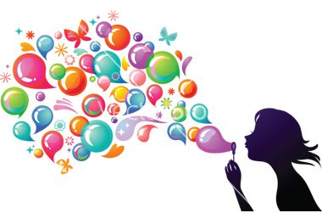
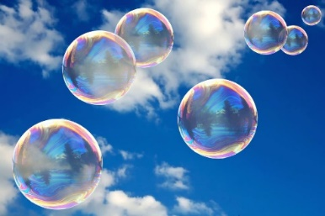
Year 4 Home Learning Friday 26th June
Please email us your work to:
REMARKABLE WRITING!

You are going to create a poem about bubbles, using specific wonderful, wow words.
If you can, blow some bubbles (see the science box below) or even make some bubbles with your soapy hands! As you do so, look at the bubbles and begin to think of:
Adverbs (have a look at the SPaG activity to help you with this part)
An adjective to go with the word ‘bubble’
A verb
A simile

Jot down any words you think of in these categories. You could ask someone else to blow the bubbles so you can look and think, or you could ask someone else for their vocabulary ideas to help you too.
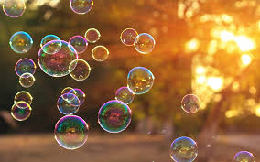
Here are 2 verses of a poem about bubbles using this structure:
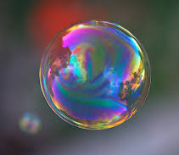
Magically
Magenta bubbles
Meander
Like floating feathers.
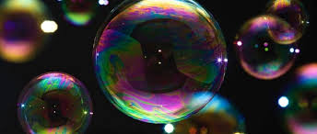
Cheekily
Plump bubbles
Swell and pop
Like perfect poached eggs.

Now it’s your turn to write a bouncing, beautiful bubble poem! Perhaps you can create a page border to make the presentation of your poem really eye catching for the reader. You may also choose to perform your poem to others in your household or even make someone’s day by staying connected and reading or performing it to family or friends you can’t see at the moment! We too would love to hear you perform your poems!

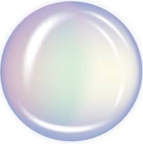  WONDERFUL WELLBEING  Time for bubble fun!  This activity is best done outdoors. Using your bubble solution, blow some bubbles.  - blow the biggest bubble  - blow the smallest bubble  - blow as many bubbles as you can in one breath  - how many bubbles can you chase and pop?  - Can you get a bubble to land  on your hand? | SPLENDID SPaG!  You are going to remind yourself about adverbs, to help you with the poetry writing activity above!  What is an adverb? What does it do? You can use either or both of these links to help you answer these questions.  https://www.bbc.co.uk/bitesize/articles/zbn492p  We realise the Supermovers link is KS1 but it is still a fun way to practice learning about adverbs!  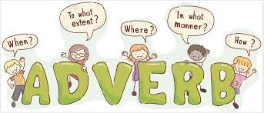  https://central.espresso.co.uk/espresso/modules/e2_grammar/activities/index.html also try the further resources tab on the left of the page and have a look at the adverb glossary.
Year4@highworthcombined.co.uk
Another Fun Friday has arrived! Today it is full of bubble fun!

MARVELLOUS MATHS!

Keep going with your times tables and division practice, as well as
practising other mental maths skills like number bonds to 100
and rounding!

Time to recap your number and place value knowledge.
Attached below is are some Year 4 number and place value
bubbles for you to complete.
With the matrices on the school website you will find a
Year 4 Number and Place Value Knowledge Organiser.
This will remind you of all the aspects of this strand of maths that you need to know and understand. If you think there is something you need more practice with, please let us know.

MORE BUBBLE FUN!

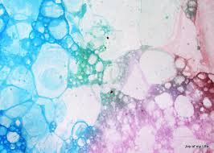
It’s impossible to catch and keep floating bubbles, but you can capture sparkling paint bubbles in a colourful new way!

Mix some paint or food colouring with a little water,
and a squirt of washing-up liquid, stir it up and then
blow into it with a straw to create lots and lots of
bubbles. You then gently place some paper over the
bubbles to take a print from them, remove, and
allow to dry.

For more fun, add bubbles of a different colour to your dry bubble paintings.

Make more bubble paintings!

Experiment to see what happens if you blow fast and slow.
Try different brands of liquid soap to see whether you get more bubbles, bigger bubbles, or bubbles that resist popping

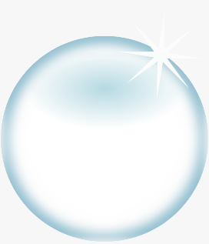
SUPER SCIENCE!

For this investigation , you will need some bubble solution. You may have some that you bought from the shops, if not, you could use this recipe to make some of your own.
Are all bubbles round?
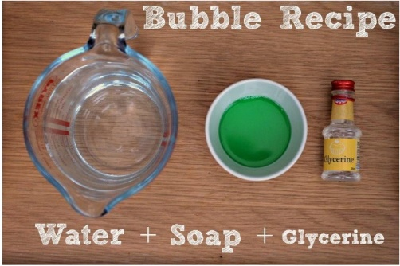
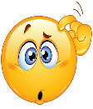
Ingredients
100ml warm water
25ml dishwashing liquid
5ml glycerine or syrup or honey (optional)
Method:
Carefully mix all the ingredients together.Try not to form
bubbles as you do this. Leave it to cool before using it.
To make a bubble wand so that you can blow the bubbles , you could use a number of
different materials, you could use a pipe cleaner, an opened out paper clip the ties that come
with plastic bags (the ones with the thin piece of wire in the middle) or even plasticine.
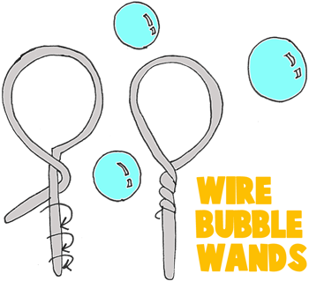

Let’s begin.
Blow some bubbles. Jot down anything you notice. Look at the shapes, sizes, what happens to them.

Do you think any force was used? Explain what you think.

A force was used to get air into the bubbles and to move them through the air.

You probably noticed that the bubbles you blew were round.

Why do you think bubbles are round?
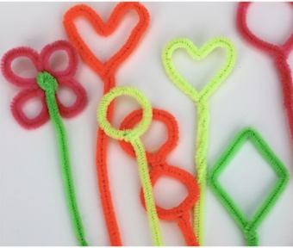
We will now investigate: Are bubbles always round?

- As explained above, try and make some different shaped bubble wands. They could be a square, star or heart shaped or even have an irregular shape.
- Blow some bubbles with each of your different wands and each time record your observations.

What can you conclude from this investigation?
The reason bubbles are always round, no matter what shape the blower is, is because when air is blown inside the bubble, it is pushed outwards in all directions evenly. This caused the bubbles to form a round shape. Bubbles are made up of a thin film or skin of soapy water.

