Year 2 Home Learning
Week Commencing 1 June 2020- Monday
Please send your work to- year2@highworthcombined.co.uk
Welcome back! We hope you had a good half term with your families and were able to get out and enjoy the beautiful weather. We look forward to seeing examples of your work again soon. Please let us know if you need any help or have any questions.

English Task  This week in English we will be looking at poetry. I have attached a poem by Michael Rosen. He is an author, poet and performer. Watch the link below to see him performing his poem- Don’t.  https://www.youtube.com/watch?v=Oaq3gzswei0  - What do you like about the poem?  - Does Michael Rose perform it well? What does he do that you like?  - Do you think he is being serious or silly? Why?  - What do you think the author thinks of the word ‘don’t’?  If there were only one ‘do’ rule and one ‘don’t’ rule in the world, what should they be?  Look at the words of the poem below. Can you try to learn and perform the poem yourself? Practice and send us a video of you having a go!  -Have you read any other books or poems by Michael Rosen? | History Task  Who was Boudicca?  Have a look at the link below to learn more about Boudicca. Watch the video and have a go at the activity.  Make a poster about Boudicca. What values did she have? What can we learn from her?  https://www.bbc.co.uk/bitesize/topics/zkrkscw/articles/zhn6cqt  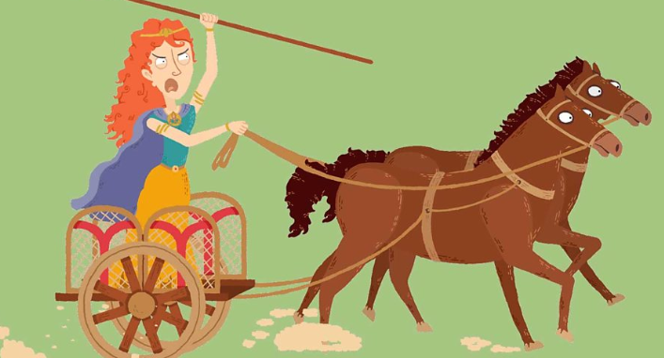
Spelling  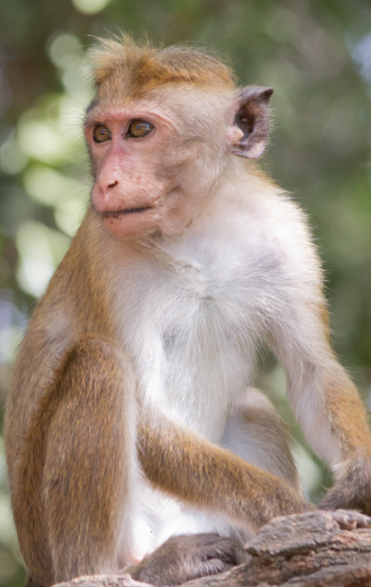  Have a look at the words below.  Did you notice that the word ‘monkey’ ends in the ee sound spelt -ey? Today we are going to look at words with the ee sound spelt -ey.  It is easy to make words ending in -ey into plurals. Just add the suffix -s.  Write a sentence with the words below. See if you can make some of them plurals.  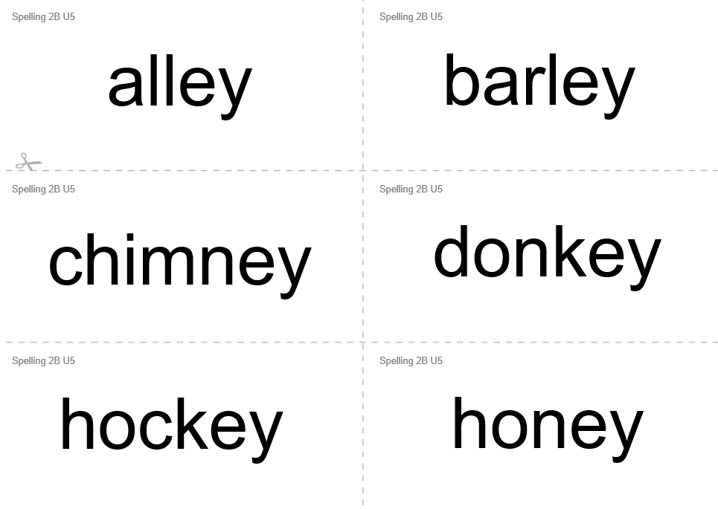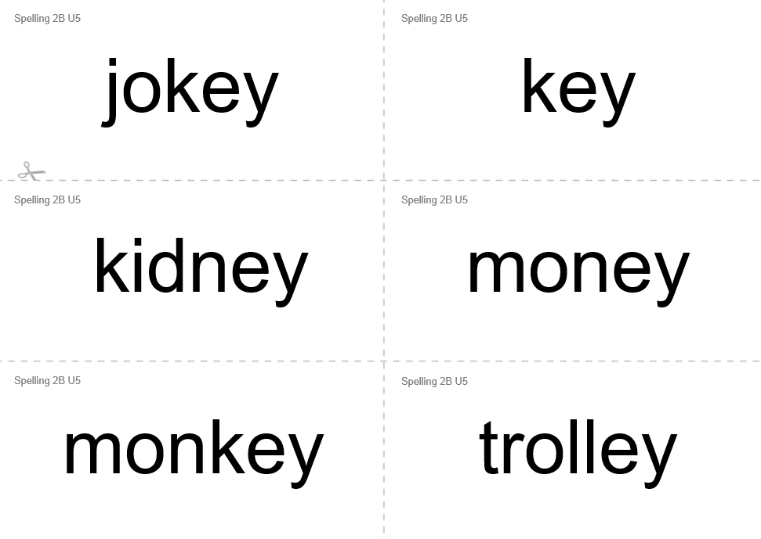 | Maths Task  Mental Maths Warm Up  1. 25 + 34= __  2. 78 - __= 21  3. 5 x 4 =___  4. 16 ÷ 2 = __  Fractions  Do you remember the different parts of a fraction?  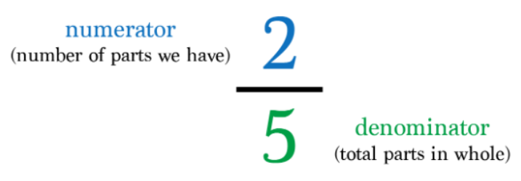  Shade the fraction of these shapes:  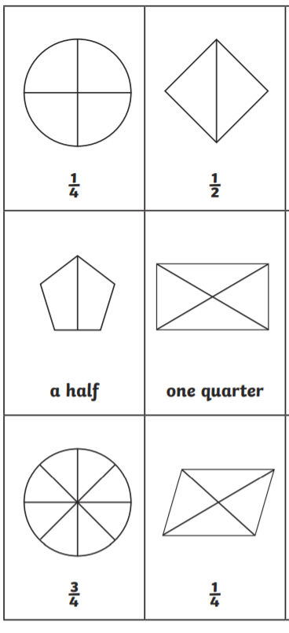
Reading  Have a look at the life cycle of a sunflower. You will need this information for your science task.  https://www.twinkl.co.uk/resource/t-l-51705-sunflower-plant-life-cycle-differentiated-reading-comprehension-activity  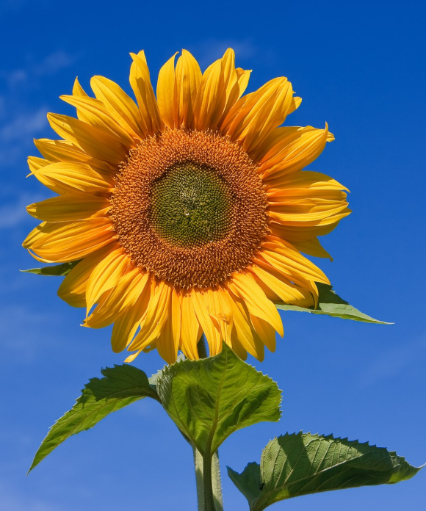 | Science  For this lesson you need to take what you have learned about in your reading session on the life cycle of a sunflower plant. Many other flowering plants have a similar life cycle. This week go on a walk or look in your garden for the different stages that plants go through. Can you find an example of the different stages? Feel free to take a picture or to draw or paint what you find.

