Year 6 Home Learning Week Commencing 1.6.20
Please email your work into us using the Year 6 email address – year6@highworthcombined.co.uk
We love hearing from you and seeing everything you’ve been up to! Take care Year 6.
Writing  We hope you have had a lovely half term holiday.  For your writing task this week we would like you to write a diary entry. You can choose whether you would like to write this about a day during half term or any day this coming week. We would love to hear about what you have been doing at home or if you have been on any great walks that you could describe.  What could you see, hear or smell?  What games you have been playing while you have been at home?  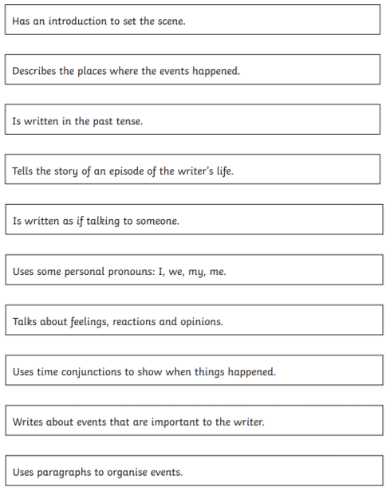  Use the checklist to help assess your own work. How many of the checklist have you managed to tick off? | Maths  This week’s work includes questions on factors, multiples and square numbers.  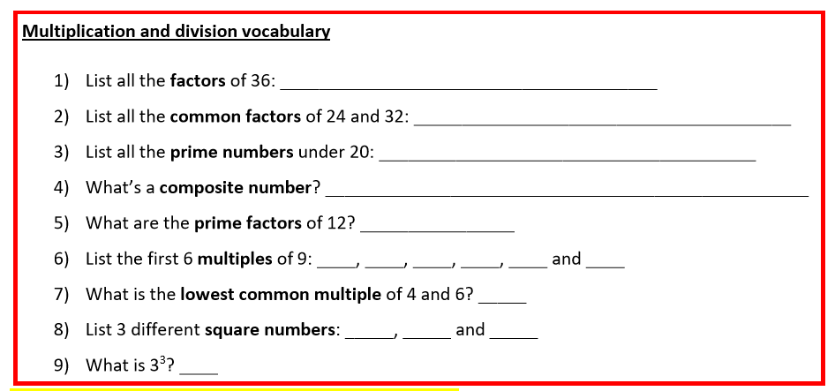  I have attached a larger version for you to complete along with a list of definitions in case you need them.  We have also attached a Maths Challenge for you to try.  You need to decide which blocks on the bottom row to place your numbers in to make the highest or lowest summit number. This one has been completed. Is 117 the highest summit number? Try moving the bottom four numbers to see if you can make a larger summit number. What will be the lowest summit number you can make?  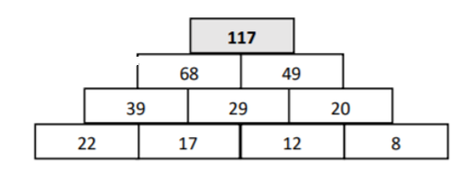
Reading  Read the story ‘The Kite’ which is attached.  Have a go at answering these questions.  - How did Tyler feel about the kite when he was first given it?  - What does Tyler do that tells you he was disappointed?  - What was the weather like? How do you know?  - How did the kite move in the air? Which words tell you this?  - How did Tyler feel about the kite at the end of the story? | Topic  Continue to use the oak national website. Have you learnt anything in addition to what you already knew? We’d love to see or hear about this!  https://www.thenational.academy/online-classroom/year-6/
Spellings  This term, you have been set lots of spelling tasks. It would be good now to see how many of your spellings you can spell correctly.  This week ask someone in your house to muddle up the letters for each of your spelling words and then see if you can have a go at solving them.  For example, q t e n e u m i p u would be equipment.  Once you have completed that activity then see if you can use the spellings in a sentence. | Wellbeing  This week we would like you to have a go at completing the ‘I Am Alphabet Game’.  With this game you need to find a word that describes you from every letter of the alphabet – or as many as possible!  This is an example of some words for the beginning of the alphabet to give you some ideas. Maybe you could make yours into a poster and display it at home. We would love to see photos of your completed work.

