Transition Day Activities
Dear children,
I’m setting you a few challenges so that I can now learn a bit more about you! Don’t forget to email them in for me to have a look at using this address: year2@highworthcombined.co.uk
I can’t wait to meet you! Have a wonderful summer holiday.
Take care,
Mrs Clarke
Activity | Example/Top Tips
‘My family’  I would like to find out more about you. Draw a picture of your family. Don’t forget to write who is who. | 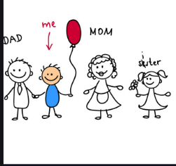
‘All about me’  What is your favourite thing to eat?  What is your favourite sport?  What is your favourite animal?  Answer each question with a full sentence and draw a picture. | I like to eat chocolate cake.  My favourite sport is football.  My favourite animal is a tiger because it is powerful.
‘Fun with number 6’.  I know that all of you are 6. (or nearly 6)  How many different ways can you show me the number 6.? | 