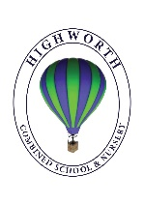
Home Learning Ideas for all
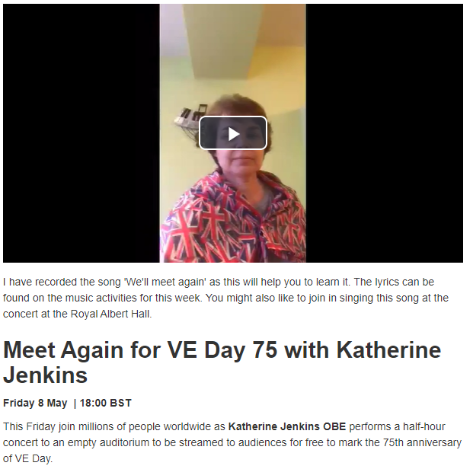
Thursday 7th May 2020
VE Day sing along tomorrow!

It’s VE day tomorrow. With that in mind, we would like to direct you all to look at the Music page Mrs Martin has been updating… she has very kindly videoed herself singing the song, “We’ll meet again” and given you information about a national sing along you can join in with.
https://highworth.eschools.co.uk/web/music_ideas/462568/cHJldmlld3x8MjAyMC0wNS0wNiAxMDozNzoyNQ%3D%3D
Wind in the Willows the Musical
VE Day Bunting
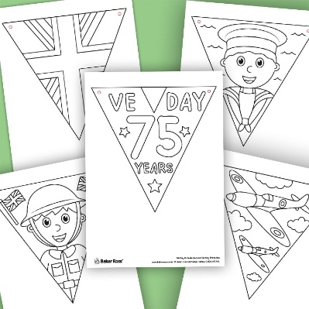
Why not design some patriotic bunting to display around your house for VE day tomorrow? For those who want inspiration (or have access to a printer) some templates are included on the pages below.

Make your own VE day aeroplanes!
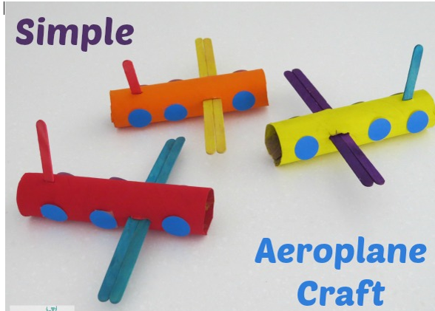
All you need is kitchen roll holders, and something to fashion as the wings – lollipop sticks have been used here. Decorate as you see fit!
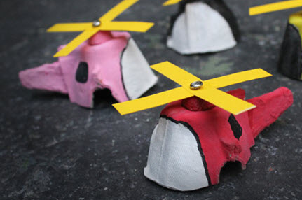
Cut up egg boxes can make excellent helicopters too…

