**Solutions**

**Paper 1**

1. What is the Highworth Combined School emblem?

A green and blue hot air balloon

**1 mark**

1. How many doors (both internal and external) are there in our block?

17 doors

**1 mark**

1. What 4 school values can be found in every classroom? Bonus point: What image is used to represent them?

CARR – curiosity, achievement, resilience and relationships. A car is used to represent them.

**5 marks**

1. Name a display board in the learning lane.

Maths, school council, Science

**1 mark**

1. Can you name three of the desired alphabet things we’d like to see in year 6 on the display between the two classrooms.

We will check these as they are emailed in ☺

**3 marks**

1. Next to the year 6 toilets there are two display boards.  What are on them?

Spelling Tree and Home learning display

**1 mark**

1. What is the name of the garden behind the Reception classrooms?

Sue’s garden

**1 mark**

1. There is an image that has been drawn and coloured in by the year 5 children in Mrs Naidoo’s classroom stuck on her window. What animal is it?

An elephant

**1 mark**

1. What is on the right hand side when immediately entering Mrs Keating’s classroom?

Mrs Cunningham’s desk

1. **mark**
2. What is the display of on the doors of the cupboard in 6H and 6S?

The year 5/6 spelling words we’ve been learning

**1 mark**

**Paper 2**

1. Bounty
2. Lion Bar
3. Mars
4. Double Decker
5. Kit kat chunky
6. Yorkie
7. Mint Aero
8. Boost
9. Snickers
10. Milky Way
11. Fudge
12. Toffee Crisp
13. Cadbury Caramel
14. Turkish Delight
15. Picnic
16. Crunchie

**Paper 3**

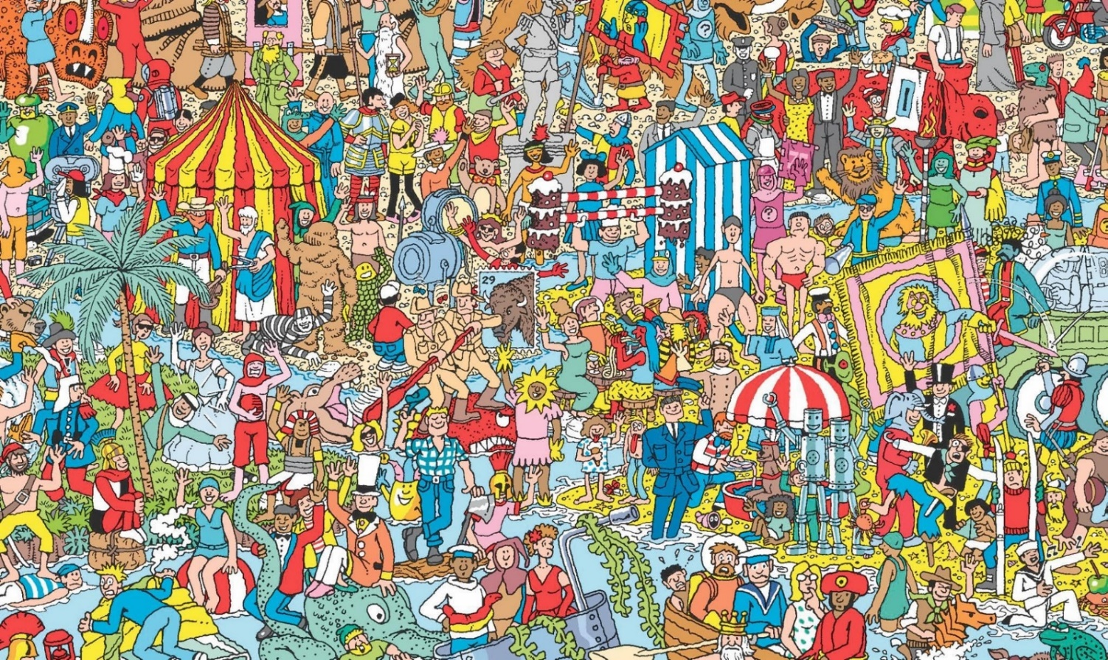

**Paper 4**

Mrs Harris – has climbed a mountain in Austria

Mrs Smith – has been scuba diving

Mrs Keating – used to do ballet and gymnastics as a child

Mrs Hastie – does boxing to keep fit

Ms Kennedy – used to be a hairdresser

Mrs Cunningham – went to the school Hogwarts was based on. JK Rowling wrote Harry Potter at a table at the back of a café in Edinburgh and from the window she could see my old school. Turrets and all!

Mrs Naidoo – shares her birthday with Queen Victoria

Ms Kern – can right legibly in her left and right hand

Ms Pankhania – once flew on Concorde

Mrs Day – went on an American road trip for my honeymoon

Mrs Dimishky – met the actual BFG (Roald Dahl’s gardener)

Mrs Strugeon – loves teaching P.E.

**Paper 5**

Timed task

**Paper 6**

1. There
2. Really
3. Is
4. No
5. Spelling
6. Test
7. Happy
8. Lockdown
9. SATs
10. Year Six

**Paper 7**

Art task

**Paper 8**

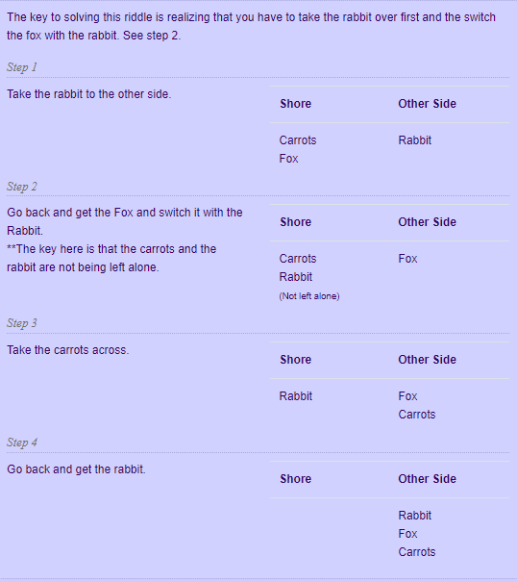

1. You!

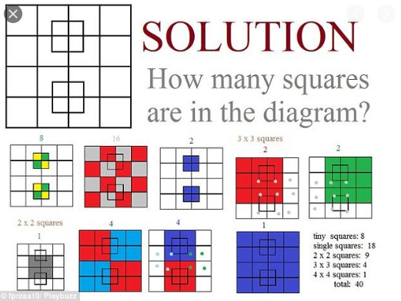



**Paper 9**

1. **Cat in the hat**
2. **The Hungry Caterpillar**
3. **Matilda**
4. **Green Eggs and Ham**
5. **3 Little Pigs**
6. **Alice and Wonderland**
7. **James and the Giant Peach**
8. **Harry Potter**
9. **Charlotte’s Web**
10. **Charlie and the Chocolate Factory**
11. **The Rainbow Fish**
12. **Tiger came to tea**
13. **Black Beauty**
14. **We’re going on a bear hunt**
15. **The lion, the witch and the wardrobe**

**Paper 10**

Secondary schools – different answers

**Paper 11**

Celebration task