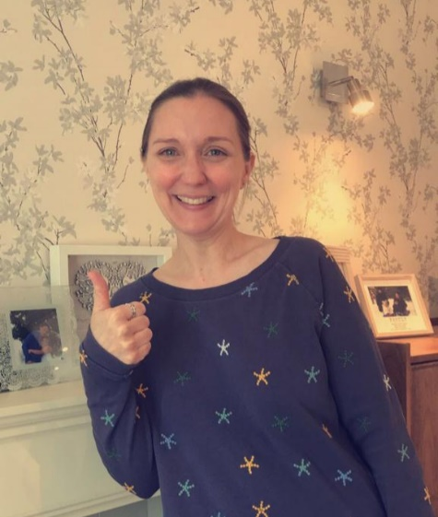

Dear RC,

Hello everyone, my name is Mrs Reed and I will be your keyworker in Reception.
I will be working with Mrs Cox to help you feel settled in your new classroom and support you when learning and at play.
I am looking forward to getting to know you and finding out your interests. I enjoy being creative, one of my favourite things to do is to paint and mix colours. I also enjoy sharing books with you, playing the piano, and teaching you new songs!
During lockdown, I have had fun walking and cycling with my own children in our local woods.
I am really excited about meeting you all and being there for you as you begin your learning journey.
Take care and have a lovely summer!
See you soon,
Mrs Reed x

