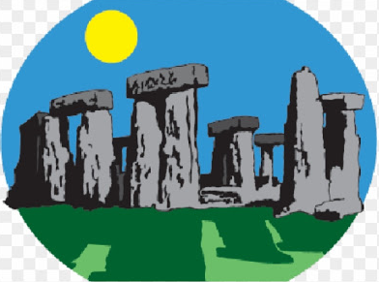
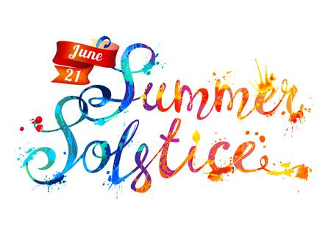
Year 4 Home Learning – Monday 22th June 2020
Please email us your work to:
Year4@highworthcombined.co.uk
The summer solstice, also known as festival solstice or midsummer, marks the longest day of the year. It happens twice yearly, once in each hemisphere. Each year on the 21 June, visitors from around the world gather at Stonehenge overnight to mark the northern hemisphere’s summer solstice and to see the sunrise above the stones.
REMARKABLE WRITING!

Read the fact file on Stonehenge.
Note down any key information or interesting facts as you read.
Using your notes create a poster about Stonehenge. Remember, it should be bold, interesting and informative.

Here are some tips to help you …

You also need to remember all the grammar parts of a tool kit:
Capital letters and punctuation
Spelling
Does is make sense when you read it?
Choice of vocabulary

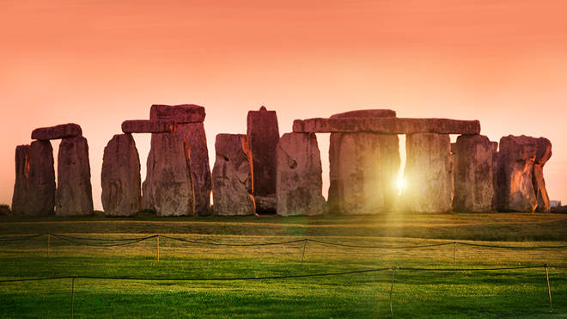

RESILIENT READERS!

Firstly, please remember to keep reading for at least 20 minutes a day!

In line with our summer solstice theme, the reading challenge we have chosen will help you learn more about this theme.
The text and questions are attached as a separate document with the Year 4 home learning matrices.

CHALLENGE: After reading the text, do you have any questions? Is there anything you would like to find out more about?

SUPER SCIENCE!
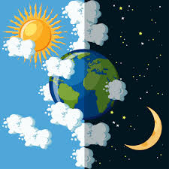
Have you ever thought about what causes day and night?
Try this experiment. It explains how we get day and night.

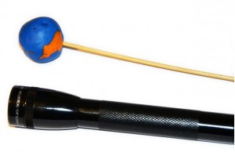
Materials
- Plasticine or Play-dough
- A wooden skewer
- Flashlight

Instructions
- Use the plasticine to make a ball, this will be Earth.
- Place the skewer into the bottom of the ball.
- You can then either hold the skewer or use another bit of plasticine to stand it in.
- Strictly speaking the ‘Earth’ should be positioned at a slight angle.
- Make the room dark and shine the flashlight at Earth while slowly rotating it.
- The flashlight represents the sun.

What do you notice?

Can you see that only one side of the ball is in the light and the other remains dark? So, on one side of the Earth it is daytime and the other night. The Earth rotates once a day, which is why some of each day is light and some dark.
Did you know? For 6 months of a year the North Pole is dark while the South Pole is light and then vice versa for the other 6 months of a year. The 6 month long night is called a Polar Night and the day a Polar Day (This is because of the tilt we mentioned earlier).

WONDERFUL WELLBEING!  Fun focus time  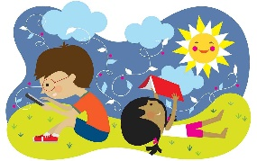  Look for some stones in the garden, then carefully place them on top of each other.  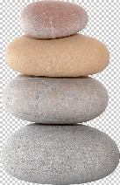  - How many stones can you balance on top of each other?  - What is the tallest pile you can make? | TERRIFIC TOPIC!  You have learnt so much about Stonehenge, why not have a go at building a model of this World Heritage Site? The template is attached below.  Did you know?  It has been 30 years since Stonehenge became a World Heritage Site. Stonehenge is the most architecturally sophisticated prehistoric stone circle in the world and, together with Avebury and their surrounding landscape, was ascribed World Heritage Site status by UNESCO in 1986.
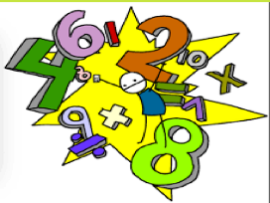
MARVELLOUS MATHS!

Keep going with your times tables and division practice, as well as practising other
mental maths skills like number bonds to 100 and rounding
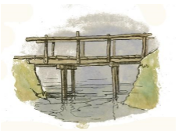
Paper Bridge Design Challenge

In keeping with the theme of building, your maths task today involves designing and building. You could try this alone or do it with someone at home.

THE CHALLENGE:
Your goal will be to design a bridge to hold as much weight as possible without the bridge
collapsing. This must be completed in a limited amount of time.

Criteria: • The bridge must span a distance of 35cm(must be 35cm long) . It can be between two desks or chairs
• The bridge must hold as many pennies as possible without collapsing

Materials:
- two pieces of A4 paper,
- 15cm of tape,
- scissors and rulers
- You have 15 mins to complete the task

Think about a design for your bridge. Build it and then see how many coins it can hold. You could use Lego pieces or anything else that is the same size to test the strength of the bridge.

Try and modify the bridge to make it stronger and then test it again.

Challenge: What do you think affects the strength of the bridge?

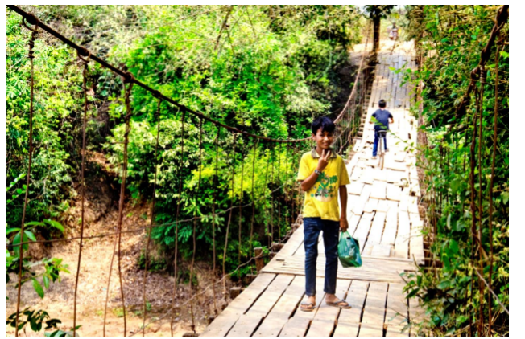

A suspension bridge

