yearr@highworthcombined.co.uk
This week’s learning activities are based around Dinosaurs
Listen to the story ‘Saturday Night at the Dinosaur Stomp’  https://www.youtube.com/watch?v=kgdyqjcmAUs | Phonics with Fred!  Available at 9.30 am  https://www.youtube.com/channel/UCo7fbLgY2oA_cFCIg9GdxtQ  Please focus on Set 1 and Set 2 lessons. | Wellbeing!  Put on some music and have dance!  Maybe you are going to the dinosaur stomp? Or joining the fairies as they skip and twirl between the flowers?  Can you listen to different types of music, which music sounds like dinosaurs, fairies etc.?
Invent your own dinosaur!  What does your dinosaur look like? Draw a picture in your home learning book to show what your dinosaur looks like. Does it have spikes or does it have wings…maybe it has both? Does it have long neck or long legs instead? Think of a new name for your dinosaur, can you write its name using your sounds and letters? Using a capital letter, finger spaces and full stops can you write 4 super sentences about your dinosaur? Make sure you use some descriptive words too e.g. ‘sharp spikey claws.’ | Creative dinosaurs!  Can you use pasta, cotton buds, paper plates or cupcake cases to make your own dinosaur?  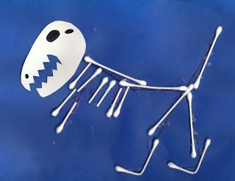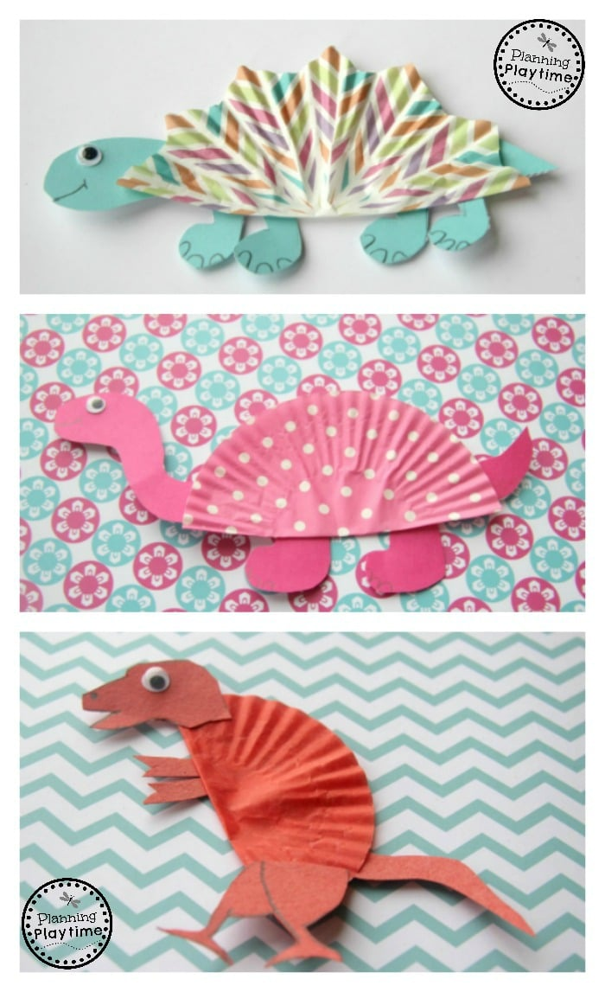  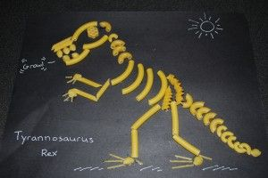 | Dinosaurs and bones!  The dinosaur’s bones have ended up in a muddle!  Can you order the bones from longest to shortest? What words could you use to describe the lengths of the bones as you compare them? (longest, longer, shorter, shortest) Either cut out the bones on the attached sheet or make your own from playdough!  Can you solve the problem? Which dinosaur (on the attached sheet) is the tallest? Is the shortest? Use objects such as pencils, stones, paperclips from around house to measure the dinosaurs and solve the problem!  How do you know that dinosaur is the (longest, shortest etc….)?  Can you cut out the dinosaurs and put them in order from tallest to shortest?



