Year 2 Home Learning
Week Commencing 4 May 2020 - Wednesday

English task  Choose a book that you enjoy or have a look on the website (Cronovirus Closure—Story time with Highworth staff) and listen to one (or even all) of the books. * Keep checking here as more will be added.  Write a book review.  - What was the book about?  - What did you like?  - Would you recommend the book to others? Why?  - Does this book remind you of any other books?  Finish your review with a picture of your favourite part of the story. | Maths task  What skill will you need to answer the word problems today?  - I have 25 cherries, and I want to share them with 5 hungry children. How many will each child get?  - In the library there are 90 books on the third shelf. If 10 children come in and take one book at a time until the shelf is empty, how many books will they each have?  - I have just been given a big chocolate cake. It is cut into 15 slices. If there are 5 people in my family, how many slices will each person get?  - I had 12 apples in my fruit bowl. There were only four left after dinner. Each child took 2 for a snack. How many children had apples?  Challenge- Write your own word problem using the same skills.
SPAG  Irregular Verb Match  Verbs come in tenses. The past is used to describe things that have already happened. The present tense is used to describe things that are happening right now, or things that are continuous.  Draw a line from the present tense to the past tense of each verb below.  say came  find said  run told  tell ran  come won  win found  *Can you write each word in a sentence? |  | Reading  VE Day Comprehension  Twinkl- VE Day Comprehension KS1  https://www.twinkl.co.uk/resource/75th-anniversary-of-ve-day-differentiated-reading-comprehension-activity-ages-5-7-t-e-2550049
Science  Go on a ‘bug hunt’ in your garden. How many different minibeasts can you find? Write some descriptive sentences about the minibeasts. Try to use at least one adjective in every sentence and try to put a verb and an adverb in your sentences too.  Example- The beautiful blue butterfly fluttered quickly around the small garden.  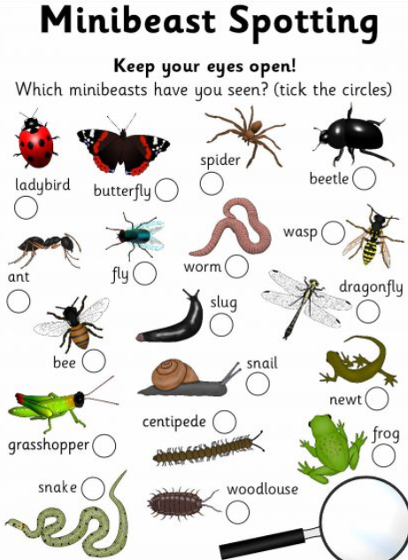 |  | British Values  Celebrate VE Day. Why do people celcbrate VE Day? What could you do to celebrate?  https://www.twinkl.co.uk/resource/t2-h-4788-ve-day-powerpoint  Have a go making some British flag (Union Jack) bunting and hang it up to celebrate VE day.

