Year 5 Home Learning – Monday 29th June 2020
We’d love to see your work! Please send it to: Year5@highworthcombined.co.uk
ENGLISH Writing: Wizards  We hope that you had fun writing your advert for your school!  Today we are going to write a newspaper report:  Can you remember the 5 Ws for your opening paragraph?  Scroll down for some examples and try the activity – writing paragraphs using the 5 Ws.  You will also need to practise writing quotes as there are usually quotes from witnesses/experts in journalistic writing.  Read the toolkit to help you remember and have a go at the activity. |  | MATHS: Equivalent Fractions and Rapid Reasoning  Look at the fraction wall and complete the worksheet on equivalent fractions (fractions that are equal).  Use the fraction initially and then try to find the pattern that you can use to find equivalent fractions – without the fraction wall.  What have you discovered? Write it in a sentence. Can you make up some of your own equivalent fractions?  Mark and correct your work.  Next, look at the Rapid Reasoning sums.  Take your time and try to work them out – you will need some paper for working out.  Mark and correct your work.
WONDERFUL WORDS
Look at the Year 5 & 6 Words List. You can find it as a link on our Coronavirus Closure, Home Learning Matrix, Year 5 tab: https://www.highworth.bucks.sch.uk/web/year_5/460996
Choose 4 or 5 words to practise at a time.
- Look up the definition in a dictionary to check the meaning of each word.
- Learn the correct spelling by using: Look, Say, Cover, Write, Check.
- Write a sentence which includes the word to show that you understand its meaning.
4. Remember to always edit your sentences to check for correct punctuation and spelling.
Scroll down for the Practise Activity to help get you started.
History  Medieval Monarchs  We are continuing our History lessons on Medieval Monarchs.  Today we are going to look at who was the worst king? King Richard I or his younger brother King John?  https://classroom.thenational.academy/lessons/who-was-the-worse-king-richard-i-or-john | Reading  Read Kidnapped.  Make sure that you understand all the tricky/new words.  You may need a dictionary.  Answer the questions that follow.  Draw an appropriate picture for the text.  Do you think that you could make a text map for this text?  Why not give it a go… |  | Science  We are going to be looking at flowers.  Look at the diagram of a flower and learn the names of the different parts and their functions.  https://www.youtube.com/watch?v=A5Pf4_LXyC4  Answer the activity sheet on pollination to help with your understanding. Try to learn and remember the pollination process.  https://www.youtube.com/watch?v=j-S5ui9Us7U  Try drawing a flower and labelling the parts from memory.
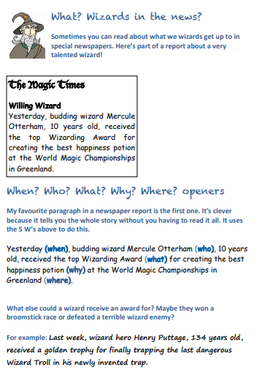

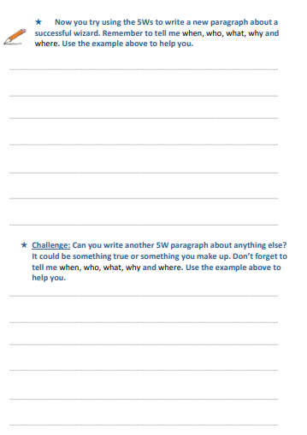

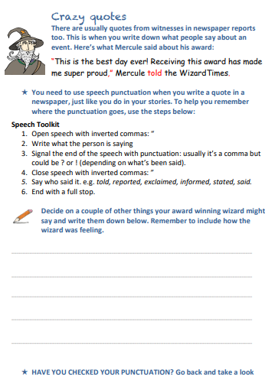

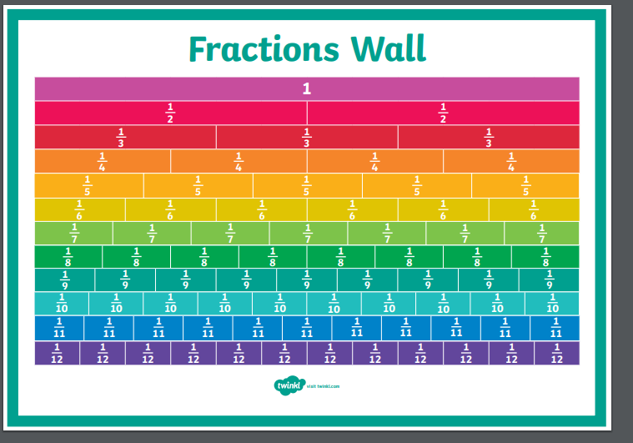

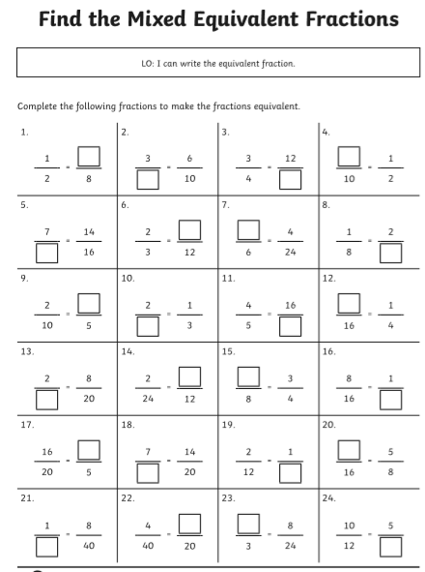

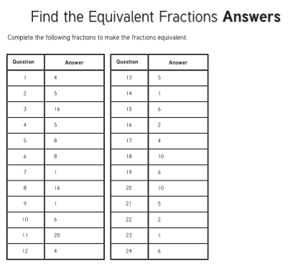

Rapid Reasoning
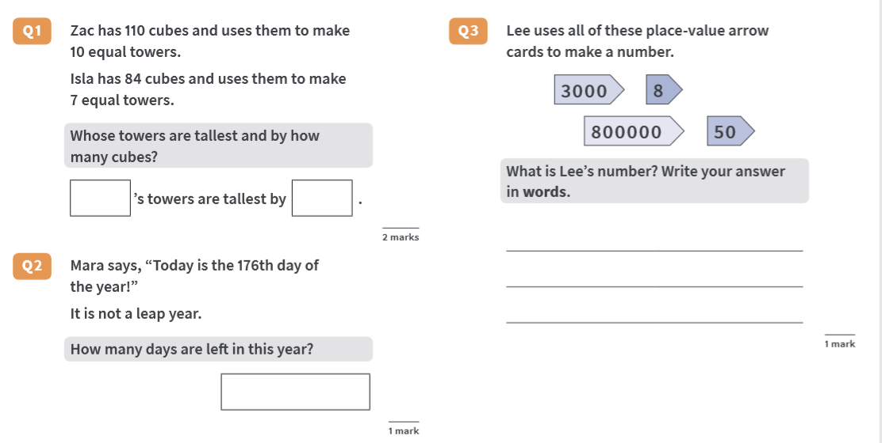

ANSWERS
