Year 2 Home Learning
Week Commencing 15 June 2020- Friday
Please send your work to- year2@highworthcombined.co.uk
We always look forward to seeing your work. Please let us know if you need any help or have any questions.
English Task
Toy Story
I am sure many of you are familiar with the Toy Story movies. Have a look at the picture and answer the questions below. You will need your inference skills so look closely at the picture to answer each question. Try and use the word ‘because’ in your answers to help explain why you think what you do.
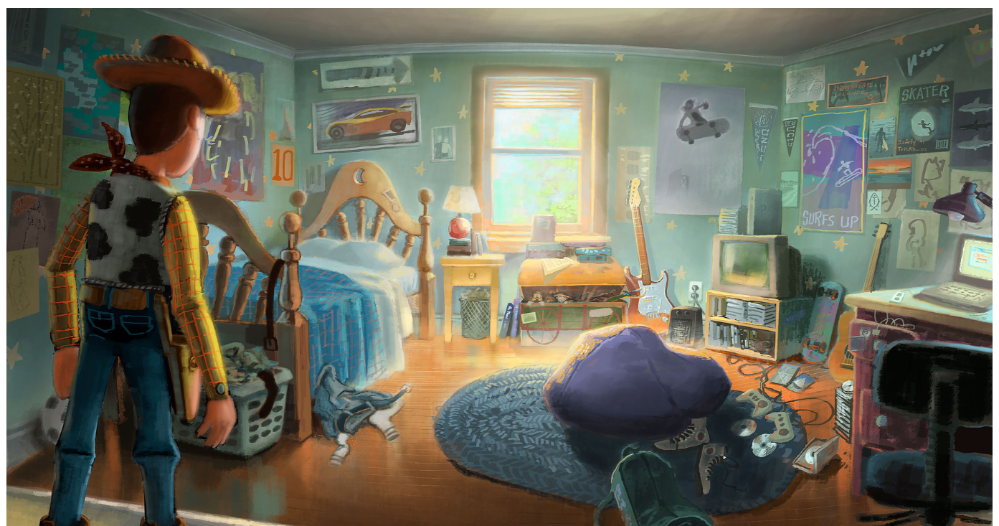
- What are Andy’s interests?
- What type of person is Andy?
- How old do you think Andy is?
- What is Woody looking at?
- What is Woody thinking?

Maths Tasks

Warm Up
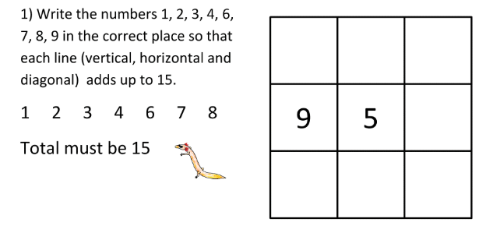

Division- As you look at the division problems, decide if you are going to be grouping or sharing. Then solve each problem accordingly.
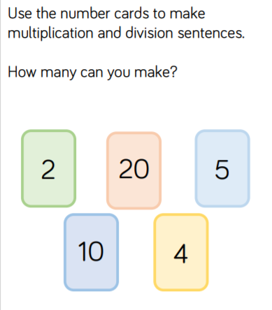
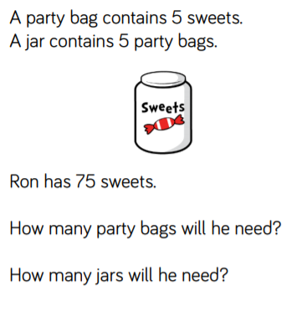
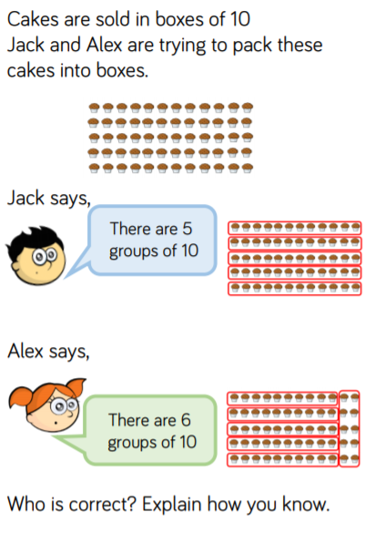
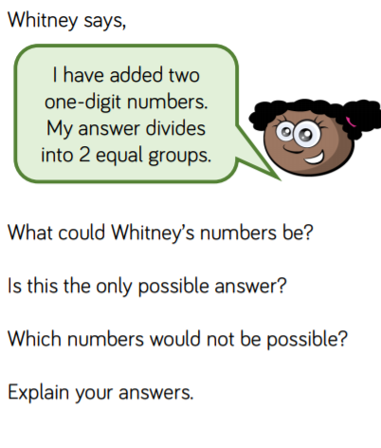

PE  Complete the Alphabet Challenge below.  *Try to do your full name.  How many times can you do it?  *Pick a few tricky words from our spelling list and try doing the actions for them! | Wellbeing  Make a list of different good qualities of people. Can you think of more than 15 different words?  Draw a picture of yourself. Around the picture write your good qualities and examples of when you have used them.
Father’s Day  I love you to the Moon and Back  You all have people in your life that care about you very much and who do a lot to help you. This weekend is Father’s Day. Make your dad or someone special in your life a card. Inside you can write a message telling them how much you care and thank them for all they do for you. I have attached instructions for a card that I think you might like to make. Don’t worry if you don’t have the exact paper or colours. It is only there to give you an idea.  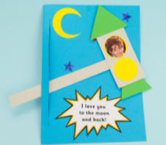 | Class Reading  World’s Worst Children  By David Walliams  Follow the link below and listen to a reading of a chapter from the book ‘World’s Worst Children’. Each chapter is about a different child and this chapter is called ‘Sophia Sofa’.  https://www.youtube.com/watch?v=RBrVac-dn6o  -Challenge- Use the PE challenge page to do the activities to spell- Sophia Sofa.  