Home Learning Ideas for all
Tuesday 31st March 2020
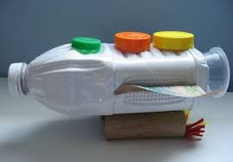
Junk modelling!
Have a look through your recycling – look for yoghurt pots, boxes, kitchen roll tubes etc. and see what you can make! Can you work with a parent or sibling to create something together? You may want to send a photo of your creation to your teacher!

Oxford Owl for Home
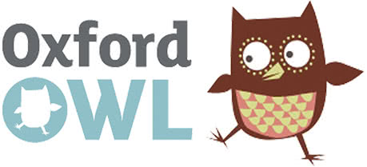
This website contains a huge variety of free eBooks for you to read online. New eBooks are being added each week – including Read Write Inc. Phonics books. https://home.oxfordowl.co.uk/books/free-ebooks/ This website also has a ‘Kids activities’ section https://home.oxfordowl.co.uk/kids-activities/ and also a fantastic Read Write Inc. Phonics section https://home.oxfordowl.co.uk/reading/learn-to-read-phonics/.

And finally, go into Espresso (log on details on the Home Learning Ideas) https://www.discoveryeducation.co.uk/what-we-offer/discovery-education-espresso and select the correct Key stage for you and complete the daily challenge… good luck!

