Year 2 Home Learning – 2nd Half of the Summer Term
Below you will see 6 homework tasks. You may choose the tasks that you wish to complete and do them in any order. Please do not hesitate to contact us if you have any queries.

Famous People  Find out about somebody who has invented or discovered something.  Some ideas:  - Leonardo Da Vinci  - Alexander Graham Bell  - Marie Curie  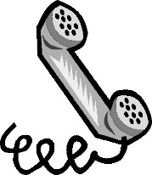 | Science Materials Hunt  See if you can find objects around your house that are made from the following materials:  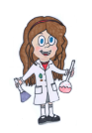  - glass  - plastic  - wood  - fabric  - metal  - rubber  Make a chart and draw the objects you have found for each material.
Around the World Day  Research and find out 5 facts about France.  You could even learn a few words in French!  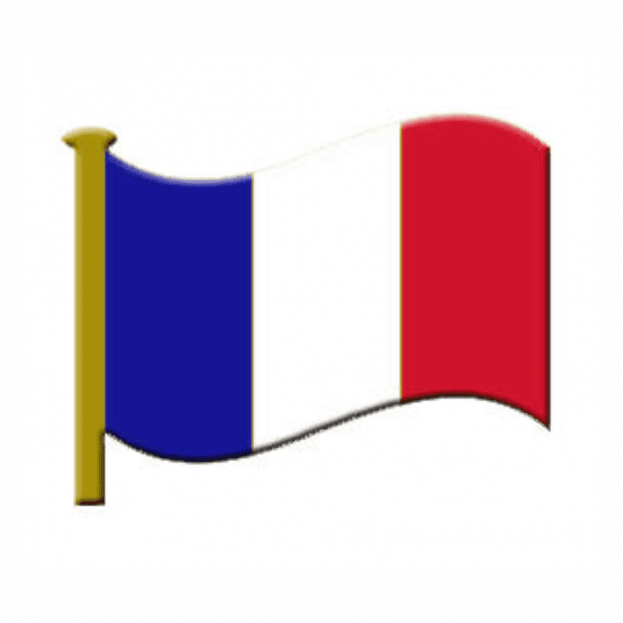 | Seaside Scene  Create a collage of a seaside scene. Try to use a range of different materials.  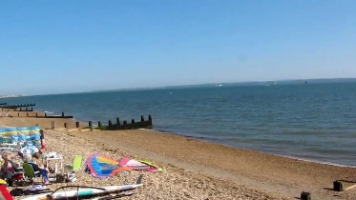
Sports  See if you can do a different type of exercise each day for a week. E.g. riding your bike, going for a walk, star jumps, going swimming.  Record the exercise that you do each day. | Write a letter to your new teacher  The end of term is approaching and next year you will have a different teacher. Write them a letter telling them all about yourself.  