Year 1 Home Learning – Monday 4th May 2020
Below, you will find 6 home learning tasks. You may choose the tasks that you wish to complete and do them in any order. Please do not hesitate to contact us if you have any queries or would like to share the work you have been doing.
year1@highworthcombined.co.uk
If we were in school this week we would have started a new topic called ‘Clothes and coverings’ so lots of the tasks today will be based on this theme.
English  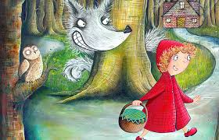  Little Red Riding Hood is a traditional tale where the main character is named after her bright red cape.  With an adult please use the link below to watch the story told over the course of seven fun videos.  https://www.bbc.co.uk/teach/class-clips-video/english-ks1-little-red-riding-hood-index/zmnrqp3  If you don’t have access to the internet perhaps you have a copy of the story or could ask an adult to verbally retell the story to you.  Once you have listened or watched the story, write your own version of ‘Little Red Riding Hood, or your own version of part of the story.  When you have finished your story look at this checklist and see if you have included these aspects of a good story:  I wrote using my very best precursive handwriting and used finger spaces between words.  I used capital letters at the start of each sentence and for names.  I wrote complete sentences.  I used a punctuation mark at the end of each sentence.  My piece of writing has a beginning, middle and end.  I tried my best to use my sounds to spell words, or I used my knowledge of spellings to spell words correctly.  I did my very best.  Challenge  Can you write ‘Little Red Riding Hood’ split up into different sections (chapters) just like the videos are split into different parts of the story? |  | Science  In the spring term we were learning about materials and their properties.  Today we are finding out about waterproof and non-waterproof materials. Lots of coats are made from waterproof material.  We would like you to test different materials to find out if they are waterproof. Record your results in a table like the one below e.g.  Object Waterproof Not waterproof  Paper  Tin Foil  Cling film  Fabric  If you don’t have these materials, you can use any materials that you do have around your house.  Which material would you use to make an umbrella?  Why would you choose this material?  Challenge  For fun can you make a waterproof umbrella for a toy?  - The most important features of an umbrella is that the material it is made from is waterproof so that you don’t get wet.  - Can you make any wellington boots so that your toys feet stay dry?  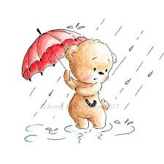
Maths
Today we are going to interpret pictograms. A pictogram is a graph showing data using pictures.

Look at the pictogram below.
= 5 hats
= 10 hats
Key:

Hats worn in the last week of the summer by 1LM
- This pictogram shows the number of hats the children in 1LM wear on each day at lunchtime.

- To work out the number of hats worn each day we count up in 10’s for each hat drawn and in 5’s for each half hat.

- On Monday there is 1 hat drawn, which is worth 10.
- On Tuesday there are 2 hats drawn, which is worth 20.
- On Wednesday there is 1 hat drawn, worth 10.
- On Thursday there are 2 and a half hats drawn, worth 25.
- On Friday there are 3 hats drawn, worth 30.
Day of the week |  | Number of hats worn
Monday |  | 10
Tuesday |  | 20
Wednesday |  | 10
Thursday |  | 25
Friday |  | 30
Hats worn in the last week of the summer by 1H
Look at the pictogram on the right for 1H to help you answer these questions.
- What does one hat picture represent?
- What does half a hat drawing represent?
- How many hats are worn by 1H on each day?
- On which day do 1H wear the most hats?
- On which day do 1H wear the least amount of hats?

Day of the week | Hats worn
Monday
Tuesday
Wednesday
Thursday
Friday

Challenge- Can you draw your own pictogram to represent the number of t-shirts you have of different colours?
How many will each drawing of a t-shirt represent? Can you write about what your pictogram shows?

E.g. This is my t-shirt pictogram. It shows I have more green t -shirts than any other colour.

Key: = 2 t-shirts = 1 t-shirt

Colour | Number of t-shirts | Total
Red |  | 7
Green |  | 8
Blue |  | 5

Wellbeing  The gratitude colour clothes game.  Gather some clothes that you have of different colours e.g. (red socks, orange shirt, green jumper, blue jeans) and put them into a basket. If you don’t have clothes of these colours, you could use toys or make coloured cards.  Ask an adult to pick an object out of the basket. Then, look at the gratitude colour chart below, and name the item that you are thankful for according to the colour. | Art  Today we are going to think about clothing! We are going to make clothes for a paper doll.  - Draw an outline of a person and cut the person out.  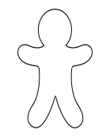  - Then draw a selection of clothes and include tabs that you can fold over to make it easier to change your paper dolls clothes.  - Now cut out the clothing for your toy doll and place it on your doll, fold the tabs over so you can change the clothes.  Challenge  Can you make clothes for different weather conditions for your doll? Can you make outfits that you like to wear in the summer or winter? Can you make outfits that are traditionally worn in other parts of the world?  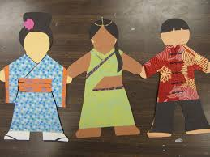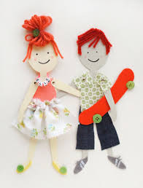  Don’t forget to send us a picture of your paper doll in different outfits!
History
We are going to think about how clothes and how they have changed over time, what is different about clothes we wear today and those in the past and what you think we might wear in the future.
Look at the three pictures below, talk with an adult about what clothes the people are wearing. What is different between what they are wearing? What is the same? What do you notice about what is on their head, what is on their feet? The length of their clothes and materials they were made of? Why do you think clothes have changed?
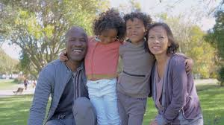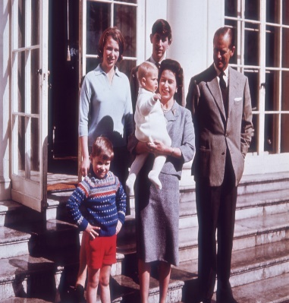
Clothes in 2020 Clothes in 1960 Clothes in the 1500
Write a sentence about the similarities and differences between the clothes in the past and clothes now.

Challenge
Draw and write a description of what you think people will wear 100 years from now in the future.
How will clothing in the future be different to our clothes?
What will people be doing, where will they live and how will their clothes reflect this?

