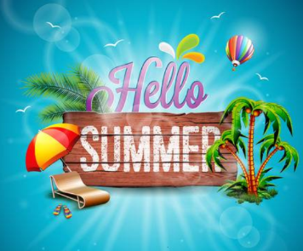
Year 2 Home Learning
Week Commencing 17 July 2020- Thursday
Please send your work to- year2@highworthcombined.co.uk by 3.00 Friday.
We hope you have a great summer break, and we look forward to seeing you in September!

English Task  Can you remember all of the stories we focused on in English this year?  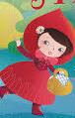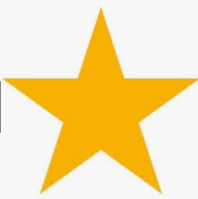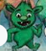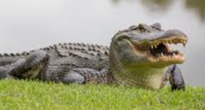  What was your favourite story you read/ learned?  What was your favourite piece of writing that you wrote?  How do you think your writing has improved this year?  What do you want to improve in your writing next year? | Maths  Maths Reflection  We have learned a lot of new things this year. We started the year learning about place value, we moved on to adding, subtracting, multiplying, dividing, reading the time, measuring and learning about shape.  What have you enjoyed the most?  What is your best achievement?  What do you want to get better at next year?
Summer Reading  Our local library has lots of books available online- ebooks. They are free to read online and there is a great selection. All you need is a library card to access and if you don’t already have one, you can sign up online.  There is a huge selection and even some audio books that you can listen to.  Have a look at let us know what books you will read this summer!  https://buckinghamshire.overdrive.com/library/kids | Vocabulary  Words to remember-  Think back to all of the ‘Words of the Week’ that we have covered this year. How many words can you remember? Write each word in a sentence.  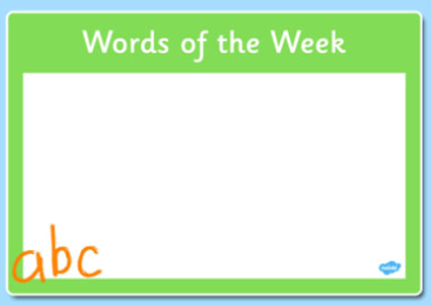
Wellbeing  Make sure over the summer holidays that you still keep active and do things you enjoy. Make a list of the things you want to do and things you think are important to do.  I have made a check list of things I want to do every day. Create your own list.  Do something creative  Do something active  Do something outside  Read a book  Write a diary  Do something helpful | PE/ Geography  Stair Challenge  Have a look at the link below and see if your family can attempt one of the climbing challenges over the summer break. All you need is a flight of stairs.  Let us know what peek you choose. What do you know about that part of the world? Write three sentences telling us facts about it.  https://www.nhsggc.org.uk/media/213470/haw_challenge_stair_climb.pdf

