Year 2 Home Learning
Week Commencing 8 June 2020- Monday
Please send your work to- year2@highworthcombined.co.uk
We always look forward to seeing your work. Please let us know if you need any help or have any questions.

English Task  This week we will continue looking at poetry. I have attached a poem ‘The Magic Box’, by Kit Wright. The poem is about the writer’s identity. Notice how the last two paragraphs change to become what the box is made from and what the writer will do with the box.  Read the poem attached below. What sights, sounds and smells has the writer put inside the box? Why do you think the writer has chosen these?  Kit Wright uses a range of writing techniques (adjectives, adverbs and alliteration) in his poem. Can you identify some of these in the poem? How do they improve the poem? Notice how the poet is very precise with his description. For example, he does not just add water, he adds a sip of the bluest water…  Now close your eyes and imagine your own box. Which 3 things will you put in your box? Use the following sentence starter and see if you can use these writing techniques to describe some things that you could put in your Magic box: (Think about things that are important to you)  I will put into my box…  For example:  I will put into my box  the tick tock of time passing,  the soft tickle of a fine feather,  the shimmer of a shooting star…  Some ideas that you could describe are stars, diamonds, flowers, rainbow, sun, volcano, fireworks, wizard, unicorn, ocean, seasons, fruit, etc. Remember the list is endless! It is your box; you decide what lovely and imaginative things you want to put inside it!  Have a go at drawing those 3 things. | Maths Task  Mental Maths Warm Up  1. 52 + 32 = __  2. 47 - __ = 25  3. 6x 5 = ___  4. 12 ÷ 3 = __  Fractions:  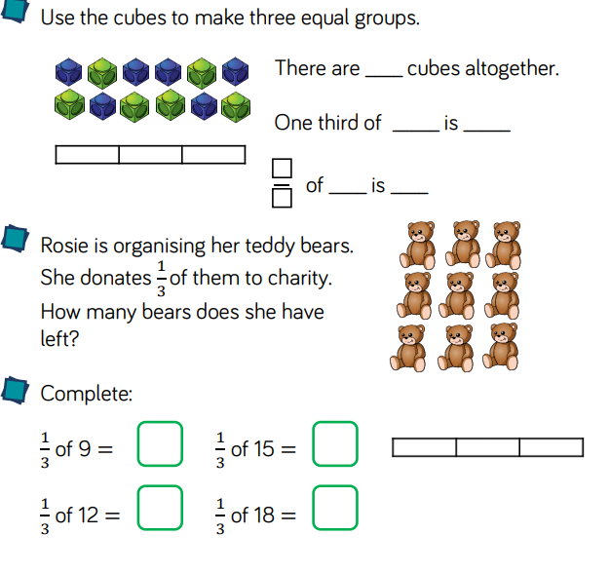  Challenge!  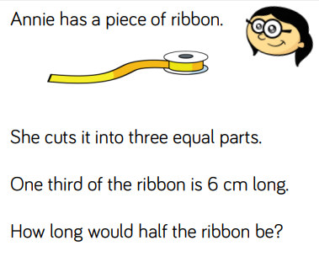
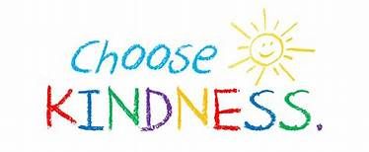  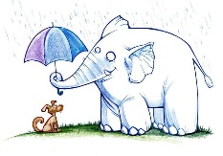  Spelling  Last week we talked about acts of kindness. The word kindness is made by adding the suffix -ness to the adjective kind.  Have a look at the words below. Practise reading the words. Now choose five different words and write a sentence with each one.  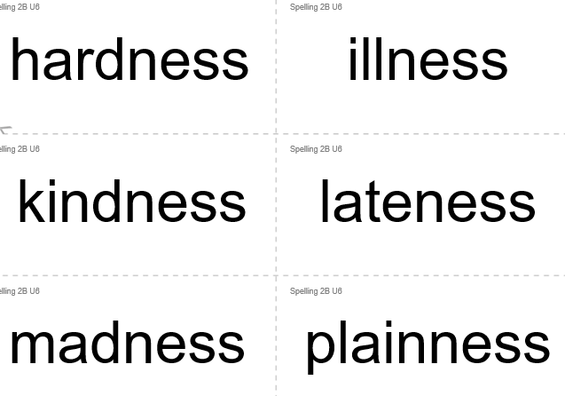  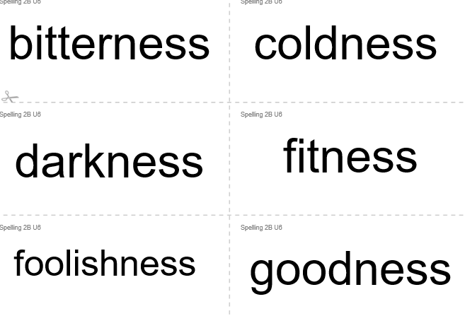  Create 2 cards for each word and play a memory game. | Science:  *Make sure you do not touch any hot light sources. Ask an adult to help you with this experiment:  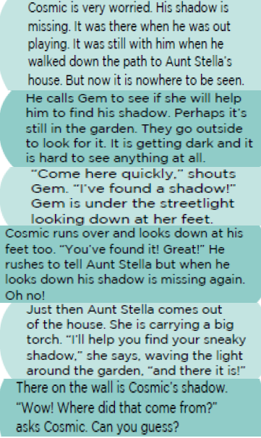  Sneacky Shadow  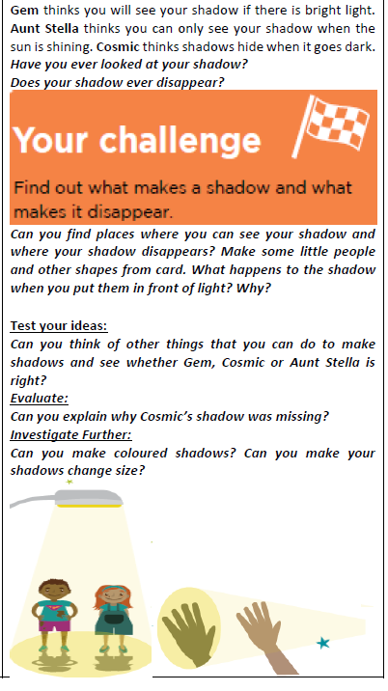
Fun with Maths  https://www.topmarks.co.uk/maths-games/mental-maths-train  (Select Addition up to 100) | Art.  This week our famous artist is Jackson Pollock. Jackson Pollock was an American artist born in 1912. He was inspired by Frida Kahlo’s husband, Diego Riveria, who was a Mexican painter. He was also inspired by Pablo Picasso’s artwork. After the Second World War, in the mid-1940s, Jackson Pollock became known as an abstract expressionist artist when he introduced his famous drip paintings.  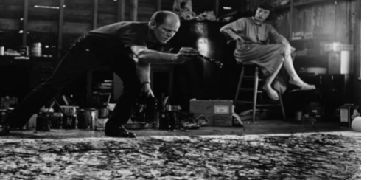  Below are some of his famous drip paintings. What do you think?  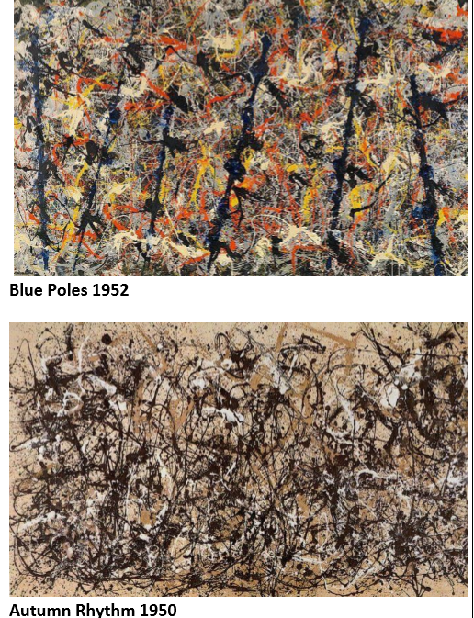  What do you like about Jackson Pollock’s work? Why? Which colours do you prefer to see in a painting? Which colours would you use? Watch this video:  https://www.youtube.com/watch?v=EncR_T0faKM  Create your own painting. Make sure you ask an adult to help you find a safe place where you can splash and flick paints.

The Magic Box
I will put in the box
the swish of a silk sari on a summer night,
fire from the nostrils of a Chinese dragon,
the tip of a tongue touching a tooth.
I will put in the box
a snowman with a rumbling belly
a sip of the bluest water from Lake Lucerene,
a leaping spark from an electric fish.
I will put into the box
three violet wishes spoken in Gujarati,
the last joke of an ancient uncle,
and the first smile of a baby.
I will put into the box
a fifth season and a black sun,
a cowboy on a broomstick
and a witch on a white horse.
My box is fashioned from ice and gold and steel,
with stars on the lid and secrets in the corners.
Its hinges are the toe joints of dinosaurs.
I shall surf in my box
on the great high-rolling breakers of the wild Atlantic,
then wash ashore on a yellow beach
the colour of the sun.
by Kit Wright

