Week 8 Home Activities 1 of 3
Here are some suggested activities you could complete as a family. Have fun and keep well! Please do send us photos of what you have been doing at yearn@highworthcombined.co.uk

Literacy/Communication  Listening to sounds. Play a game of listening to the sounds and saying which sound is the odd one out.  Click on the link below and have a go…  https://www.bbc.co.uk/teach/school-radio/eyfs-listening-skills-sound-games-1/zm72kmn   | Mathematical Development  Recognising numbers to 10 and putting numbers in the correct order.  Have a go at playing the game ‘Bud’s Number Garden’  Click on the link below and have a go…  https://www.bbc.co.uk/bitesize/topics/zjkphbk/articles/zd4b382  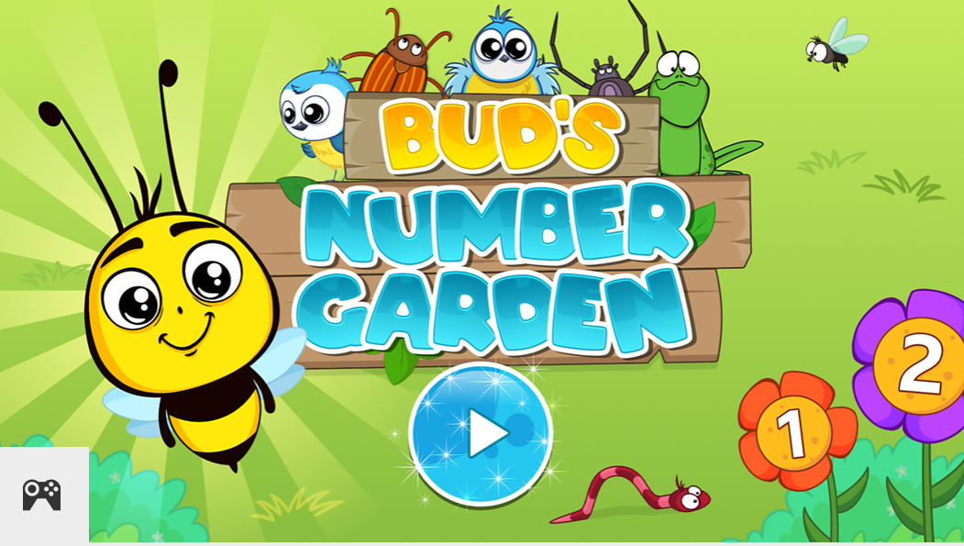 | Knowledge and Understanding of the World  Observing similarities and differences in nature.  Take a walk either in your garden or at the local park. We would like you to collect a selection of natural objects eg. Leaves green and brown, sticks/twigs, moss, acorn cups etc. Talk about what you have found and use words to describe what they look like. You are going to use these objects to make a picture of your face. (See Creative)  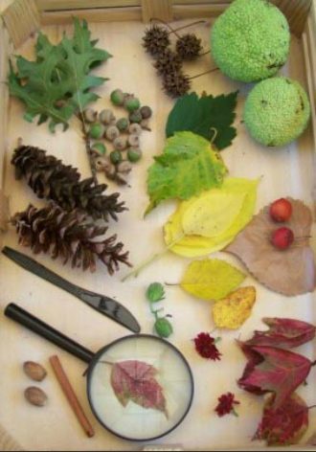
Physical  Keep practicing writing your name…We love seeing the pictures of your writing so do share at yearn@highworthcombined.co.uk.  Go for a walk in the local woods;  Can you...  - Find a tree to climb?  - Run down a hill?  - Make a den using sticks and leaves? | Personal and Social  Make a card for somebody you are missing. Tell your grown up why you miss them and what would you say to them if you could see them.  Don’t forget to write your name in the card.  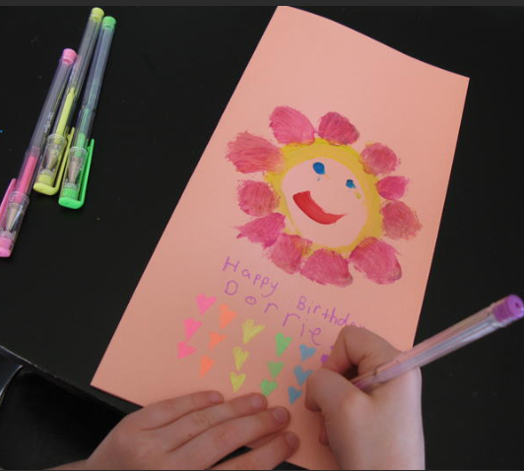 | Creative  Using the natural objects that you found on your walk lay them out in front of you. Select different objects to represent different parts of your face for example, your eyes, your nose and your mouth. Create a picture of yourself. Take a picture of your finished work and send it to yearn@highworthcombined.co.uk  

