Year 5 Home Learning – Friday 3rd July 2020
We’d love to see your work! Please send it to: Year5@highworthcombined.co.uk
ENGLISH: Wizards  Well done! We have nearly reached the end of our topic on Wizards!  We have to write our invent today:  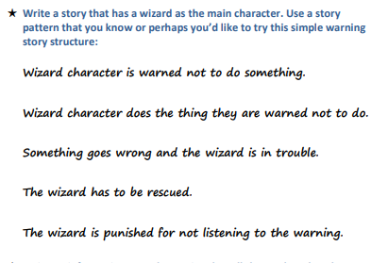 |  | MATHS:  Equivalent Fractions and Rapid Reasoning worksheets.  Look at the Equivalent fractions challenge cards. They start with one star and move on to three stars. (This is a separate attachment that you will have to download with the matrix.)  Try to answer as many questions as you can.  Remember to look at the Fractions Wall to help you with equivalent fractions.  Scroll down for more Rapid Reasoning questions.  The answers are included so, when you have finished, you can mark your work.  If you have any incorrect answers, re-read carefully to make sure you’ve understood the question, check your work and see if you can spot your mistake.
WONDERFUL WORDS
Look at the Year 5 & 6 Words List. You can find it as a link on our Coronavirus Closure, Home Learning Matrix, Year 5 tab: https://www.highworth.bucks.sch.uk/web/year_5/460996
Choose 4 or 5 words to practise at a time.
- Look up the definition in a dictionary to check the meaning of each word.
- Learn the correct spelling by using: Look, Say, Cover, Write, Check.
- Write a sentence which includes the word to show that you understand its meaning.
4. Remember to always edit your sentences to check for correct punctuation and spelling.
History  Medieval Monarchs  We are going to continue with our next History lesson – In what ways was Edward I a ‘great and terrible king!’  https://classroom.thenational.academy/lessons/in-what-ways-was-edward-i-a-great-and-terrible-king  You will need paper, pen and your brain! | Science Potions  We have been writing poems on potions in English so we thought that it would be fun for us to try some investigations on ‘potions’ in Science!  You will need ADULT PERMISSION.  Scroll down for some ideas.  Can you write down/think about:  - What you predicted will happen.  - What happened?  - Why do you think this happened?  We would love to see some pictures! |  | Wellbeing: Positive thoughts  Thinking negative thoughts is common. However, we can sometimes carry on thinking only negative thoughts which can make those negative thoughts and feelings more powerful.  Today we are going to practise how to change some negative thoughts into positive thoughts.  Have a go at the worksheets and try to change some of your negative thoughts into positive ones.  Have a lovely weekend!
SCIENCE
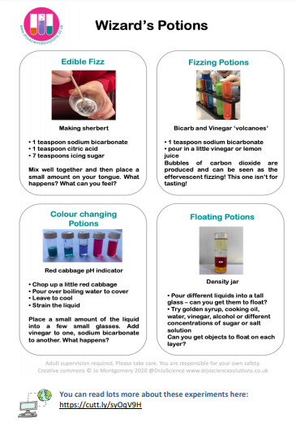

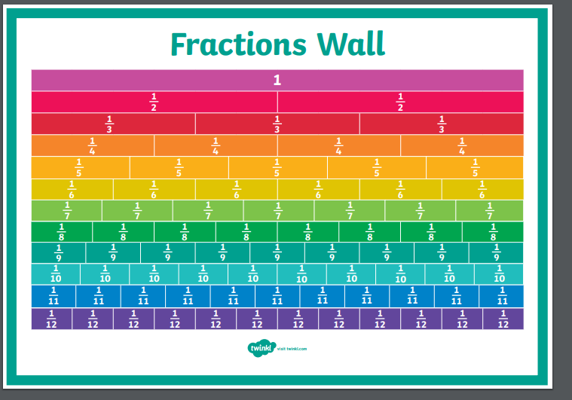
IVALENT FRACTIONS
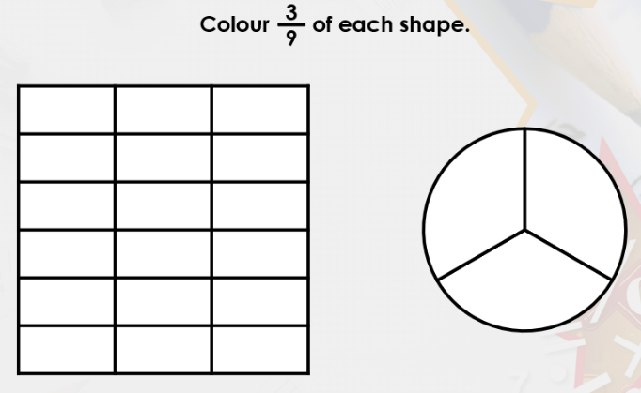
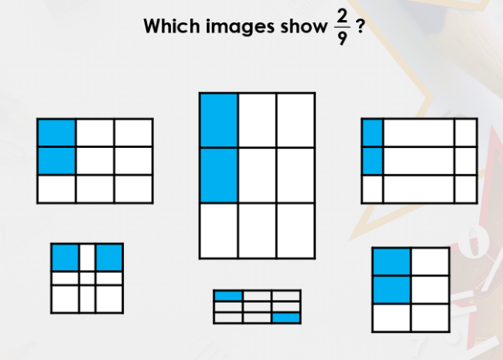
1) 2)

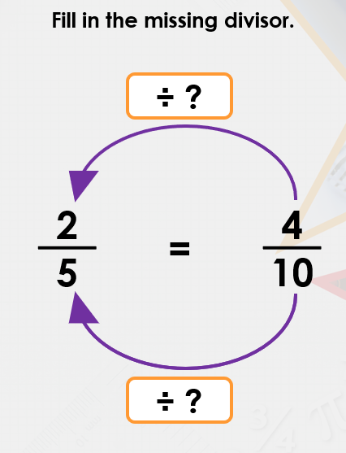
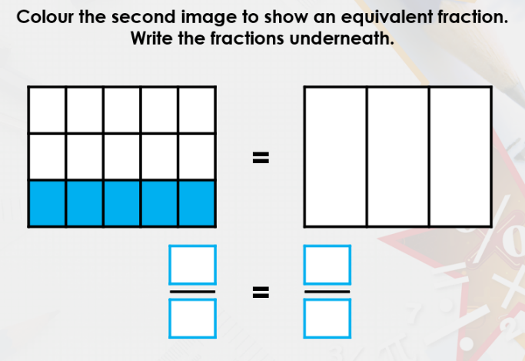
3) 4)

5) 6)

RAPID REASONING
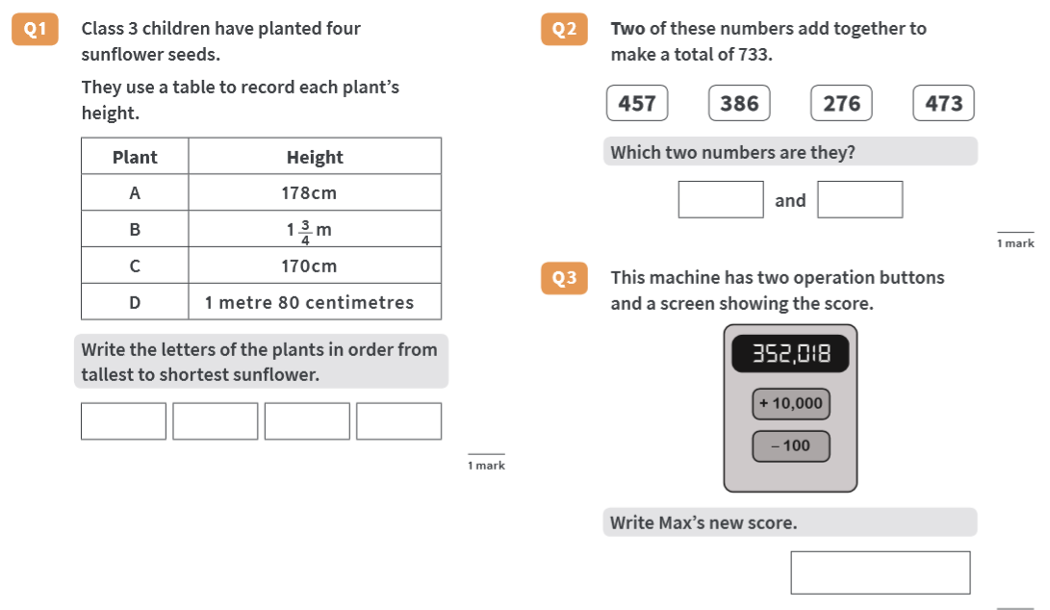

RAPID REASONING: ANSWERS

