Year 1 Home Learning – Friday 27th March

Below, you will find 6 home learning tasks. You may choose the tasks that you wish to complete and do them in any order. Please do not hesitate to contact us if you have any queries.

English  We sing the days of the week song to the tune of The Addams Family in class. https://www.youtube.com/watch?v=HtQcnZ2JWsY  Days of the week, (clap clap)  Days of the week, (clap clap)  Days of the week, days of the week, days of the week. (clap clap)  There's Monday and there's Tuesday, there's Wednesday and there's Thursday, there's Friday and there's Saturday, and then there's Sunday.  Days of the week, (seven days!)  Days of the week, (seven days!)  Days of the week, days of the week, days of the week. (seven days!)  Write your own days of the week song to a familiar tune. Practice writing the days of the week several times to ensure you have spelt them right. | Maths  Find three small bags or containers that are the same (pillowcases would be ideal).  Place an unbreakable object in each bag e.g., a wooden block, a cotton –wool ball, a toy car.  Lift each bag and decide which bag is the heaviest and which is the lightest. How can you tell?  Label your bags as ‘heavy’, ‘heavier’ and ‘heaviest’ and order your bags according to their weight.  Can you use scales if you have them?
Science

The weblink should help you, but please remember internet safety and always only use the internet with an adult.

Watch this video clip with an adult showing a time lapse video of seasonal changes in the countryside.
https://www.bbc.co.uk/bitesize/clips/zhfnvcw

Talk with an adult or older sibling about how the seasons changed and the affects it had on the plants.

Fold a piece of paper into 4 equal parts and label it with the 4 seasons, spring, summer, autumn, winter.

- Can you draw what the plants and trees look like at these different seasons?
- Can you add a person into each of your pictures?
- What would they be wearing in each season?

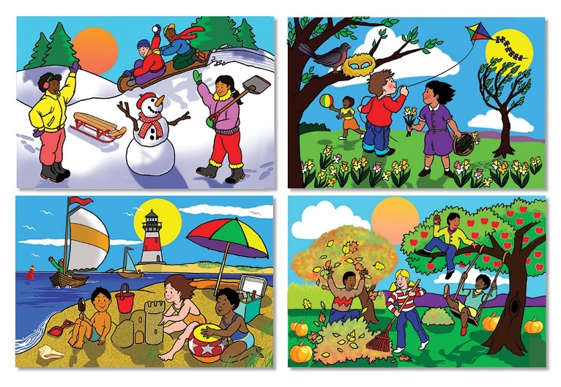

History  Today we are going to be finding out about two famous musical composers who made music from a young age.  Ask an adult to help you listen to some music by Andrew Lloyd Webber and Wolfgang Amadeus Mozart and find out a little bit about their lives.  Talk with an adult or older sibling about how the music is different, what would have been different about the way they made the music and the way they performed their music.  - Can you make your own music?  - How will you record your music?  - Can you make your own instruments? (shakers, pots and pan drums etc.)  https://makingmusicfun.net/htm/f_mmf_music_library/hey-kids-meet-wolfgang-amadeus-mozart.php  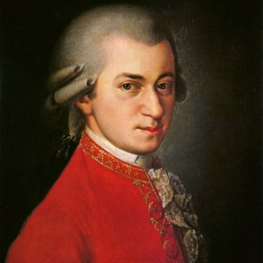 | Geography  Draw a map for a made-up seaside town.  Include a factory in your town. What will it make?  Include a farm on your map. What will be on your farm? Will it be plants or animals or both?  Include a port or harbour. Don’t forget to include some water on your map!  Include a shop in your town. What will it sell?  Can you make a key for your map?  As a challenge use your toys and objects around the house to make the map into a 3D town.  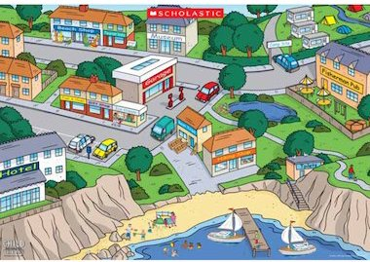
Design Technology

With an adult's support find some pictures of kites.

What materials do you have at home that would be good to make a kite from? E.g. Tin foil, wrapping paper, straws, sticks, tape, string, ribbon.

Now, design a kite that you would like to make. Don’t forget to label your design with your materials that you will use, and the key design features.

Try and follow your design to make your kite! Send us a picture if you can!

Now evaluate your kite. What was good about it? How could you improve it?

https://www.twinkl.co.uk/resource/t2-d-095-lets-go-fly-a-kite-activity-sheet-making-a-delta-kite

