Welcome to Year 3FM Transition Day Activities
Dear children,
I am looking forward to getting to know you all and below are some activities which will help me to do this. I hope you enjoy completing them. When you are finished please ask an adult to send an email to me at this address. year3@highworthcombined.co.uk Thank you!
Have a lovely summer and I cannot wait to meet you all in real life in September.
Take care
Miss McCallum
All About me  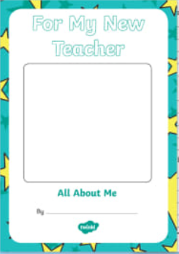 | Complete the All About Me booklet or make your own using a sheet of paper folded in half. On the front draw a self-portrait – a picture of yourself. On the inside write a few sentences under each heading.  - About me and my family (and pets)  - At school I like  - At home I like  - Over the summer holidays (describe a special day)  - Next year I am looking forward to…  - A special message for my teacher  Tell me anything extra that you would like to share or use this space to ask me questions.  - Finally, on the back draw a special picture.
Stories-Book Review  Tell me about your favourite story or about the last book that you read.  It can be a story you read in school or  at home. | In your Book Review write  The title (name) of the book  The name of the author  Tell me about the main character or characters? Write  the name(s), what they look like and anything else you think is important.  Tell me why you enjoyed the story.  Did you like the end of the story? Why?  How many marks would you give it out of 10?
What makes you happy?  List 6 things that make you feel happy.  Draw 6 pictures to show the different ways you feel happy. | Being happy means different things to different people. You might think of a favourite toy, game or treat but there are other things too. A happy feeling can include being with special people in your family or with friends. You might feel happy when you have learned something new. Helping someone can also make us happy.  I look forward to finding out what makes you happy.
Here are 6 different things that make me feel happy.
Name: ________________

