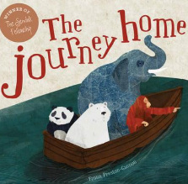
Year 2 Home Learning
Week Commencing 11.05. 2020 - Wednesday
Please remember to email your teachers about what you have been doing. We love receiving your emails. Send them to:
Year2@highworthcombined.co.uk

English task The Journey home  Listen to the story on our school website in ‘Story Time with Highworth staff’ section.  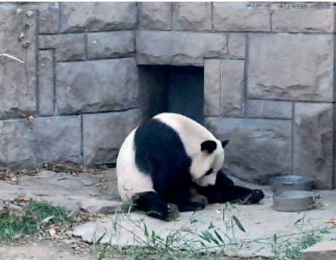  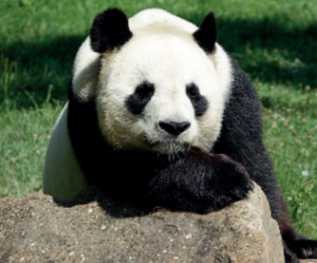  Now, let’s meet our second member of the crew – the Panda.  What words would you use to describe the mood of the Panda in those pictures? Write 2 sentences using the conjunction ‘because’ to describe how the Panda is feeling.  Challenge! - You are not allowed to use the adjective ‘sad’.  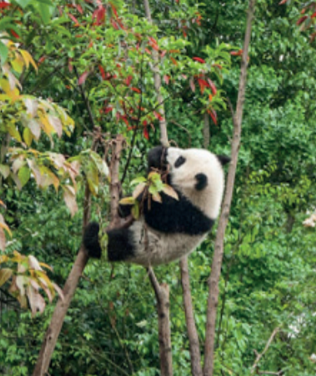  Now look at this picture of a panda in the wild.  This panda looks happy there but sadly lots of forests are being destroyed and other panda habitats have been eaten by big cities. It is not safe out there for some pandas anymore and there is nowhere else for them to go.  Let’s write a letter to the zookeeper and ask him to make Panda’s life better in the zoo. What can he do? Explain to the zoo keeper how Panda is feeling and why. Tell him what she might be missing and which things can make her happy.  Here is how you may wish to start your letter:  ‘Dear zoo keeper,  I have a recently visited your zoo and I have noticed……’  Please remember to thank the zookeeper for all his hard work and for taking the time to read through your letter. Don’t forget to say who the letter is from.  If you would like to learn more about Pandas have a look at this:  https://www.nationalgeographic.com/animals/mammals/g/giant-panda/ | Maths task  This week we will look at measuring, ordering and comparing lengths and heights.  Choose 5 different objects in your house and measure how tall they are. You can choose to measure your wardrobe, a picture frame, a fridge, the height of your table etc.  Can you order them from shortest to tallest?  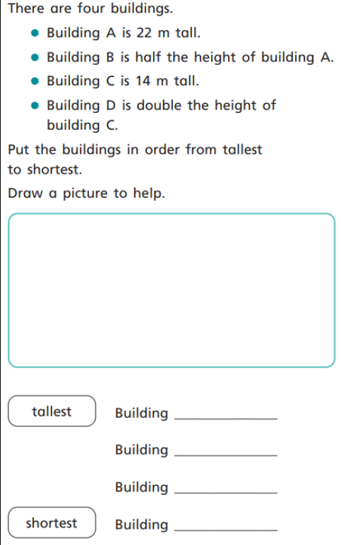
SPaG: Apostrophes  Let’s do some revision on apostrophes for contractions.  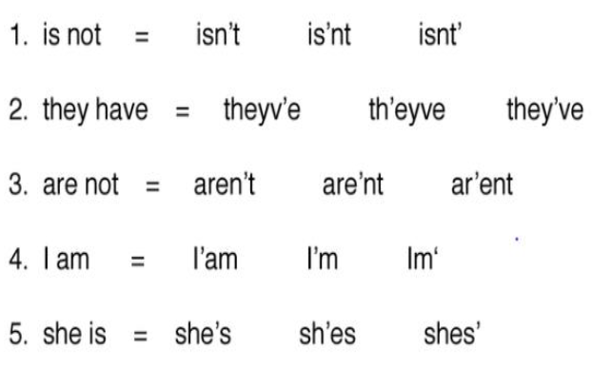  Underline the word that shows the proper placement of the apostrophe.  Now complete the contractions below:  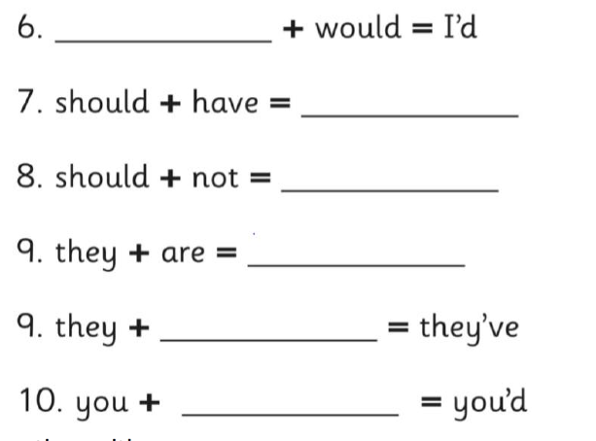  Choose any 3 contractions from examples 6- 10.  Use them in your own sentences. | Science Reflection  In our book ‘The journey home’, the Polar Bear and the Panda going in the boat in search of their homes. They have to travel in the night time too. What do colours do you think they need to wear to help them see each other in the dark? Something bright? Something shiny? Something white? Make a list of materials that you think will reflect light and will help them to be seen better in the dark. Now write a prediction of which material you think will best and why.  Now put your prediction aside for now and read through this information.  Some things produce light, for example, a lamp, the Sun. We call these light sources. Other things can reflect light, but they do not produce light of their own, for example, a mirror, aluminium foil, a white T-shirt. We call these reflectors. Some colours reflect more light than others. White is easier to see than red; red is easier to see than black. Reflectors will be seen if there is a source of light. Even on a dark night, there is usually light around especially in towns. A good reflector may be visible on a dark night because of this. Cat’s eyes and reflective strips will also reflect the lights of cars.  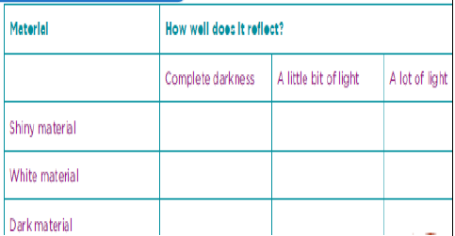  Can you now test your ideas and record the results in a table similar to the one below?  For complete darkness, you may draw the curtains or go to a dimly lit area – make sure an adult is with you.  How did your investigation go? Which materials can you see the best? What difference does it make to have more light? What can you see in complete darkness? Do some colours work better than others? Was there anything you could have improved about your test?
Geography China  This week you have already done research about China.  Let’s go on the journey together and find out more about this country.  Watch the following video.  https://www.bbc.co.uk/bitesize/articles/zfcbrj6 | Maths revision  Watch this lesson about adding and subtracting two digit numbers. Complete the activities.  https://www.bbc.co.uk/bitesize/articles/zbypscw  You have done a lot of practice. Well done!  Now you can have a go at this game.  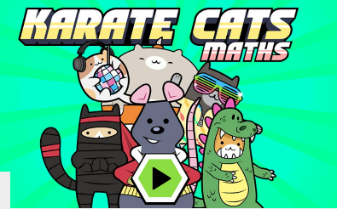  https://www.bbc.co.uk/bitesize/topics/zjkphbk/articles/zf4sscw

