Year 4 Home Learning – Monday 1st June 2020
Please email us your work to:
Year4@highworthcombined.co.uk
Remarkable Writing and Splendid SPaG (working together for Wonderful Work!)
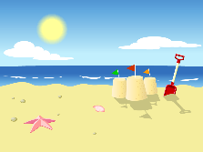
When we think of summer, one thing we often think of is the beach, so today’s writing
activity is a setting description of a beach.
We have given you model texts for two very contrasting pictures of a beach.
These are attached below.
You should begin by reading these descriptions and then try the questions at the bottom of the sheet (this is the SPaG part to help you think about how to improve your sentences).
Hopefully this activity has got your mind whizzing with great ideas for your own description!

Now it’s your turn!
If you need help to get going, there is a second sheet below that has some simple sentences to describe a beach. We are sure you will agree this is not a very exciting description, so you could use these as a starting point by improving these sentences. Otherwise, you could challenge yourself to write your own description of either beach picture. There is also a word mat below to help you with ideas.

Whichever you choose, think about:
How to start your writing – you want to draw your reader in and make them want to read more.
Using your senses – think about what you can see, hear, smell, touch or taste.
Vocabulary choices – adjectives, verbs, adverbs, similes, metaphors, alliteration, onomatopoeia.
Openers – how can you vary these to keep your writing interesting?
PLEASE REMEMBER TO EDIT!

Challenge: You could either write the other setting description or you could compare the two settings in the original activity. Which do you prefer? Can you explain your reasons?

Wonderful Wellbeing!  Today’s winning way to wellbeing is……  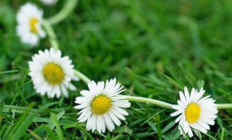  With summer upon us, so are the daisies. Make a daisy chain and then teach someone else to make one.  You could make one for each other. | Terrific Topic!  Keeping with our summer theme, we  would like you to design a super summer  t-shirt! There is an outline below to help  you. You could add other items of summer clothing to your design too. Think carefully about your design, being as creative as you can.  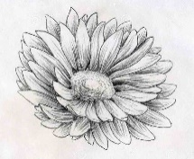  Another art themed suggestion linked  to the Science and Wellbeing on here is  to sketch a daisy. Go outside and look  very carefully at a single daisy. Use just  a pencil to sketch all the details you can see,
Welcome back to the rest of the summer term! Today is meteorologically the first day of summer so we are going to have a summer themed couple of days!
Marvellous Maths!  Times Tables and division practice for quick recall. You can use this link: https://www.topmarks.co.uk/maths-games/daily10 Don’t forget you can use Daily 10 to practice other mental maths skills too! Let us know about any you have tried and how you got on.  Remember that you can practice these skills without the internet, using the ideas in previous matrices.  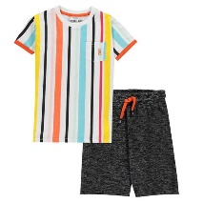  Summer Outfits  You are off to the beach for a summer break and you are trying to pack sensibly and take as few items as you can.  To do this you check to see how many different combinations of t-shirt and shorts you can put together before having to repeat an outfit.  There is a sheet attached at the end to draw your different combinations on , if you wish to.  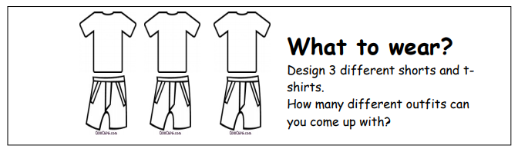  Write down how you could change this investigation.  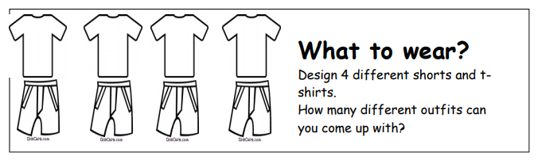  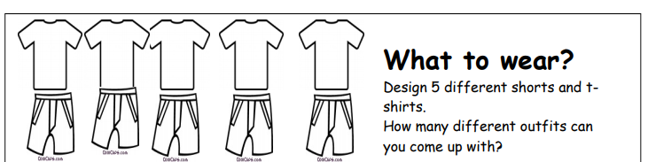  What have you noticed with your results?  CHALLENGE: How many different outfits do you think you would get with 6 different designs? | Super Science!  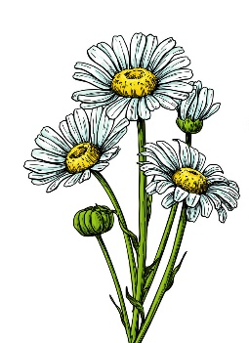  Look at a daisy plant. Draw and label a scientific diagram to show the parts of the plant. (remember the part below the ground)  In class, we learnt about scientific diagrams and how to correctly present them. Try to include the elements we learnt.  Write down the function of each part of the part.  Can you think of other scientific vocabulary linked to plants? You could list the words in alphabetical order and write a definition for each, or you could create a crossword puzzle.  Do you think there would be any effect on an ecosystem if all the daisy plants in that ecosystem were destroyed? Explain your answer.  Challenge: Have you ever noticed how the daisy flowers tend to close up at night. Research to find out why.

The air smelt salty and fresh. Grains of golden sand slipped between fingers and toes, whilst the calm, lapping waves whispered in the gentle breeze. Soft fluffy clouds twinkled in the sunlight as a yellow wooden boat bobbed serenely on the silky sea. Pink, sticky ice-cream dripped on clean white towels and parasols framed the coastline.
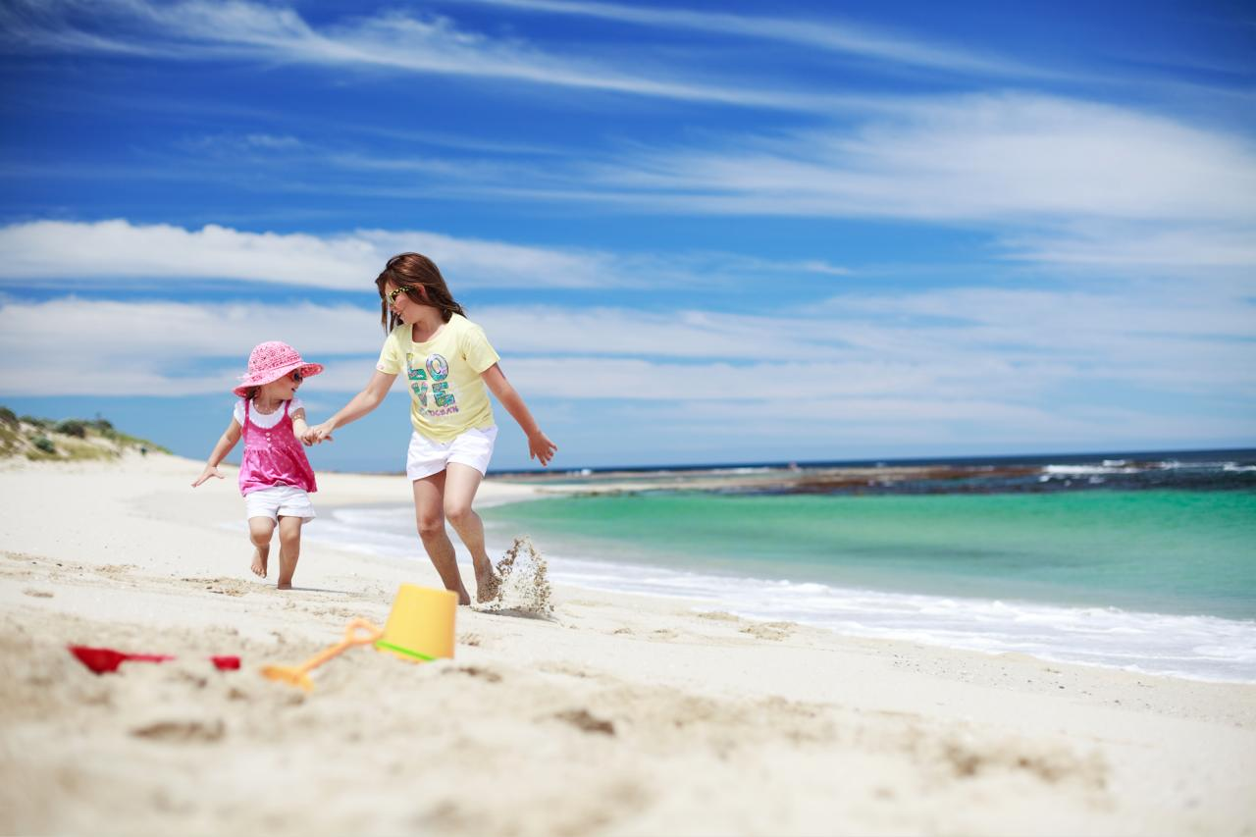

Raucous buzzing screeched in all ears, as currents of electric ripped through the darkest blue skies. Pounding waves leaped and darted between and over bashed rocks. Cries of pain erupted from the nests of seagulls and violent shouts of fury from the mouth of the ocean. Whilst beaches parted in fear and threatening waves rose from the depths, boats were thrown and tossed in the night sky, with no hope of rescue.

- Highlight all the powerful verbs in each paragraph. Which is the most effective and why?
- Highlight all the interesting adjectives in each paragraph. Which is your favourite? Can you think of synonyms for the word?
- Underline the conjunctions used in the two paragraphs.
- Which paragraph do you think is the most effective and why?
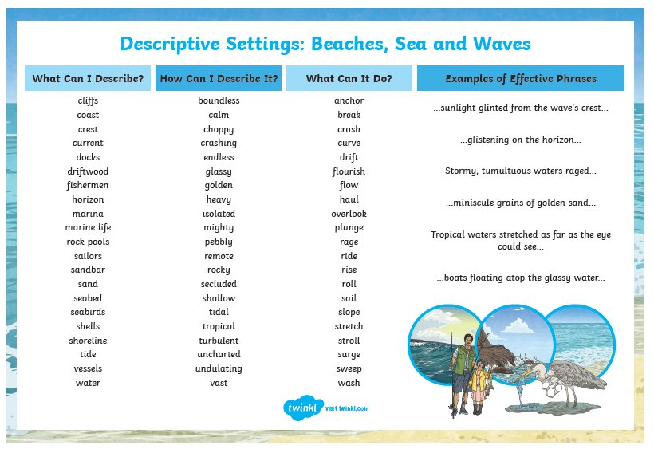
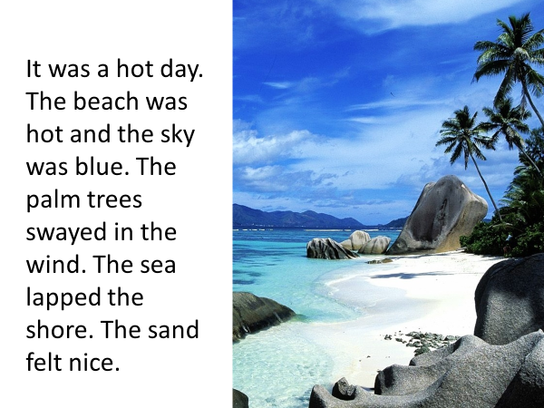
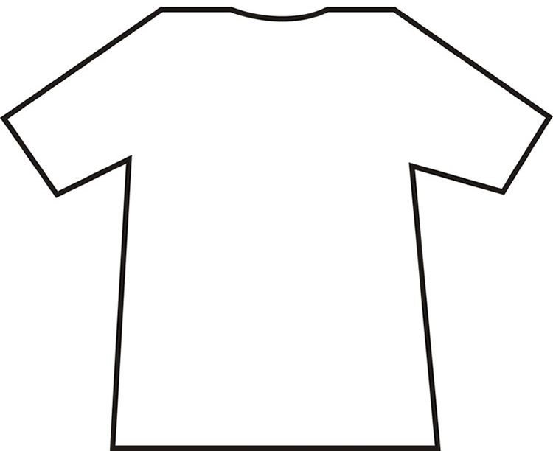

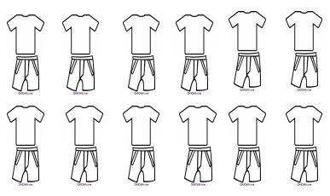
Outfit Combinations

