Year 2 Home Learning
Week Commencing 20 April 2020- Friday

Maths Task  Dice Game  Use the dice we made earlier in the week (or one you already have).  - Roll a dice 2 times and write down each number.  - Use the number to make an array with each number either representing rows or columns.  - How many different equations can you make with those numbers?  - Solve the equations.  Example-  - Roll- 2, 4  - * * * *  * * * *  - 2 x 4= __  4x2 = __  8 ÷ 4 = __ ….  - 2 x4 = 8  4 x 2= 8  8 ÷ 4= 2 …  Were there any other problems I could have done?  I’ll give you a hint. There are 6 different equations! | English Task  Reporter  Tell me about your family. Who is in your family? What do you call them? What do they like? This time I want you to find out more about your family and tell me about them.  Create a poster with a picture of everyone in your family and write about each person.
SPaG/ Spelling  Alliteration Hunt-  Have a look around your house and see how many different things you can find that start with the letters of your name. Then use those to come up with examples of alliteration (a string of words that start with the same sound). Finally, can you put each one in a sentence?  Example  S- snake, socks…  Smelly stinky socks  I found a smelly stinky sock under my son’s bed. | Wellbeing  Look at the picture of the blob tree. There are lots of ‘blobs’. Pick a few different blobs- How are they feeling? Who do you think is the happiest person? The saddest? Who do you think feels the same way you do right now? Who would you like to feel like?  -We all have different feelings at different times. Make sure you always talk to the people around you and let them know how you are feeling.  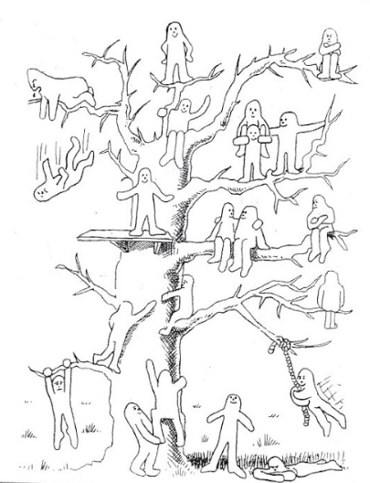
RE- Ramadan  Ramadan has started for many Muslims around the world. Look at the following link to learn more about Ramadan and what Muslims do during this time.  https://www.bbc.co.uk/newsround/23286976  Normally people make a special effort to reach out to people around them. Take some time to think about the people around you and make a card for someone you aren’t able to spend time with. Think of a way to show them that you care even if you can’t be with them. | App/ game  App Recommendation  On most phones or tablets you can search for tons of different maths games. I recommend …  DK 10 minutes a Day.  It is a great game to practice those times tables. Start with 2, 5, and 10.  Happy playing!  