Remarkable Writing!  Imagine your recycling monster comes alive!  If you haven’t had a chance to make a monster, now’s the time for you to design one and create an illustration of it!  So … your recycling monster is with you for the day. What things would you do with them? What would they teach you? You could write this in story form or even as a diary.  Think about:  Beginning by noting down your ideas – you can make them as imaginative as you like!  Think about the vocabulary you will use: adjectives, adverbs, similes, alliteration, onomatopoeia.  How will you make this exciting for your reader?  Will you include speech?  You also need to remember all the grammar parts of a tool kit:  Capital letters and punctuation.  Spelling.  Does is make sense when you read it.  Paragraphs.  Spelling.  EDITING! | Sensible SPaG!  We would, like you to use BBC Bitesize to practice using apostrophes. Go to BBC Bitesize, choose year 4 and then scroll down to 29 April using apostrophes for possession.  This is the link: https://www.bbc.co.uk/bitesize/articles/zmt2mfr  You can then complete the daily lesson, which includes video clips and activities. There are links to other activities too.  If you wish to, you could also use the lesson from 28 April to revise using apostrophes to combine words.  Challenges:  - Make a poster to remind you how to use apostrophes for possession.  - Investigate how to use apostrophes for plural nouns.  - Teach someone in your household how to use apostrophes.
Wonderful Wellbeing!  Please continue to complete the Ramadan acts of kindness calendar you started  This week’s winning way to wellbeing is:  Keep learning  (eg. try something new, set yourself goals, read a book)  Note down 3 things you are grateful for.  Watch Happy News  https://www.bbc.co.uk/newsround/news/watch_newsround  Can you some happy news with us? | Terrific Topic!  We are going to keep up our art theme, but today we are making a link to History and the Vikings.  You can design a Viking shield, design a Viking sword handle or try some Viking loop patterns.  There are pdf files on the website under the learning matrices, for all three ideas to get you started.  Attached below you will find a digestion quiz by Layla and a wordsearch created by Daniel that you may like to try!
Year 4 Home Learning – Monday 4th May 2020
Marvellous Maths!  Times Tables and division practice for quick recall. You can use this link: https://www.topmarks.co.uk/maths-games/daily10  Don’t forget you can use Daily 10 to practice other mental maths skills too! Let us know about any you have tried and how you got on. You could also try some different mental maths activities online such as Hit the Button or Mental Maths Train (both are free via Topmarks website).  Without Internet: You could write them out, chant them walking around or up and down the stairs (exercise too!), ask someone to quiz you or create your own beat the clock grid (copy below to remind you). Can you create a rap / song / poem to help you practice any times tables you find more tricky?  Today’s maths involves problem solving of a different kind because there are no calculations involved!  Once you have read the question you will need to think about how you will record your investigation and how you can check you have all the combinations!  Whilst at the beach, you decide to buy a delicious ice cream. There are 6 different flavours available:  Vanilla  Chocolate  Strawberry  Mint choc chip  Toffee  Honeycomb  There is a sign that says “6 flavours, 2 scoops”.  Can you work out how many different combinations there are?  Challenge: if you have solved the original problem, can you work out how many combinations of 3 scoops there are? | Super Science!  Super Hoop glider  You will need  A plastic drinking straw  Card  Tape scissors  What to do  - Cut 3 strips of card 2.5cm by 13cm  - Take 2 of the pieces of paper and tape them into a hoop. Be sure to overlap the ends by 1cm.  - Use the last strip to make a smaller hoop, overlapping the edges like before.  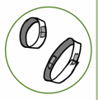  - Tape the paper loops to the ends of the straw. Ensure the straw is on the inside of the hoops.  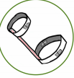  - That’s it. Hold the straw in the middle and throw the hoop glider, angled slightly up. With practice this could fly further than standard paper planes.  Make it an experiment  Try the demonstration above. To make it a true experiment, try to answer the following questions.  - Does the placement of the hoops on the straw affect the flight distance?  - Does the length of the straw affect the flight?  - Do the hoops have to be lined up for the glider to fly well.  CHALLENGE: Can you think of other questions to investigate?
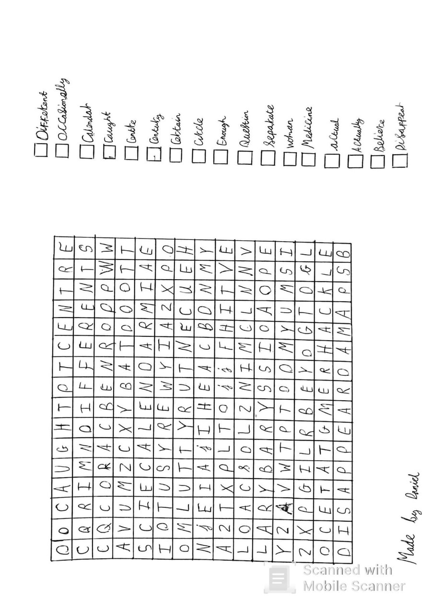
The Digestive System Quiz!
By Layla, 4NS.
- What is the Digestive System? What do you think?
____________________________________________________________________________________________
- What is bile and where is it produced?
____________________________________________________________________________________________
- Name 6 parts of the Digestive System!
1-____________ 2-____________
3-____________ 4-____________
5-____________ 6-____________
- What are the steps from stages 1-3?
______________________________________________________________________________________________________________________________________________________________________________________________________________________________________
- What is the function of the salivary glands?
______________________________________________
- In which part of the Digestive System can you find acid?
__________________________
- What happens in your stomach?
______________________________________________________________________________________________________________________________________
- Why do you think we need a mouth? Explain your reasoning!
_________________________________________________________________________________________________________________________________________________________________________________________________________

