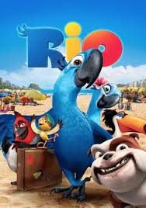
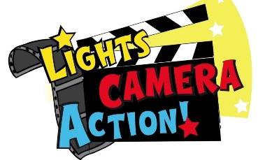
Year 4 Home Learning Friday 19th June 2020
Welcome to the second Year 4 film day!

The film we have chosen to plan activities around this time is Rio. We chose this because it has links to Brazil and the rainforest which have been themes of recent Year 4 matrices. It is available to view on Amazon Prime or you can buy or rent it from You Tube movies. It would be great if you could connect with your family and enjoy watching the film with someone in your household.
You could choose a different U rated film to inspire you to create activities using the ideas below to help you. For example, Finding Nemo or The Little Mermaid for an under the sea theme.
We have planned some activities using the Rainforest theme of Rio (or Rio 2). Please feel free to invent your own activities too if you would like to. These could include finding Rio on a map or creating a fact file about the Rio, the rainforest or an animal living in the rainforest. Can you learn how to say hello to someone living in Brazil? What sort of music or dance are native to Brazil? The list of possible activities is long!
We hope you will enjoy these ideas and look forward to hearing from you and seeing what you have been doing!
Mrs Sparkes and Mrs Stewart
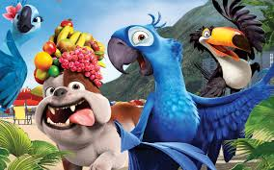
Year 4 Home Learning – Friday 19th June 2020

Please email us your work to:
Year4@highworthcombined.co.uk

REMARKABLE WRITING!

When you have watched Rio, Rio 2 or a U rated film of your choice, we would like you to write a film review. This is rather like a book review, with the purpose of providing the reader with a taster to help them decide whether to watch the film or not. It should not tell the whole story, because otherwise the reader might not see the point of watching the film!

Think about:
- How will you make this exciting for your reader?
- What is there in the film that would help someone decide whether it is a film for them? (eg type of story, music etc)

You also need to remember all the grammar parts of a tool kit:
- Capital letters and punctuation.
- Spelling.
- Does is make sense when you read it?
- EDITING!

There is a checklist attached below to help you and a film review writing frame, if you would like to use it, is on the website as a separate document. Please do think about adding some colour to make it more eye catching!

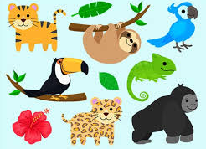
RESILIENT READERS!

There is a short reading comprehension with a rainforest theme attached below. They may be short questions but please think carefully about your answers and please remember to write in full sentences!

Extra challenge: Can you write some comprehension questions about the film you have watched? You will need to provide a separate answer sheet and we may be able to share them for others to try!

MARVELLOUS MATHS!

You will find a recap maths activity attached below that gives you
a whole variety of maths to think about!

Challenge: Can you create a similar maths activity sheet with different areas of Year 4 maths? How can you include some challenges? Please remember to include a separate answer sheet!

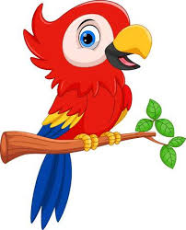
SUPER SCIENCE AND TERRIFIC TOPIC!

We would like you research macaws (one species of parrot) using these links…

General parrot facts: https://www.youtube.com/watch?v=Zf6wVsaUMQ8

Different macaws: https://www.youtube.com/watch?v=OW7J_3z1MOI

Now, can you have a go at drawing a macaw using one of these step by step videos…
https://www.youtube.com/watch?v=CiI2sWm-AlU
https://www.youtube.com/watch?v=PmLnz-qWUvs
WONDERFUL WELLBEING!

Close your eyes and have a listen to the opening music from the film Rio. As you are listening, think about:
- How does it make you feel?
- What is it about the music that makes you feel that way?

Play the track again, and this time watch the animation at the same time! Think again about:
- How does it make you feel?
- What is it about the music that makes you feel that way?

Play the track a third time and either get up and dance / move to the music OR take a plain piece of paper and a pencil and let the pencil move to the music! What pattern will you create? Afterwards, can you add some colour that represents how the music made you feel?

https://www.youtube.com/watch?v=gpS2sKBLODk

