Year 5 Home Learning – Monday 8th June 2020
We’d love to see your work! Please send it to: Year5@highworthcombined.co.uk
ENGLISH  Today is WORLD OCEAN DAY  We have attached some information about it and there are some questions for you to answer to help you learn.  There are three different levels for you to choose from but do try to give yourself a challenge.  The answers for each level are included so, when you have finished, you can mark your work to see how you did. |  | MATHS  LONG MULTIPLICATION  Scroll down for questions to practise multiplying 2-digits by 2-digits.  Remember to align the digits according to their place value and use a 0 place holder when multiplying by the tens digit.  The answers are included so, when you have finished, you can mark your work.  If you have any incorrect answers, look back over your work, check your calculation and see if you can spot your mistake.
WONDERFUL WORDS
Look at the Year 5 & 6 Words List. You can find it as a link on our Coronavirus Closure, Home Learning Matrix, Year 5 tab: https://www.highworth.bucks.sch.uk/web/year_5/460996
Choose 4 or 5 words to practise at a time.
- Look up the definition in a dictionary to check the meaning of each word.
- Learn the correct spelling by using: Look, Say, Cover, Write, Check.
- Write a sentence which includes the word to show that you understand its meaning.
4. Challenge yourself to include a RELATIVE CLAUSE in each of your sentences. Scroll down to the
REVISION CARD for a reminder about them.
SCIENCE  ROCKET LAUNCH  Did you catch the recent SpaceX launch? On May 30th, American astronauts Bob Behnken and Doug Hurley travelled to the International Space Station on the Crew Dragon spacecraft. But how was the Crew Dragon actually able to reach space?  Watch this video to find out  https://www.youtube.com/watch?v=E9J7F9crFMo&feature=youtu.be&utm_source=newsletter&utm_medium=referral&utm_content=tsr-summer-school-04-june&utm_campaign=tsr-summer-school  Scroll down for some questions to think about whilst you watch the video a second time.  There’s also another fascinating video about how astronauts exercise in space! | Today is  WORLD OCEAN DAY.  You can watch this fun video to find out what it’s all about  https://worldoceanday.school/film/  and there are lots of live videos and activities here  https://worldoceanday.school/  Here’s a question for you:  Is a dolphin a fish or a mammal?  We’ve attached a fact-pack about dolphins and also an origami activity for you to try.  Choose 5 facts that you find the most interesting and produce your own dolphin fact-pack, or maybe a poster. |  | GEOGRAPHY  CONTINENTS, OCEANS and SEAS  We’ve attached an activity sheet, Our Oceans, for you to label the continents, oceans and seas. Can you say which continent has not been included?  We have also attached a Map of the World to help you and the activity sheet answers are included so you can see how you did.  You could try shading in each continent in a different colour (scroll down to see an example).
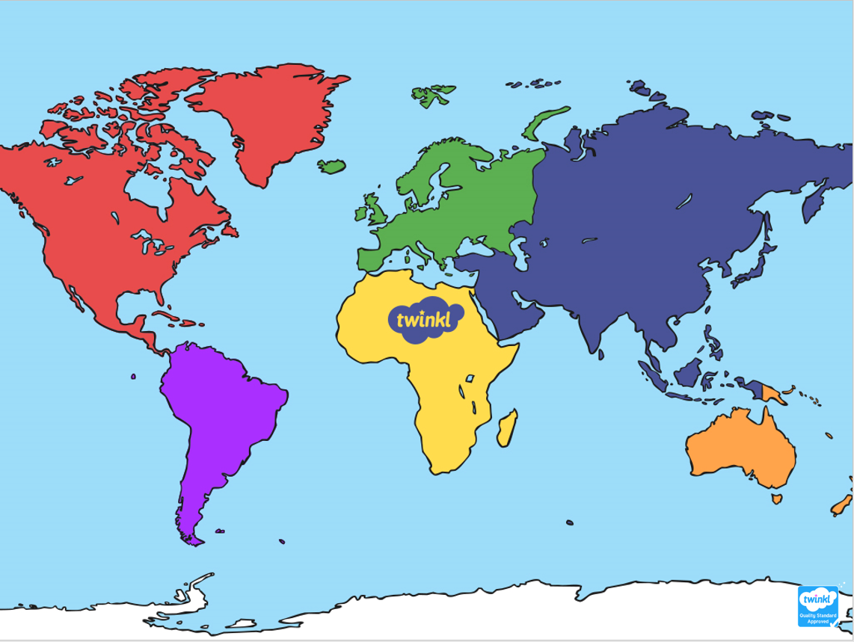
LONG MULTIPLICATION
Remember that ‘multiplicand’ is a quantity which is to be multiplied by another.
e.g. 54 is the multiplicand in the calculation 54 x 32 = 1728
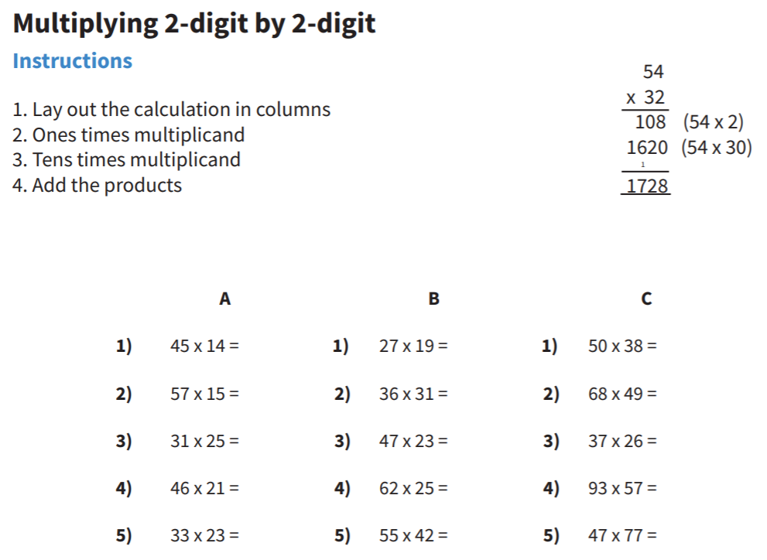

LONG MULTIPLICATION ANSWERS
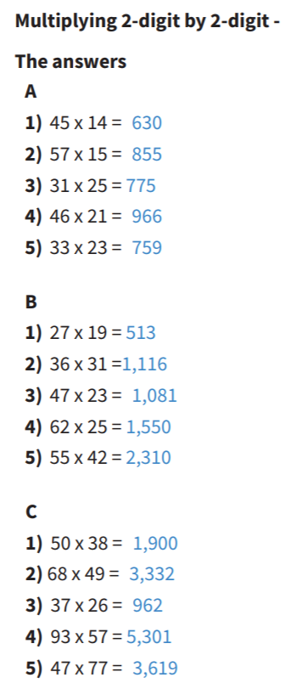
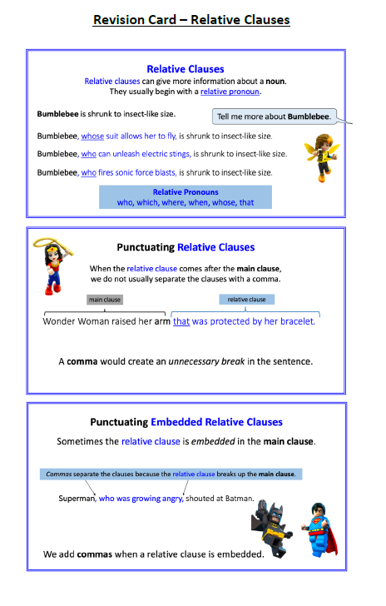
ROCKET LAUNCH
https://www.youtube.com/watch?v=E9J7F9crFMo&feature=youtu.be&utm_source=newsletter&utm_medium=referral&utm_content=tsr-summer-school-04-june&utm_campaign=tsr-summer-school
1) What is Newton’s third law, and why is it important?
2) How can we use Newton’s third law to explain how rockets are launched into space?
3) How do you think your daily life is affected by the fact that every force has an equal and opposite force? For example, what happens when you push yourself forward on a skateboard?

HOW DO ASTRONAUTS EXERCISE IN SPACE?
Just a few weeks ago, NASA astronauts Bob Behnken and Doug Hurley travelled to the International Space Station (ISS) on the SpaceX Crew Dragon spacecraft. Behnken and Hurley didn't stay on the ISS, but if they had, there would be no time for them to relax. Watch this video to find out how astronauts exercise in space—and why it's important they do so.
https://www.youtube.com/watch?v=wxbBa57vtv8&feature=youtu.be&utm_source=newsletter&utm_medium=referral&utm_content=tsr-summer-school-04-june-bonus&utm_campaign=tsr-summer-school
QUESTIONS TO THINK ABOUT WHILE YOU WATCH:
1) Why is it important that astronauts exercise while they're in space? What might happen to them if they didn't?
2) What are the difficulties of exercising in space? How do they solve these issues on the ISS?
3) What fun things would you try if you were in a spacecraft with no gravity?
THE 7 CONTINENTS OF THE WORLD

