Year 6 Home Learning Week commencing 8.6.20
Please email your work into us using the Year 6 email address – year6@highworthcombined.co.uk
We love hearing from you and seeing everything you’ve been up to! Take care Year 6.
Writing  This week we would like you to write a description of your future robot servant.  Have a think about what you would want your robot to do for you. Make your bed? Do your homework? Make your dinner? Or something more exciting?  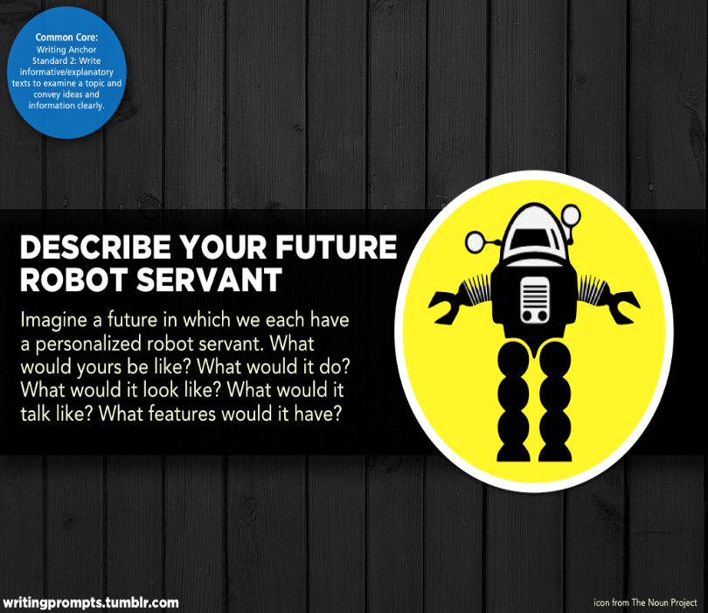  Try to answer all of the questions below in your writing.  Here are some examples to help you.  What will your robot look like?  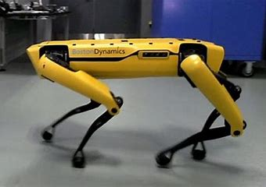  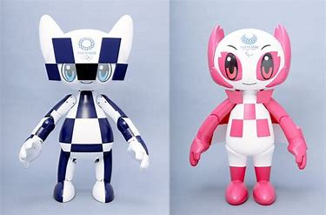  We would love to see a drawing of your robot, with labels to explain its features.  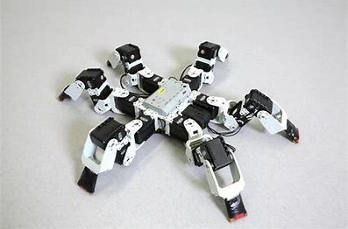 | Maths  This week we have some games that you can play using a pack of cards. You will need to deal out all the cards to the players. Some of the simpler versions of the game require you to add your 2 or 3 cards together whilst other versions involve negative numbers or fractions. You can decide which version you would like to play but maybe have a go at something that is a challenge!  Card Addition Players turn up 2 cards each and add together. The player with the highest total wins and takes the cards. Card Addition + Increase the number of cards you turn to 3 or 4. Subtraction Game Players turn up 2 cards and subtract the smaller number from the larger number. Card Multiplication Players turn up 2 cards each and multiply. The player with the highest total wins and takes the cards. Card Multiplication + Turn up three cards. Make two of them into a 2-digit number, then multiply by the third. Example: Suppose you turn up 3, 4 and 5. Should you arrange them as 5×43 or 4×53 or 3×54 or . . . ?  Fraction Cards Players turn up two cards and make a fraction, using the smaller card as the numerator. A 5 and 8 becomes ⅝. Improper fractions This time use the larger card as the numerator. Positive/Negative Cards Black cards are positive numbers; red cards are negative. The greatest sum wins. Remember that -2 is greater than -7.
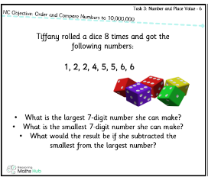
Maths Challenge!

We have attached 3 sheets of Maths challenges for you to complete.
There are 9 reasoning problems involving place value, rounding and negative numbers. Remember to explain how you have worked them out!

Reading  This week we have a selection of reading activities for you. We would really like you to complete at least one but we are happy for you to choose which you would prefer. If you would like to complete all three then we would be delighted!  Read the next page or chapter of your book. Read it in your head first. Read it a second time using a whisper voice. Read it a third time, this time aloud and with as much expression as you can manage!  OR  Choose a book that you think will be boring. Read it for 10 minutes. At the end of this time, rate the book out of 10 (1/10 = AWFUL! 10/10 = BEST BOOK EVER!) Read on for another 10 minutes. Has your rating changed? Why?  OR  Choose a book or poem that you really love. Create your own read-aloud by recording yourself reading it. Maybe you could share it with members of your family or some of your friends. | Topic  Continue to use the oak national website. Have you learnt anything in addition to what you already knew? We’d love to see or hear about this!  https://www.thenational.academy/online-classroom/year-6/
Wellbeing and Mindfulness

Gratitude Jar
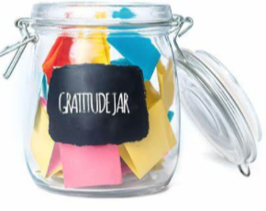

This week we would like you to make your own gratitude jar.

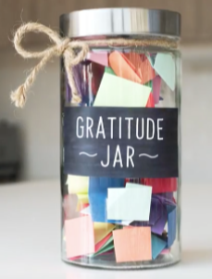

Write down ten people or things in your life that you are grateful for on individual pieces of paper. Explain why you are specifically grateful for those people or things.

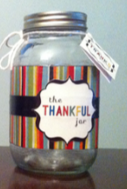

You do not need a fancy jar; you can just as easily use an old jam jar or even a plastic tub and decorate it to make it special.
Keep some extra pieces of paper near your jar so that you can add to it when you feel like it.

We would love to see photos of your finished jars. 😊

Spellings

This week we have attached two different activities for you to complete – both involving the year 5/6 spellings with double consonants.
There is a wordsearch and a crossword with a page of answers. Please ask your adults to only give you the crossword to start with. Once you have completed as much as possible then you can have the answers sheet and mark your own work. Good luck!

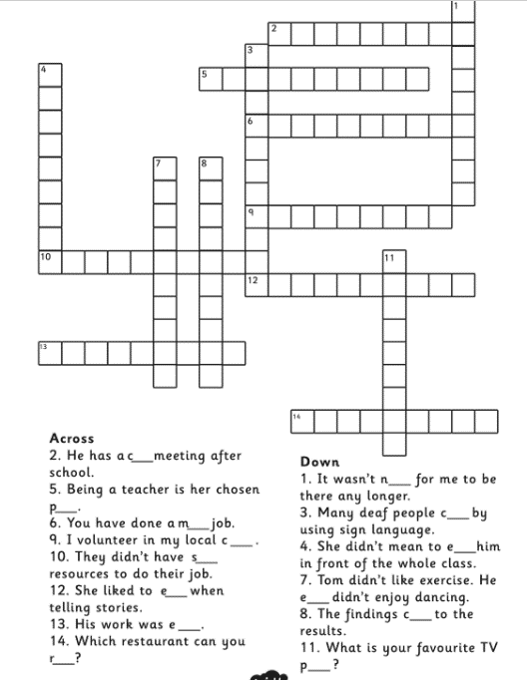

Maths Challenge!
