**Year 6 Home Learning**

|  |  |
| --- | --- |
| **The King of the Fishes**  You have now practised writing all parts of your story and it’s time to put them together as one! Have a go at drafting your story, remember, refer back to the model text to ensure that you have structured it correctly. Once you have drafted it, leave it to one side. The next day, go back to your story and read it aloud – can you spot those errors?  Look out for:   * Incorrect uses of commas to mark two main clauses * Missing punctuation * Spelling mistakes * Language choices that could be upscaled * Repetition or omissions of words * Could you add in some higher level punctuation?   Once you have edited your work, present it on a double page spread as we’ve done in class before. We were speaking to Mrs Lenehan this week and she shared her son’s home learning with us! We’ve attached it below – have a look through and see if you identify things you like or could magpie. It’s not about the same topic, however, it’s a brilliant example of how you could present your stories! We can’t wait to receive yours and we hope to put a selection we receive on the website for you to read through and spot your own ☺  Free write:  If you feel inspired by reading the information text on pandas, you could always pick a topic that interests you and produce something very similar! It could be something we’ve look at in class e.g. the Industrial Revolution, the start of our Civil Rights Topic, Population, Evolution or anything else that takes your interest! Hopefully, we can all learn something from you! Remember, if you are researching to put it into your own words when writing up. | **Maths**  Write a list of all the square and cube numbers like this:  12 = 1 13 = 1  22 = 4 23 = 8  32 = 9 33 = 27  42 = 16 43 = 64  and so on up to 102 and 103.  Then write the numbers 1 to 100 on a piece of paper like this:  1 2 3 4 5 6 7 8 9 10 11 12 13 14 15 16 17 18 19 20  and so on.  You job now is to make up calculations using the square and cube numbers and then cross the answer off your grid. For example, if the calculation was 33 + 42 = 43 then I would put a line through the 43 on the grid.  Another example would be 63 – 53 = 91 so I could cross off the 91.  How many numbers will you be able to cross off?  We are posting a Maths Quiz that has been sent to us from one of you below! In the next home learning grid, we will reveal the answers so you can see how many you got correct.  Send some of your quizzes into us and we can post them on the website for others to have a go at solving! |
| **Reading**  *Word Association Game*  This is best played with another person  Pick a word. The next person then has to say a word that is associated with that word and so on until someone can’t go. The other person would then win the point. If playing on your own, it would be until you could no longer think of anymore. You can then pick a new word and try and beat your score from the last round.  You could add additional challenges for example, the associated word isn’t allowed to begin with the same letter or it can’t be a synonym of the word. Have a dictionary to hand to check if someone says a word you’re not convinced has a connection!!  We have also put a quiz below from a member of 6S about David Walliam’s book ‘Gangsta Grannies’ for you to have a go at. Remember to keep sending your quizzes in. | **Project Work – The Mayans**  Have a go at creating a scrap book about the Mayans. Each home learning grid, we’ll update with the websites and sections you can use to write about. By the end of time, you will have a project book about the Mayans that you can bring in to school to read in our book corners. It’s a really exciting opportunity to make it as creative as you’d like. We can’t wait to see the end results!  Day 5 – Mayan artefacts  Have a go at the Maya object quiz we’ve put below. There are different artefacts that you need to have a go at identifying what they are, what they were used for and who used them. We’ve put the answers in as well so you check afterwards and carry out further research on anything that takes your interest!  Learn about Mayan Masks and have a go at designing your own. If the link doesn’t work, you can type Mayan Masks into Twinkl and it’ll come up.  <https://www.twinkl.co.uk/resource/t2-h-5599-ks2-mayan-masks-powerpoint>  This could take up two pages of your project book. The first could be an information page about Mayan masks and the second could have your design on it. There are templates available online, however, we know what fantastic artists you are you may not need them! Be sure to decide the event you are designing your mask for and ensure the colours and patterns you choose match the research you have read about. If you have any coloured paper at home, you can cut small pieces to create the collage effect. This is a good youtube video that shows you how to do it and also gives a few interesting Mayan facts along the way –  <https://www.youtube.com/watch?v=a7HxkPGdKYg> |
| **Spellings**  Pick 5 words from the year 5/6 spelling list to learn. Can you think of a rhyme, saying or acronym to help you remember how to spell it?  Practise using those words in contexts. Write a sentence with them in and try to use a different English device in each sentence e.g. a semi-colon, brackets, dash, fronted adverbial etc… | **Illustrate your story!**  Use your art time today in illustrating your double page spread. Think back to previous ones you’ve done in class or take inspiration from the example below. |

Reading Quiz

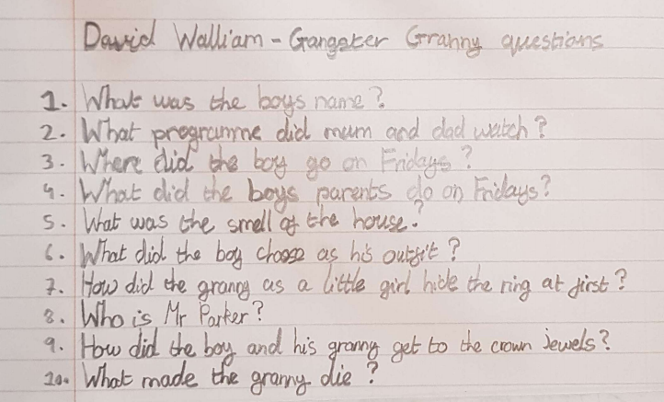

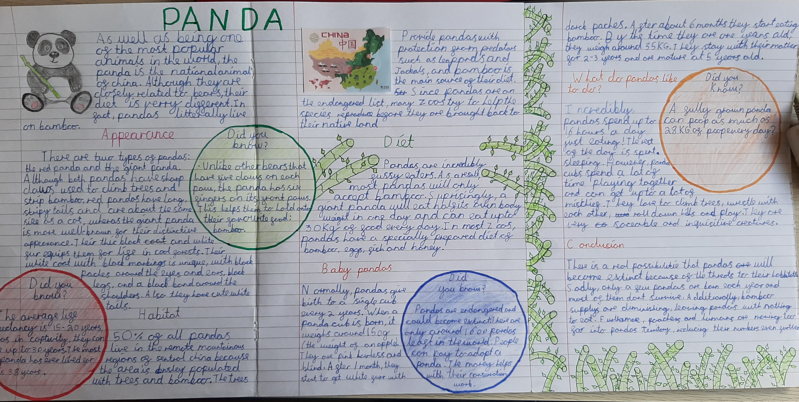

What could these Mayan objects be?

|  |  |  |
| --- | --- | --- |
| Object | What could it be used for?  (By whom? Priest, rich or poor?) | Justify your ideas! |
|  | Clue: when’s your birthday? |  |
|  | Clue: hole in one! |  |
|  | Clue: not quite a crown… |  |
|  | Clue: similar to a shin pad |  |
|  | Clue: probably not dishwasher safe! Cleaning it out will turn water brown. |  |
|  | Clue: a way of making lots of notes |  |

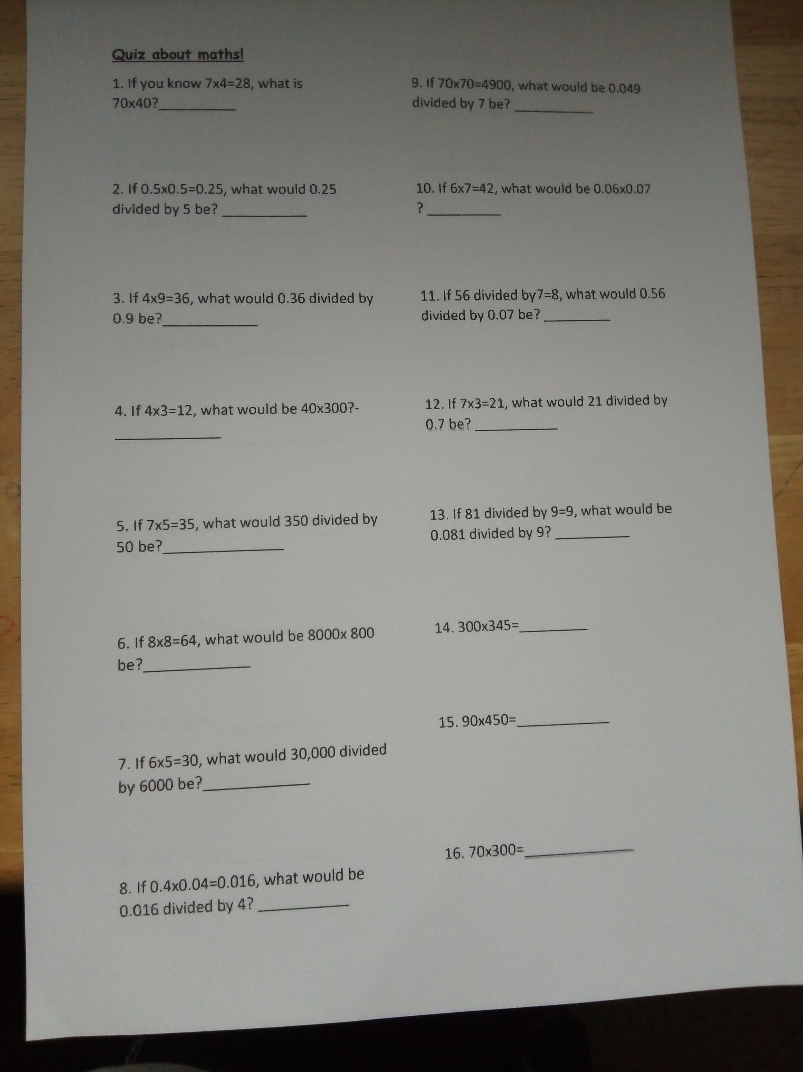

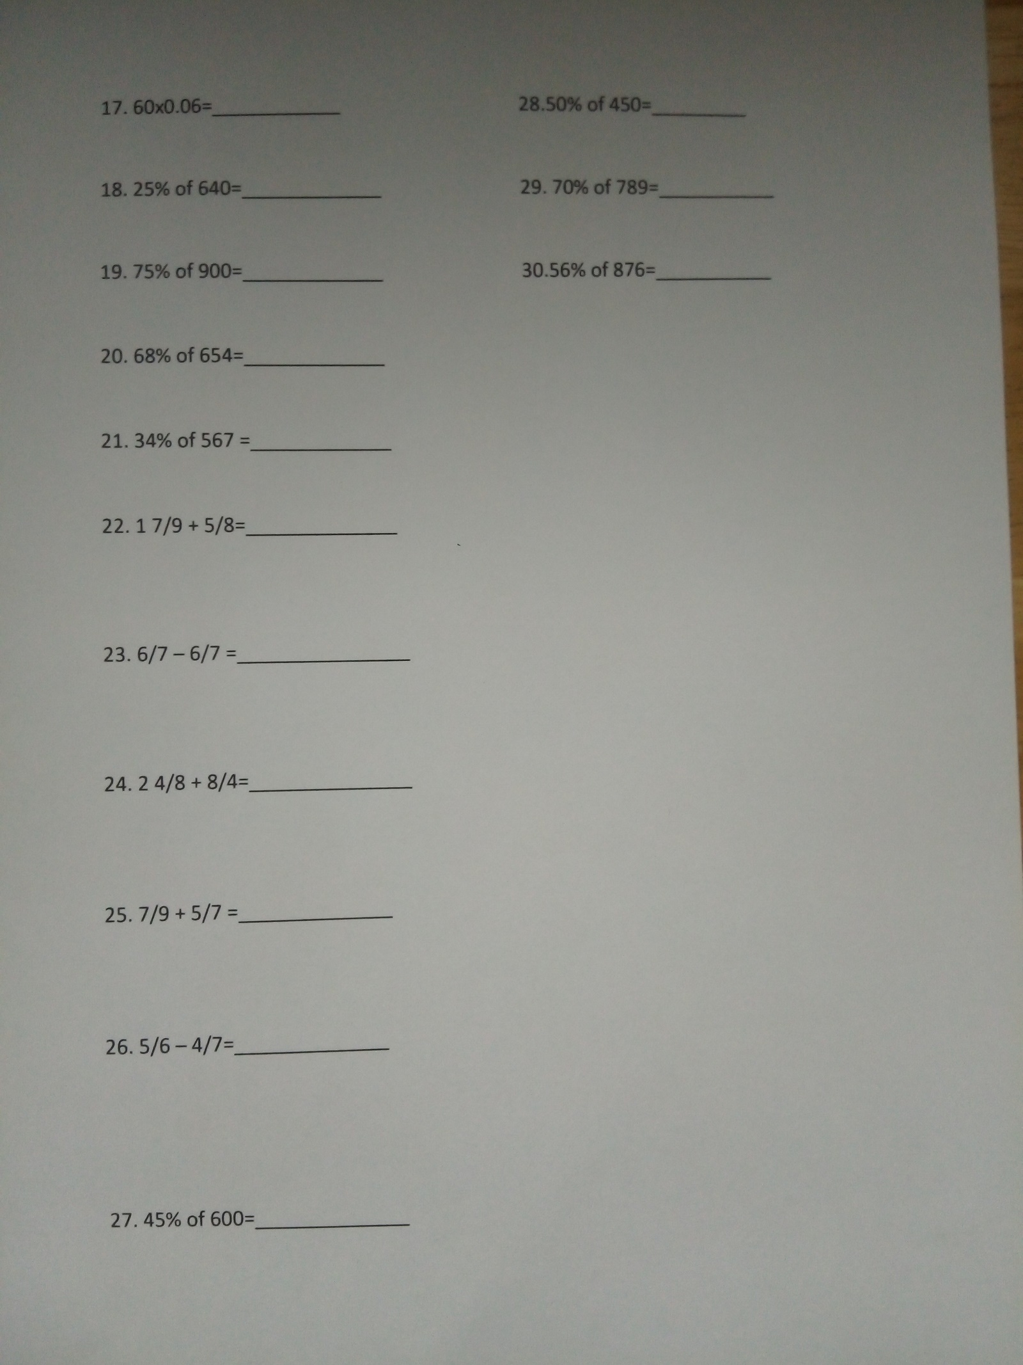

What could these Mayan objects be? ANSWERS

|  |  |  |
| --- | --- | --- |
| Object | What could it be used for?  (By whom? Priest, rich or poor?) | Justify your ideas! |
|  | Mayan Calendar  Priests? | Priests could use the calendar to plan festivals |
|  | Hoop for Pok-A-Tok ball game Men | The rich as their blood was more valuable? |
|  | Mayan Jade Pendant  This pendant has a hieroglyphic inscription of a ritual that took place at the end of a king’s rule. Several of these pendants were tied together at the waist and worn for many generations as part of a king's formal attire. | King  http://www.miho.or.jp/english/member/shangrila/vol14/eshan14_1.htm |
|  | Mayan stone protective gear Mesoamerican ballgames were sacred rituals that started from the time of the Olmecs and symbolized battles in which life was sacrificed to the gods. Heavy gear such as this, carved with a powerful creature, was worn to protect the athletes from the rubber ball used in the game. | The rich as their blood was more valuable? Men?  http://www.miho.or.jp/english/member/shangrila/vol14/eshan14_1.htm |
|  | Mayan earthen vessel This three-legged vessel is incised with scenes of a paradise of an afterworld filled with music and blossoming flowers. The inscription indicates that a king drank a special cocoa out of this cup. | King http://www.miho.or.jp/english/member/shangrila/vol14/eshan14_1.htm |
|  | Ocharina (musical instrument)  Maya figural ocarina from Honduras, c. 200 - 500 AD. This Early figural example stands on two mammiform legs and depicts an individual adorned with a spiked headdress and ear spools. | Unknown who would have played it http://www.ancientresource.com/lots/precolumbian/ancient-musical-instruments.html |