Year 5 Home Learning – Friday 19th June 2020
We’d love to see your work! Please send it to: Year5@highworthcombined.co.uk
ENGLISH Writing  Wizards  You will need to read the advert for Wizard School again.  There are persuasive words (weasel words) that are used - you would have done some work on these words already earlier in the week.  Today we are going to look at persuasive phrases – phrases that are written to convince the reader to take action or agree with the writer.  Complete the activity to practise writing persuasive sentences. You will also be able to practise imperative verbs (bossy verbs) which is a much-used persuasive technique. |  | MATHS  SHORT DIVISION  We will continue to practice our division. Choose the level that you want to work at.  Scroll down for a help sheet and the activity is in a separate attachment.  Here are two videos for some extra help: https://www.youtube.com/watch?v=SLze82Zcc4Y  https://www.youtube.com/watch?v=FApcjdAhnrY  The answers are included so, when you have finished, you should mark your work.  If you have any incorrect answers, look back over your work, check your calculation and see if you can spot your mistake.  (You don’t have to complete all the sums but you do need to practise the method for short division. If you are stuck look at the video again or ask an adult and keep on trying!)
WONDERFUL WORDS
Look at the Year 5 & 6 Words List. You can find it as a link on our Coronavirus Closure, Home Learning Matrix, Year 5 tab: https://www.highworth.bucks.sch.uk/web/year_5/460996
Choose 4 or 5 words to practise at a time.
- Look up the definition in a dictionary to check the meaning of each word.
- Learn the correct spelling by using: Look, Say, Cover, Write, Check.
- Write a sentence which includes the word to show that you understand its meaning.
4. Challenge yourself to show possibility by including an adverb or a modal verb in each of your
sentences. Scroll down to the REVISION CARD for a reminder about them.
HISTORY  Medieval Monarchs  In our first lesson we are going to be learning about the three men who were battling to become King of England in 1066.  Complete the first lesson on the Oak National Academy website:  https://classroom.thenational.academy/lessons/in-1066-who-was-the-rightful-heir-to-the-throne/activities/1 | Reading  We would love to hear about the book that you are currently reading.  - Write down a short summary of your book so far.  - Then, draw your favourite character from your book and write down a short description of him/her.  - Next, write down five questions that you would like to ask your favourite character.  E.g. Why were you rude to your Ayah, Mary? (A question to Mary Lennox from ‘The Secret Garden’.) |  | Wellbeing  Talents  A talent is something that you are good at.  Think about all the talents that you have. You will have many talents!  Write down and draw some of your talents on a page.  e.g.:  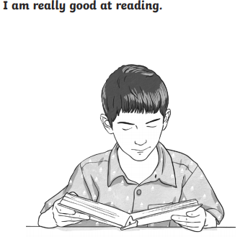  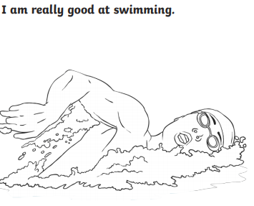  We are sure that you have many talents! You are certainly very special and you should be very proud of yourself! Keep your talent page safe and you can add on all your new talents as they develop.

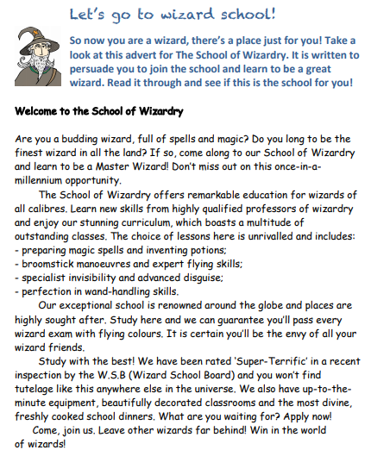

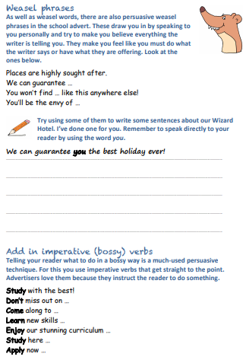

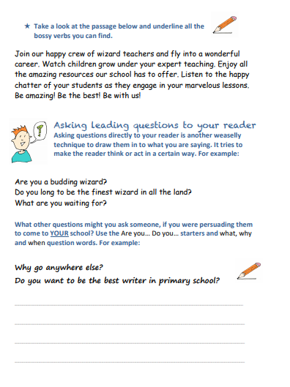

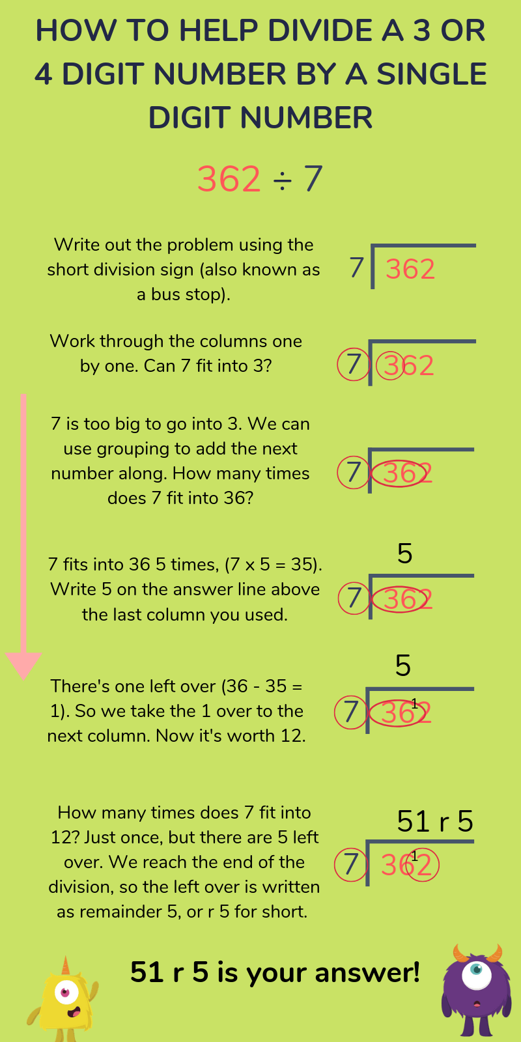
SHORT DIVISION HELP SHEET

Help Sheet
Adverbs and Modal verbs

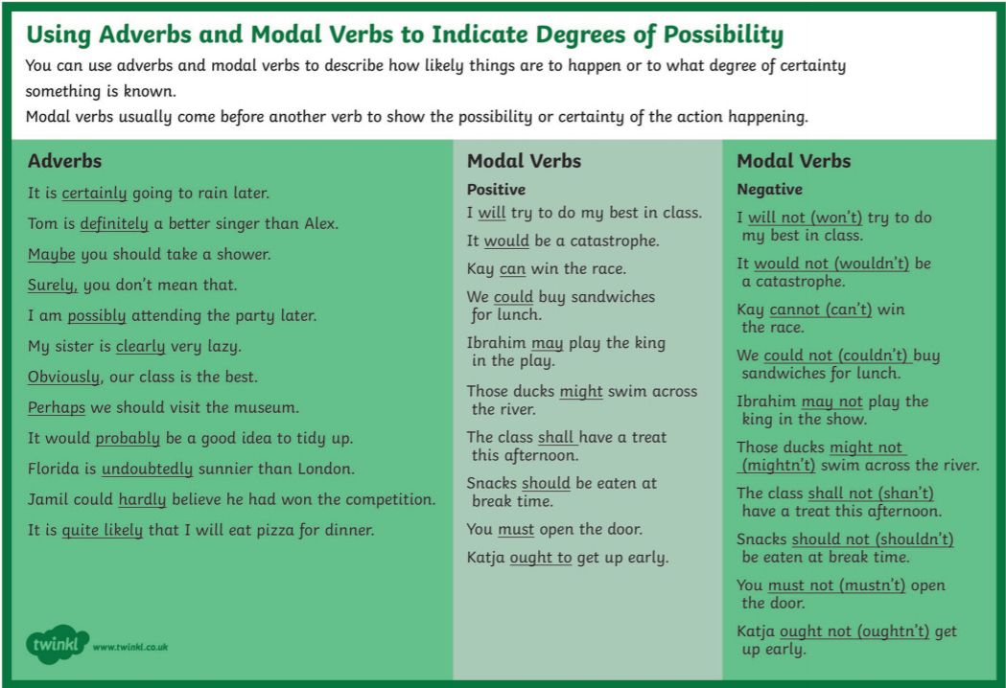
WHAT LIVES IN THE DEEP OCEAN?
https://www.youtube.com/watch?v=HEdDOr1rqDI
1) What is the abyss? What is life like in the abyss?
2) Why do you think the deepest parts of the ocean are
difficult to explore?
3) Would you like to travel to the abyss, if you could? What
would you like to see?
4) Why is World Oceans Day important and why do you think we
need to protect our oceans?

