Home Learning Ideas for all
Tuesday 24th March 2020

Dave the Dog is worried about coronavirus book:
https://nursedottybooks.files.wordpress.com/2020/03/dave-the-dog-coronavirus-1-1.pdf
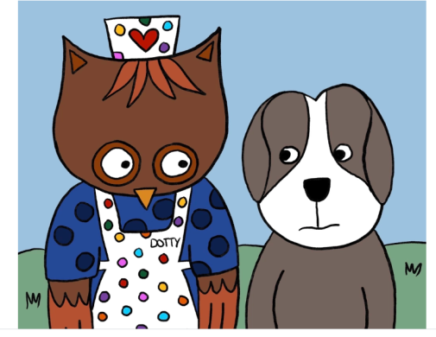
This book has been written by a Nurse at Southampton Children's Hospital to help children who are feeling worried about the coronavirus outbreak. This book aims to open up the conversation about coronavirus and some of the things they might be hearing about it and provide truthful information in a reassuring and child friendly manner.

Have a look at animals live in action at Edinburgh Zoo! Check out their live webcams below:
https://www.edinburghzoo.org.uk/webcams/panda-cam/
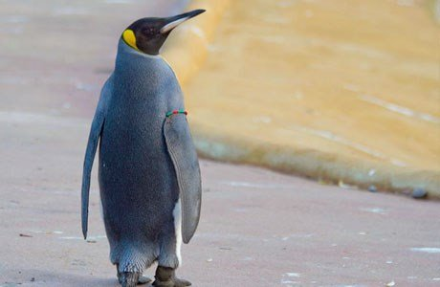
What different animals can you see? Can you draw or write about what the animals are doing?

And finally, go into Espresso (log on details on the Home Learning Ideas) https://www.discoveryeducation.co.uk/what-we-offer/discovery-education-espresso and select the correct Key Stage for you and complete the daily challenge.

