Reception – Friday 3rd April

Here are some more activities you could complete as a family. They are linked to our Early Years Foundation Stage Curriculum and current learning. Have fun and keep well!

Complete one of the Lego challenges.  What will you make?  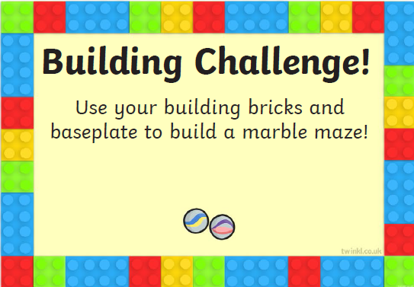  Please see the Lego Challenges link. | Design and decorate an Easter egg.   (You can use the template  provided if you like) | Please complete some of the handwriting activities attached. Please stick the sheets in your home book. 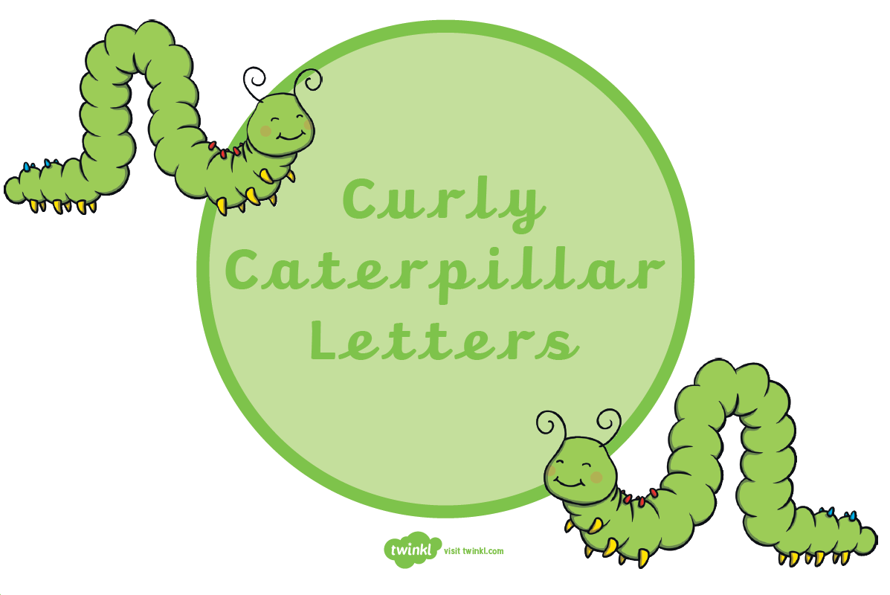  If you don’t have access to a printer, please copy the letters into your home book.
Use your scissor skills to cut out and make an Easter chick    (Please see attached sheet) | Play Four-in-a-Row (see attached sheet).  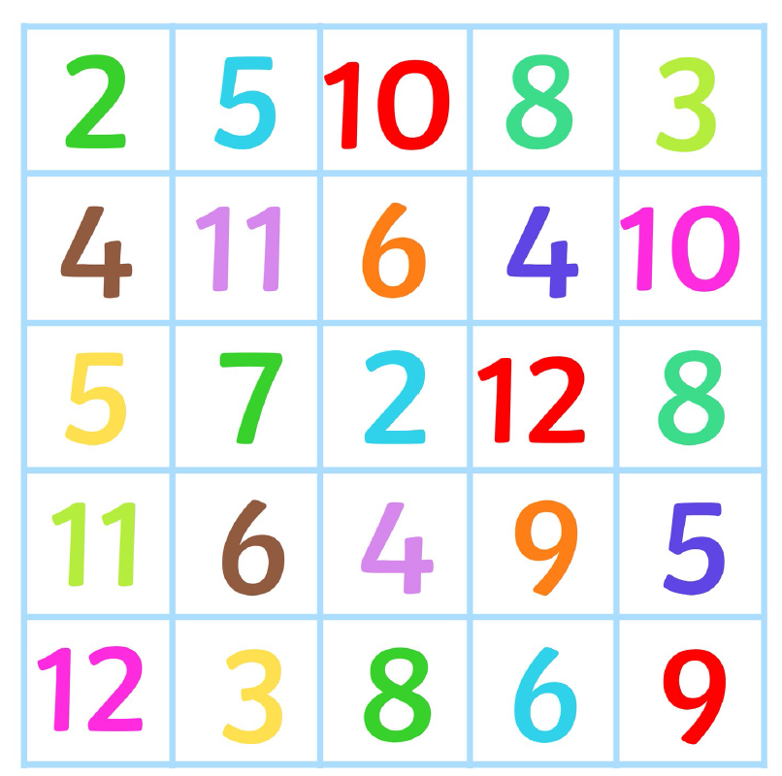  Can you roll the dice and add the numbers together? | Complete a Phonics Play game. Phase 2 and 3 are appropriate.  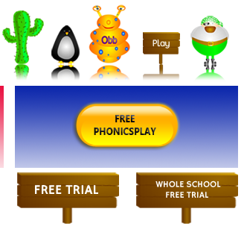  https://www.phonicsplay.co.uk/  Please note – click on the free link – do not pay for this site!

