Year 6 Home Learning
Writing  A new type of car has just been invented: The Spider car. Write about all the cool features of this car. Then invent your own cool car.  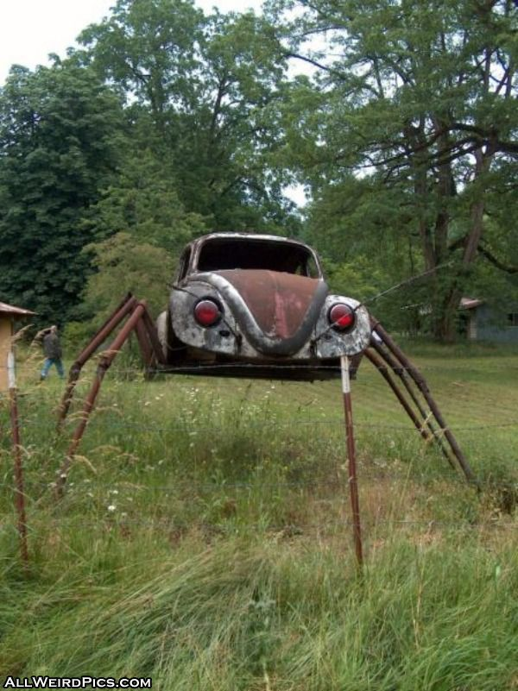 | Maths  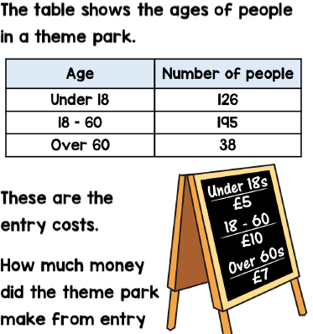  Can you create your own word problems using the above idea? Challenge yourself by using more complicated entry prices.
Reading  Look at the Extract 2.  Give two impressions the main character has of Lockwood, support each impression with evidence from the text.  Extract 2  It had come fully into focus now. Long black hair flapped around the skull. Remnants of one eye showed in the left-hand orbit, but the other was a void. Curls of rotting skin clung to spars of bone on the cheeks, and the lower jaw dangled at a rakish angle above the collar. The body was rigid, the arms clamped to the sides as if tied there. A pale haze of other-light hung around the apparition; every now and then the figure quivered, as if it still dangled on the gibbet, buffeted by wind and rain.  ‘It’s getting near the barrier,’ I said. ‘So’s mine.’  ‘It’s really horrible.’  ‘Well, mine’s lost both hands. Beat that.’  Lockwood sounded relaxed, but that was nothing new. Lockwood always sounds relaxed. Or almost always: that time we opened Mrs Barrett’s tomb – he was definitely flustered then, though that was mainly due to the claw-marks on his nice new coat. I stole a quick sidelong glance at him. He was standing with his sword held ready: tall, slim, as nonchalant as ever, watching the slow  approach of the second Visitor. The lantern-light played on his thin, pale face, catching the elegant outline of his nose and his flop of ruffled hair. He wore that slight half- smile he reserves for dangerous situations; the kind of smile that suggests complete command. His coat flapped slightly in the night breeze. As usual, just looking at him gave me confidence. I gripped my sword tightly  and turned back to watch my ghost. And found it right there beside the chains. Soundless, swift as thinking, it had darted in as soon as I’d looked away. I swung the rapier up. The mouth gaped, the sockets flared with greenish fire. With terrible speed, it flung itself forwards. I screamed, jumped back. The ghost collided with the barrier a few inches from my face. A bang, a splash of ectoplasm. Burning flecks rained down on the muddy grass outside the circle.  Now the pale figure was ten feet further back, quivering and steaming.  Spellings  Pick 5 words from the year 5/6 spelling list to learn. Can you think of a rhyme, saying or acronym to help you remember how to spell it?  Practise using those words in contexts. Write a sentence with them in and try to use a different English device in each sentence e.g. a semi-colon, brackets, dash, fronted adverbial, etc… | Project Work – The Mayans  Write your own Mayan creation story. Use the text from Wednesday’s matrix to help you.
Art

On Wednesday, you sketched some of your ideas for your creation story. Have a go at turning your story into a comic strip.

