Year 2 Home Learning
Week Commencing 18 May 2020- Wednesday

Maths Task  Times Table Challenges-  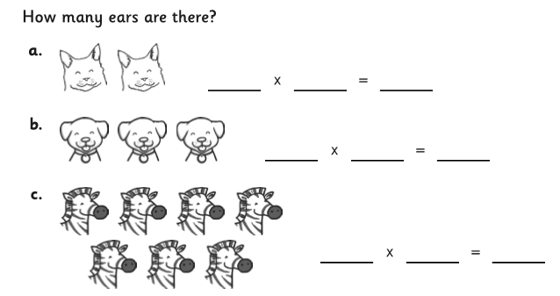  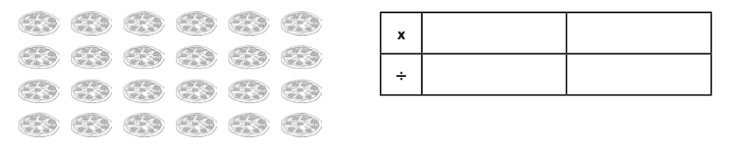  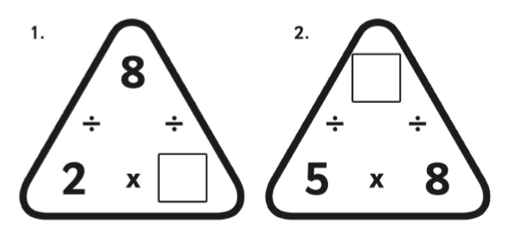 | 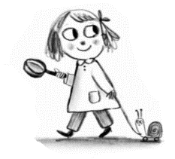  English  Scavenger Hunt Story  - Find and draw 3 red things  - Find and draw 3 noisy things  - Find and draw 3 smelly things  - Find and draw 3 things starting with ‘s’  - Pick your favourite from each group and write your own story.
Spelling  Have a look at the words below. Can you spot what suffixes have been added to the words? Write out the different words, put them in sentences, and look for our spelling patterns.  Remember the suffix rhyme:  Is there a letter I need to swap?  Is there a letter to double or drop?  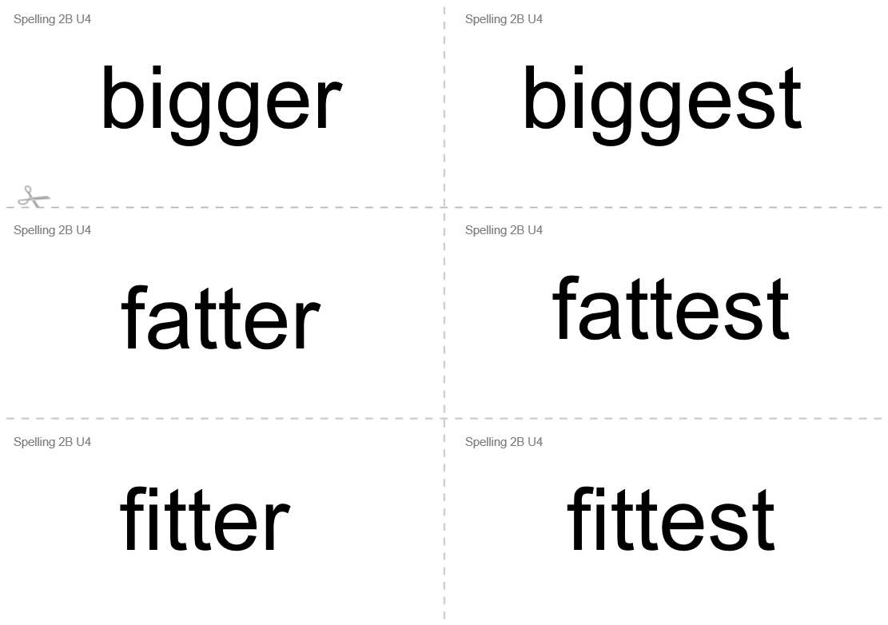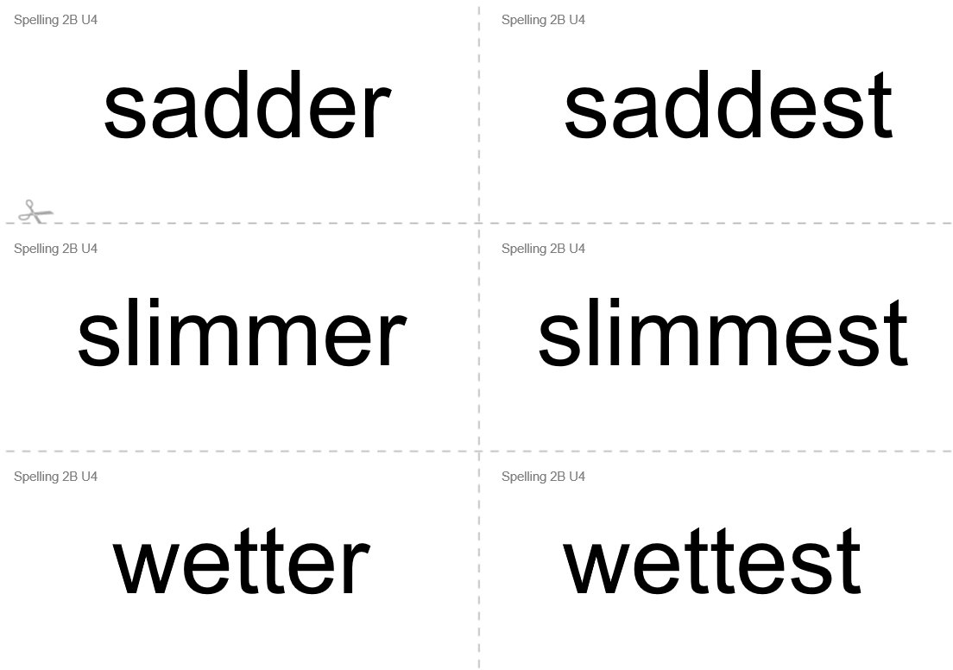 | Wellbeing  The Listening Game  This is an activity we have used many times in the classroom. I can remember one child telling me when the game was finished, “I like this because it makes me feel calm.” Enjoy some calm time.  https://www.youtube.com/watch?v=uUIGKhG_Vq8&vl=en-GB
Art  Piet Mondrian- Abstract Art  Mondrian became famous for creating art on a white background with straight lines and blocks of primary colours (blue, red and yellow).  Look at the picture below. What shapes does he use? Have a go at trying to create your own piece of art like Mondrian. You can use paper or you could even try to create one on the computer.  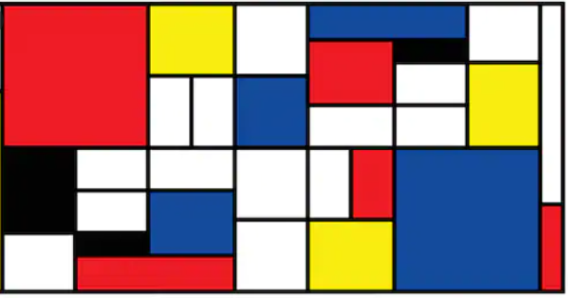  Follow the link if you would like to learn more-  https://www.tate.org.uk/kids/explore/who-is/who-piet-mondrian | App/ game  We have introduced you to Karat Cats Maths now you can play an English version. Give it a go!  https://www.bbc.co.uk/bitesize/topics/zd63xyc/articles/zdp4pg8

