Year 1 Home Learning –Thursday 16th July 2020

Below, you will find 6 home learning tasks. You may choose the tasks that you wish to complete and do them in any order.
Please do not hesitate to contact us if you have any queries.
year1@highworthcombined.co.uk
It is the last two days of the school term and this is our last home learning matrix before Summer holidays. If you need some ideas of other activities over the holidays or more activities for this week as you are not in school, you could always look back at home learning sheets from previous dates. Or try a different year group’s home learning tasks especially as you are nearly in year 2! The BBC bitesize website has lots of activities and lessons across a range of subjects you can use that are suitable for year1 https://www.bbc.co.uk/bitesize/levels/z3g4d2p and the Oak National Academy also has a range of lessons for different subjects you could access that are suitable for year 1 to help continue with your home learning https://classroom.thenational.academy/subjects-by-year/year-1/
English  A suffix is what we add to the end of a word that changes its meaning. We are going to look at some suffixes that help us change a noun from singular to plural. There are lots of rules about changing words from singular to plural so be careful as we are only looking at two of the rules.  A noun is a naming word e.g. cat, dog, pencil  We are changing a naming word from telling us about one of an object, or animal to being more than one of them e.g. one cat to three cats.  Sometimes we can add -s to a noun to show there is more than one noun, e.g. one dog, two dogs. But if a word ends in sc, ch, ss, s ,x, z, then we add es e.g. Box-boxes, dish- dishes, church- churches.  - Copy the table below.  - Write the singular word e.g. one cup.  - Then write the plural e.g. two cups.  - Add two more of your own examples at the bottom of your table.  - Change the words in the table below into plurals and then use the plural words in suitable sentences.  box jumper pen dish  fox wish witch car  river boat bottle tree  desk year shop chair  class watch beach flash  coach lunch dog girl  flower shoe bike apple | Maths  - Find these objects around your house; a pencil, book, phone, shoe, toothbrush, spoon, hairbrush and a selection of your toys and then order them by length.  - Talk to an adult to compare the objects using the language shorter, shortest, longer, longest.  - Now measure your objects using a non-standard measurement e.g. measure the length using Lego bricks or teddy counters or coins whatever you have at home and write down the non-standard measurement. Make sure you use the same object to measure with each time. Record your measurements in a table  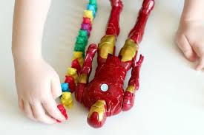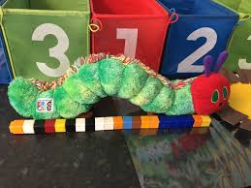  - Now measure the objects using a ruler and record your results.  Length Challenges.  - How long is a stick of spaghetti, is it the same length after it has been cooked?  - Measure the length of your foot. Then measure  the distance between your wrist and your elbow. Compare the two distances.  - Measure your height. Then, with someone’s help, measure the distance from fingertip to fingertip when you stretch your arms wide. Compare the distances - do you notice anything?  - How many things can you find which measure exactly 15 cm?
Art
In your garden or outside space collect some, natural materials that you can use to create your own natural art picture. Look at the pictures below for some inspiration.
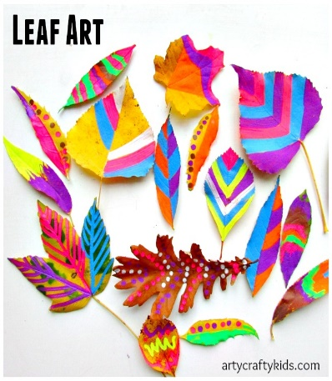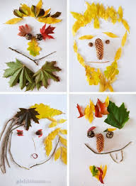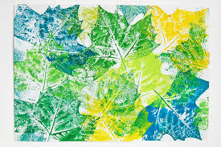
Painting leaves portraits with natural materials leaf printing

Don’t forget to send us a photograph of your work!

Wellbeing  Glitter jar  To be made and used with adult supervision  1. Find a plastic jar or bottle, decorate it how you would like 2. Fill the bottle up ¾ of the way with water  3. With an adults support. Add glitter, sequins, or food colouring and glitter it is your choice.  4. Ask an adult to seal the lid and shake  5. Make sure your family members know that this is unsafe to drink or place near your mouth and what it is.  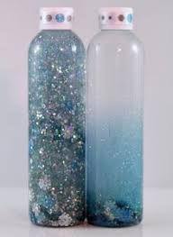  When you shake up your glitter jar, watch the glitter swirl around the bottle, this is like the thoughts and feelings in your brain. If you keep the jar still the glitter will settle, just like your thoughts and feelings when you sit calm and still and take big breaths for a few moments. |  | Geography  Today we are thinking about your local area (where you live).  Make a fact sheet about the local area that you live in. You could include:  - The name of the town you live in?  - Some sentences about where you live e.g. I live in a (town, village, hamlet) .There are (no, few, some, lots of) fields or buildings in my local area.  - You could draw a map of your local area and include a title, map symbols and a key.  - You could write about what is near by- shops, places of worship etc.  - What facts or information do you know about your local area?  - You could write sentences about things you know about the local area.  - What do you like or dislike about your local area and can you say why?  - What are the different types of housing in your local area? E.g. detached, terraced, semi-detached, cottages, bungalows, flats, caravans, boats etc.  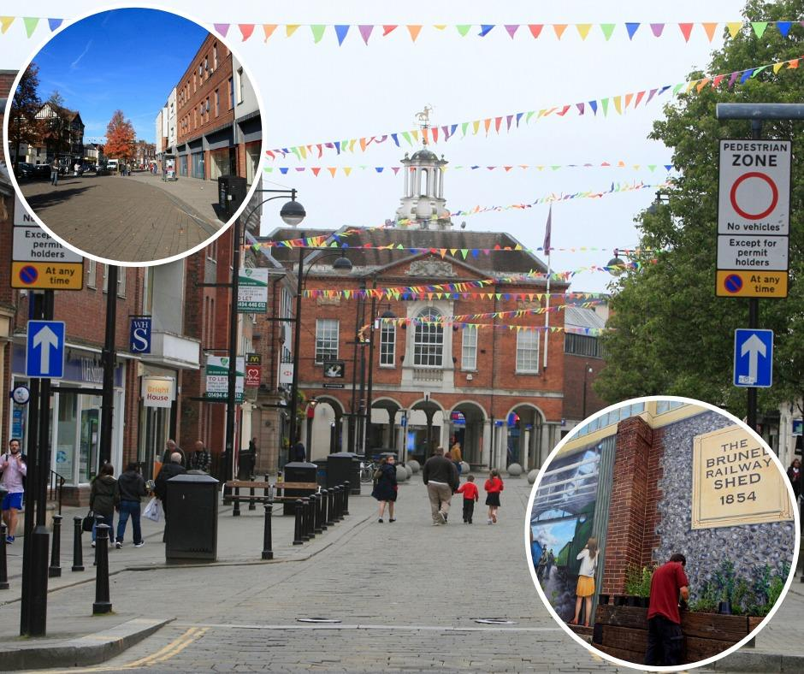
Science
In the Spring Term we were learning about Materials and their properties. The pictures and information below will help you remember some of the words and information that we learnt , please look at it carefully as it will help you complete today’s activities.

Activities
- Collect 5 different objects that are in the same room as you, draw the objects and describe them. Try to use some of the scientific vocabulary that we learnt and name the everyday material each object is made from. Explain why you think it is made from that material (the key words and scientific vocabulary boxes above will help you).

- How would you group the objects above? Draw the objects you would group together, then write a sentence to explain why you would group them together.
- Go on a material hunt around your home and garden. Collect objects that you find interesting. Write NATURAL and MAN- MADE on two pieces of paper and put the objects you have found into the correct group. Can you name the materials that they are made from?

