Priests were the most powerful people in the Maya times as they believed that they could talk to the Gods.
Priests and nobles were the only people who could read and write.
People gave the priests gifts and did work for them for free for whatever they needed.
The people only saw priests during the religious festivals.
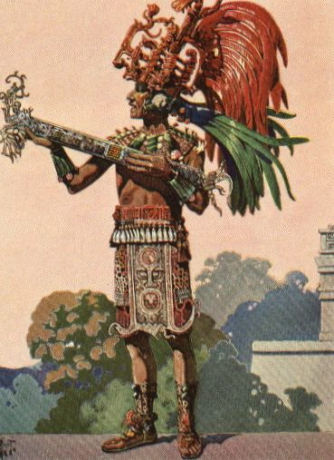
Living conditions
Priests usually lived away from other people and lived a life of luxury with servants.
Entertainment
Religious ceremonies were the main source of entertainment. They also played music, danced and played ball games.
Job
During religious festivals that happened every 20 days, the priests would dance on the steps of the temple, so that the people could see them speaking with the gods so the gods would be happy with them.
The priests were responsible for telling the people when to plant, harvest, go to war, marry, make a personal sacrifice and even how to behave.
The Kings asked the priests what to do when bad things happened. They also asked what may happen in the future.
Some priests taught children but only from noble families. They taught maths, science, astronomy, medicine, writing, and other subjects.
Clothing
During the religious festivals the priests would have worn elaborate and scary costumes.
At other times they would have worn colourful clothing made from animal skins. They also wore tall hats and feather headdresses and fancy jewellery.
Food
The Maya ate very well. The most important food that the Maya ate was maize. They made all types of food from maize including tortillas, porridge, and even drinks. They also ate beans, squash, and chilies. For meat the Maya ate fish, deer, ducks, and turkey.
Priests liked a chocolate drink with chilli peppers.

