Year 2 Home Learning
Week Commencing 1 June 2020- Wednesday
Please send your work to- year2@highworthcombined.co.uk

English Task  Look at our poem, ‘Don’t’ by Michael Rosen.  At the start of the poem he repeats himself, and then he does the same thing at the end of the poem. Did you spot that? It looks like there are two different parts as well. In the first part it sounds like things that he heard as a child and then he changes to talk about what others might say, ‘One day…’  • Today I want you to write a get-your-own-back poem of dos and don’ts for your parents, brothers, sisters or teachers. You can either repeat ‘do’ or ‘don’t’ on each line, or divide your poem into two sections, one for ‘dos’ and one for ‘don’ts’. You can think about whether you want the ‘dos’ or the ‘don’ts’ to come first in your poem.  In case you didn’t watch the link from Monday, I have attached it again.  https://www.youtube.com/watch?v=Oaq3gzswei0 | Vocabulary  Have a look at the link below. There is a passage for you to read and some different vocabulary activities.  https://www.vocabularyninja.co.uk/uploads/1/1/0/0/110032277/6-7__9781472969217_preview.pdf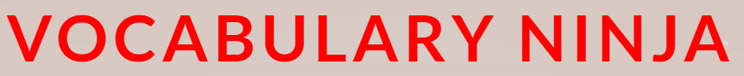  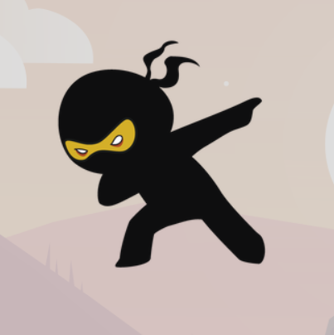
Maths
Mental Maths Warm Up
1. 17 + 36 = ___
2. 88- 18 = ___
3. 5 x __ = 20
4. 90 ÷ 10 = ___

Today you need to use your reasoning skills to answer each of these questions.
Key words that you might find helpful- numerator, denominator, because!
- 2. 3.
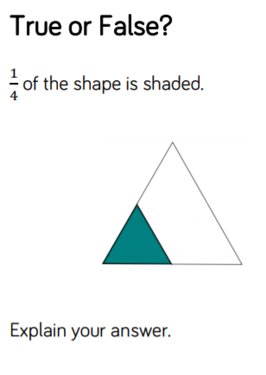
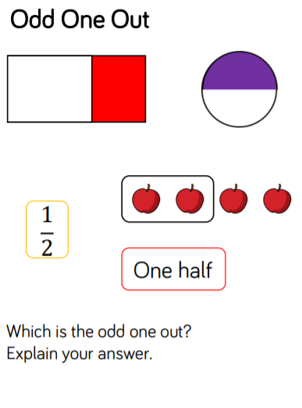
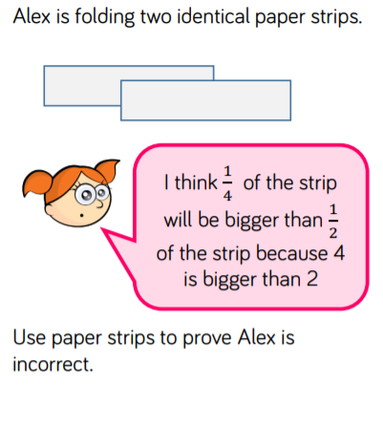

4.
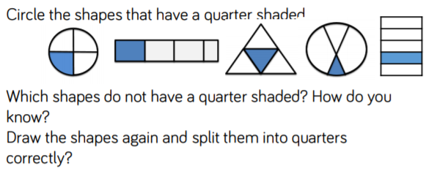

Geography  Recap on the UK  We have looked at the four countries that make up the United Kingdom (UK). Can you remember the names of the four countries and their capitals? Use the following link to remind you about the different countries and see if you can learn more about each place.  https://www.bbc.co.uk/bitesize/articles/z42pnrd  Did you know each of the countries have their own flag, Patron Saint and a national flower? Have a look at the table below and try writing a sentence about each of the different countries.  *Don’t forget the names of countries and cities start with capital letters.  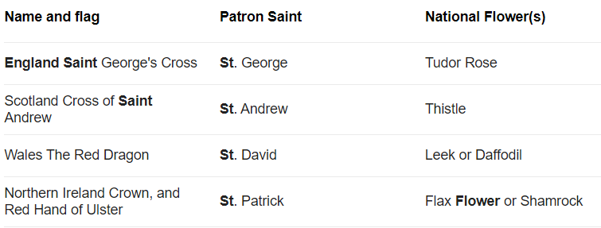  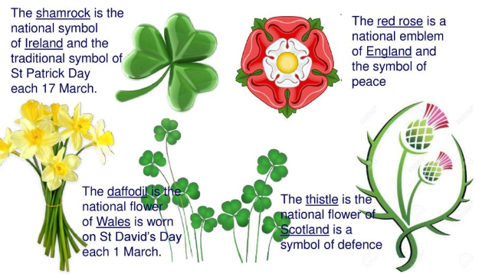 | Wellbeing  Mindfulness Challenge  