Home Learning Ideas for all
Wednesday 20th May 2020

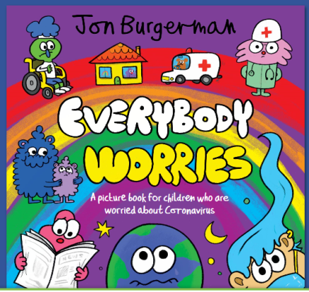
Mental Health Awareness Week
As you will have seen yesterday in our daily update, this week is Mental Health Awareness Week. We have found an online picture book for children who are worried about Coronavirus and we think it could be very reassuring for children to read. https://en.calameo.com/read/000777721945cfe5bb9cc?authid=Xu9pcOzU3TQx

Mental wellbeing activity
Can you join in with the ‘Power of Yet’ dance to stay physically and mentally healthy? There are also worksheets you can complete after!
https://imoves.com/home-learning/1535

Foil Sculpture
