Year 5 Home Learning – Friday 27th March 2020
ENGLISH  Practise identifying and using modal verbs:  https://www.twinkl.co.uk/resource/t2-e-2105-complete-the-sentences-with-modal-verbs-differentiated-activity-sheets |  | MATHS  Choose an activity to practise your knowledge of fractions:  https://www.twinkl.co.uk/resource/year-5-diving-into-mastery-equivalent-fractions-teaching-pack-t-m-30700  https://www.twinkl.co.uk/resource/t2-m-534-equivalent-fractions-challenge-cards
Wonderful Words

Look at the Year 5 & 6 Words List. You can find it as a link on our Coronavirus Closure, Home Learning Matrix, Year 5 tab: https://www.highworth.bucks.sch.uk/web/year_5/460996

Choose 4 or 5 words to practise at a time.

- Look up the definition in a dictionary to check the meaning of each word.
- Learn the correct spelling by using: Look, Say, Cover, Write, Check.
- Write a sentence which includes the word to show that you understand its meaning.
4. Challenge yourself to include a FRONTED ADVERBIAL in your sentence.

SCIENCE  We have been learning about materials and their properties. Create a wordsearch of all the vocabulary that we have learnt. Challenge yourself to use as much of the vocabulary as you can remember.  If you get stuck, use this link to remind yourself of the properties:  https://www.abpischools.org.uk/public/activescience/module14/game.html | PSHCE  Try this activity for a Winning Way to Wellbeing:  (Zoom this page up on your computer much larger to read it!)  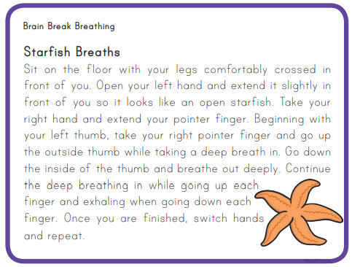 |  | HISTORY  Test your memory of our learning about the inventions from the Victorian era and produce a poster to show as many as you can recall.  You could include the year of invention too. Why not try presenting it as a timeline of inventions?  You can use this link to jog your memory:  https://www.twinkl.co.uk/resource/victorian-inventions-flashcards-t2-or-572

In addition to the tasks above, please remember to spend 10 minutes reading every day!

