Week 8 Home Activities 3 of 3
Here are some suggested activities you could complete as a family. Have fun and keep well! Please do send us photos of what you have been doing at yearn@highworthcombined.co.uk

Literacy/Communication  Phonics. Learning to hear sounds and recognise letters.  Watch Alphablocks. Here is the link: https://www.bbc.co.uk/iplayer/episode/p0872x41/alphablocks-magic-words-1-meet-alphablock-a  Play a letter recognition game with your grown up. Can you recognise and say all the letter sounds that are in your name? What other letter sounds do you know?  Have a go at writing the letters.  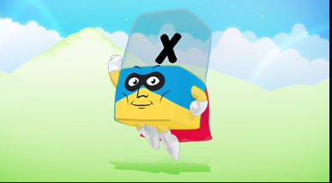 | Physical  Keep practicing writing your name. Remember to send us a picture of your writing to yearn@highworthcombined.co.uk  Ask your grown up to join you in a yoga session.  Here is the link: https://www.youtube.com/watch?v=LhYtcadR9nw   | Personal and Social  Encourage children to be kind and think of others whilst at home with this tick sheet  

