Year 2 Home Learning
Week Commencing 15 June 2020- Monday
Please send your work to- year2@highworthcombined.co.uk
We always look forward to seeing your work. Please let us know if you need any help or have any questions.
English Task  Today I want to know what you prefer. For this type of question there isn’t a right or wrong answer. It is down to you and what you would prefer, or like more.  Have a look at the question below and decide your answer. Then you need to think of at least 3 reasons why you have made your choice.  -What can you see, hear, feel or do?  Here is my example with only one reason.  I prefer playing in the sand because you can build tremendous sand castles covered in beautiful shells.  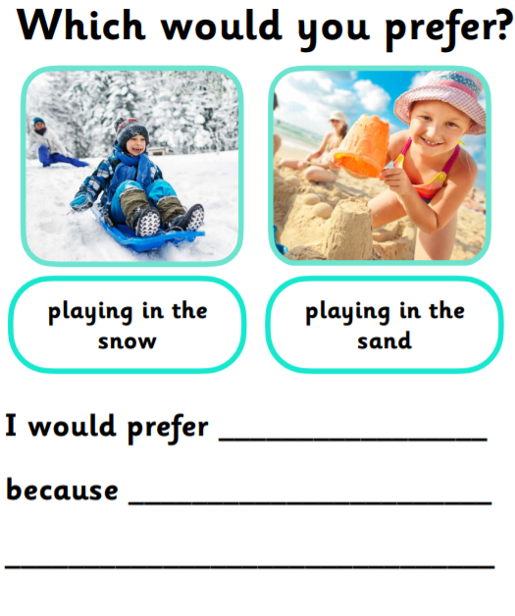 | Maths  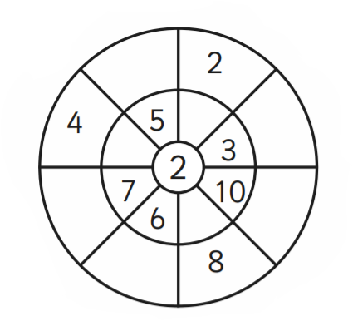  Warm up-  Division-  For division, you divide by making equal groups. Then you count on to find the total number of groups. You can do this using concrete manipulatives or by drawing pictures. We want you to recognise the link between division, multiplication and repeated addition.  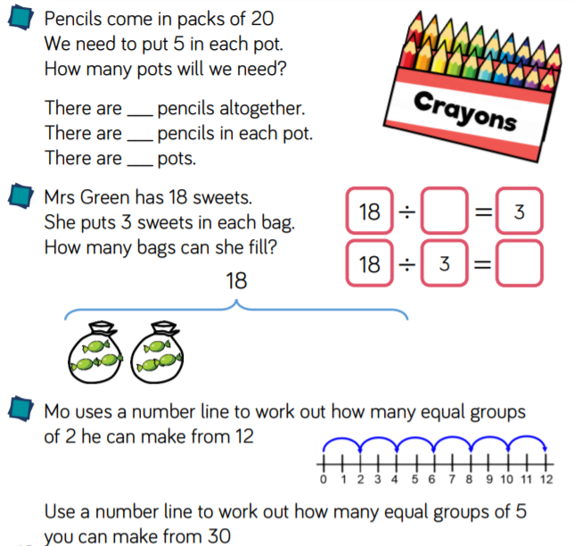
Reading  At the bottom of the matrix I have attached a reading comprehension. Enjoy reading about some of the different Kings and Queens of England.  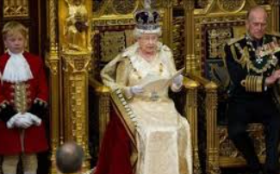 | Vocabulary  When we are writing we get to choose the words we want to use. However, often we use the same words over and over. I have picked some simple words that I see in your writing. I have written another column with a list of synonyms. Can you match the words together?  Basic Interesting  Nice unaccaptable  Bad immense  scary thoughtful  Fun entertaining  Big frightening  Challenge- Can you write a sentence using the new words.
Science  Take the Ally Pally Wildlife challenge!!  Think up and draw an invention idea that help all wildlife.  https://allypally.littleinventors.org/  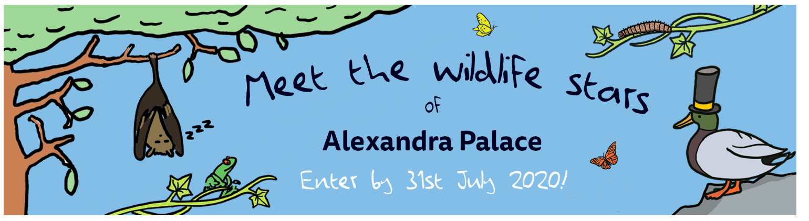 | Apps and Games  Enjoy exploring this site has lots of different types of games and science experiments. Enjoy!  https://wowscience.co.uk/

Memorable Monarchs
There have been many memorable monarchs of Britain. A monarch is a King or Queen ruling over a country. Some have been famous because they did lots of good things. Others are well-known because of the bad or unusual things they did.
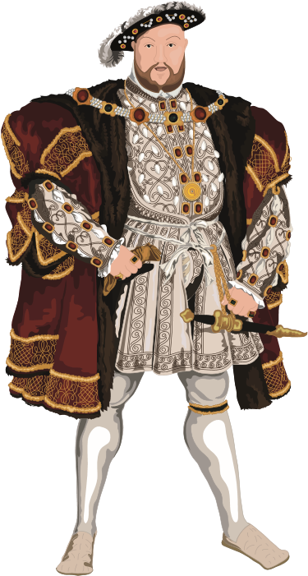
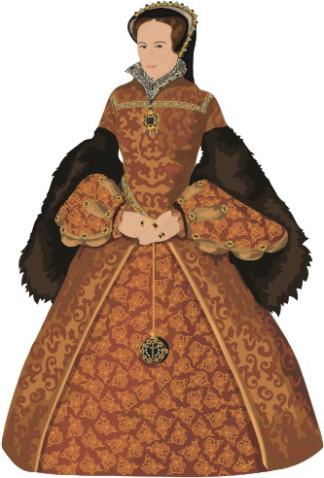
These are just some of the most memorable monarchs.

King Henry VIII (reigned: 1509 - 1547)
Most people know that King Henry VIII had six wives. He divorced two of them and chopped off the heads of two more. He wasn’t a nice man! He is always shown as being very fat. In fact, he was toned and strong for most of his life. He was also a talented musical composer. He wanted to raise money for a war against Scotland and France. Coins were watered down with cheaper metals like copper. The silver on the outside would oft en wear away just where his nose was on the coin. This led to him being given the nickname Old Coppernose.

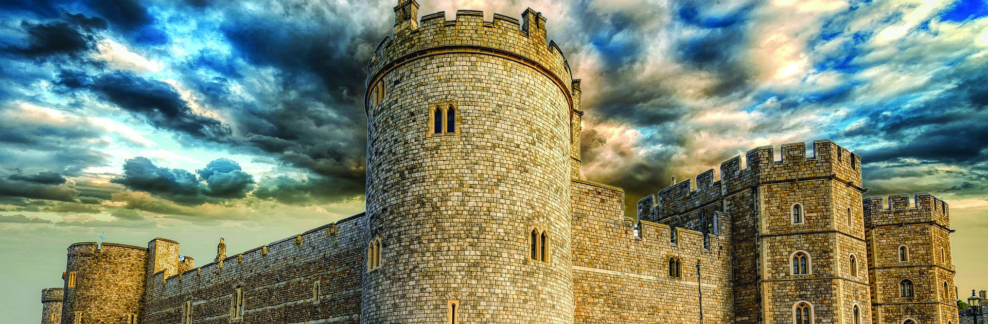
Mary I (reigned: 1553 - 1558)
STAGE 2
Unit focus: British Royalty
Text focus: Information Text (610L)
King Henry VIII had formed the Church of England and got rid of the Catholic Church in England. Mary I didn’t agree with this decision even though she was King Henry’s daughter. She believed that the Catholic Church was the only true church. She had over 280 people executed because they didn’t agree with her. She definitely earned the nickname Bloody Mary! She was the first Queen of England to rule on her own merit. This meant that she wasn’t just Queen because she had married a King.

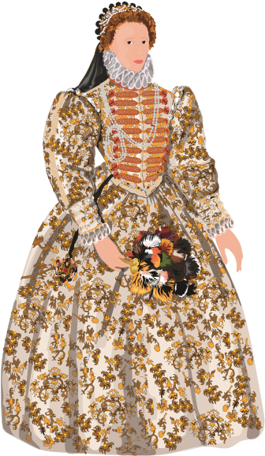
Queen Elizabeth I (reigned: 1558 - 1603)
Elizabeth was the younger half-sister of Bloody Mary. She immediately changed the country back to the Church of England. She was very tolerant. She didn’t execute people who didn’t agree with her religious beliefs.
Queen Elizabeth decided to rule the country by listening to lots of trusted advisors. This was different from lots of monarchs before her. They had ruled by doing whatever they thought was best. It earned her the nickname Good Queen Bess. She was the last Queen of the Tudors. She didn’t marry or have any children.
William Shakespeare and Francis Drake were famous people during her reign. They meant that the reign of Elizabeth is often remembered for theatre and adventures around the world.

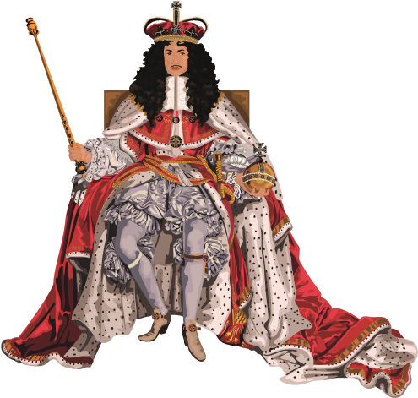
King Charles II (reigned: 1649 - 1685)
There is a bit of confusion over the dates that King Charles II reigned. He technically became King in 1649 after the Civil War. However, a man named Oliver Cromwell didn’t agree. He wanted England to be a commonwealth. This meant that the country would be run by a government rather than a king. King Charles was beaten by Cromwell in a battle in 1951. Charles fled to Europe for the next nine years.
Oliver Cromwell died in 1658. England decided that it wanted a king again. Charles was invited back, and he became King again. It was decided in 1660 that his official reign began in 1649. He was a very popular king. He was nicknamed the Merry Monarch.

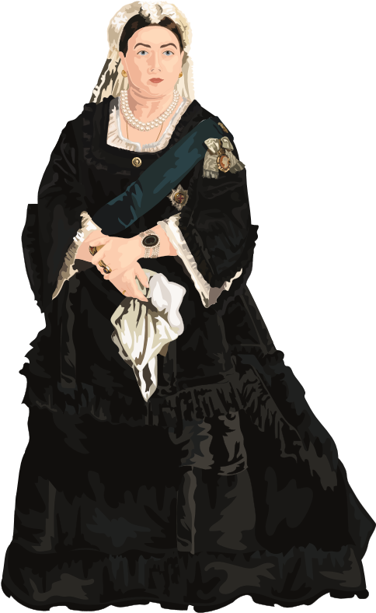
Queen Victoria (reigned: 1837 - 1901)
Queen Victoria was the longest-reigning monarch at the time. She reigned for 63 years. Only Queen Elizabeth II has reigned for longer. The Victorian era was a time of great change for Britain. The British Empire expanded overseas. This meant that Victoria became Queen of lots of other countries.
She married Prince Albert in 1840. They had nine children together. Albert died in 1861. Queen Victoria wore black clothes every day from then on.
Britain wouldn’t be the place it is today without Queen Victoria. The Industrial Revolution increased rapidly during her reign. She encouraged lots of changes in society. This included opening schools for children.

VOCABULARY FOCUS
- Which word or phrase tells you that lots of people will remember some of the monarchs?
- What does the nickname Bloody Mary tell you about Mary I?
- What phrase in the text tells you that King Henry VIII was good at writing music?
- What is an “advisor”?
- What does the nickname Merry Monarch tell you about Charles II?
 | VIPERS QUESTIONS
R | When did Oliver Cromwell beat King Charles II in battle?
I | Why did Queen Victoria have a big impact on how Britain is today?
R | Name a famous person from Queen Elizabeth’s reign.
S | Why is there some confusion over the dates King Charles II reigned?
S | What is the main difference of being a commonwealth?
Answers:
- Memorable
- She killed a lot of people/was violent
- A talented musical composer
- Somebody who advises/tells you what you should do
- He was happy/cheerful/fun/people liked him
R: 1951
I: She introduced lots of changes/school for children/Industrial Revolution
R: William Shakespeare or Francis Drake (or any other person from the era that they know from previous research)
S: He was banished from the country for a while and the country technically had no king during that time
S: A commonwealth is ruled by a government rather than a king

