Year 1 Home Learning – Monday 13th July

This is the last week of our Summer Term; today we will have a summer focus for our home learning activities. Year 1 will have a home learning matrix going out on Monday , Virtual transition day activities on Wednesday and home learning matrix on Thursday this week as school will be closed to most children this week.
Please do not hesitate to contact us if you have any queries.

year1@highworthcombined.co.uk

The last week of school always feels like the closing of one door and the opening of another. We want to thank you all for the warmth, the memories and the learning that we have shared this year both in person and virtually. It was a great pleasure to have each of you in our classes. You have all grown in many ways, definitely a few cms taller, wiser, more responsible and more mature than when we met you back in September. It has been a pleasure and privilege to see your personalities grow over time and how you have developed in your learning both virtually and in real life.
We have laughed, played, learned and enriched each other’s lives. You have had a very uncertain and different year of school to what I hope you will ever experience again in your school lives. Whilst we were apart from you all, all of the year 1 teachers have said how truly precious you each are and how important it has been to keep you safe, along with how much we have missed you all. Remember that we will always have a great interest in your lives and destinies, wherever you may go, whatever you do and whomever you become please come back and say ‘hello’ as we will be missing you.
To your parents we want to say THANK YOU. You have supported your children more than we would have ever thought possible or essential back in September 2019 by becoming their class teacher during this lockdown. We hope you have made many memories that you too will cherish!

We would like to wish you all the best for year 2 and say how very proud and grateful we are that you have all been part of our classes. We are sad to say goodbye but you will love year 2 and fingers crossed it will be more of a typical school year for you.
From Mrs Lawrence, Mrs Milner and Miss Hawes xxx

English  At the start of the Spring Term, we made a poem about spring and so it felt right as we come towards the end of the Summer Term to write a summer poem.  Today we are going to write an acrostic poem where the first letter of each line spells a word.  Write the word SUMMER down vertically. Think of words, sentences and phrases that describe summer that start with each letter. Fill in the rest of the lines to make a poem. Now decorate your poem.  Challenge  - Can you make your poem rhyme?  - Can you make an acrostic poem for other summer related words?  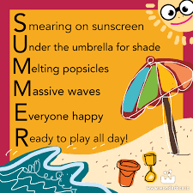 | Maths  Tally chart marks look like this. The fifth line goes across diagonally, like a gate. Look at the tally chart marks next to the number 5.  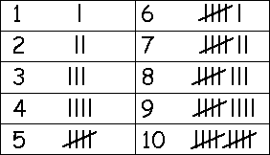  A tally chart is a way of collecting data using tally marks.  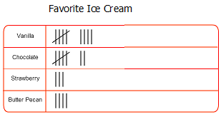  Look at the tally chart above and answer these questions.  - How many children like vanilla ice cream?  - How many children like chocolate ice cream?  - How many children like strawberry ice cream?  - How many like butter pecan?  - What is the most popular flavour? What is the least popular flavour?  Challenge  - Can you make our own tally chart, for the colours of t-shirts that you have? What does your tally chart show you?
Art
Summer time is when we usually head to the beach. Below is a selection of beach themed art made by other children.
Make your own beach art work using one of the ideas below or any other ideas you have yourself.
Seaside collage | Seaside drawing with pencils | Felt tip seaside picture | Painting made with lots of dots (pointillism)
We would love to see some photographs of your work!
PE and wellbeing  Please try some of these activities to help keep your body and mind active, please only select the ones that you have the resources for and always remember to warm up, cool down and keep safe:  - Play musical statues  - Play sleeping lions  - Do the Hokey Cokey.  - Go for a bike ride.  - Go for a walk  - Go on your scooter  - See how many times you can throw and catch a ball with another person.  - Record how long you can stand on one leg.  - Record how many times you can bounce a ball.  - Make a trail and follow it on tiptoes.  - Roll a dice and then jump that number of times.  - Take giant footprints across your garden, how many did it take from one side to the other?  - Make your own obstacle course in your garden.  - Skip for as long as you can.  Keep a journal of the physical activities that you do at home this week, maybe take a photograph and try and think of as many creative physical (and safe) activities that you can do at home with the resources that you have in your house or garden.  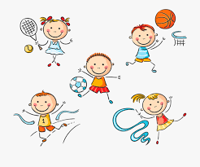  Notice how you feel before and after doing exercise. | Computing  Remember you MUST always only use the internet with an adult.  We are learning about internet safety look at these website links with a grown up.  https://www.bbc.co.uk/bitesize/topics/zymykqt how to take care of your personal information and use the web safely.  https://www.childnet.com/resources/smartie-the-penguin smartie the penguin story talks about how to keep safe online.  https://www.highworth.bucks.sch.uk/web/children/295423 to see the school link to child net be safe on the internet rules and a selection of internet safety websites. Your adult will help you select.  Once you have shared these web links with an adult, make a poster to show you know how to keep yourself safe when using the internet.  Keep safe when using the internet this summer  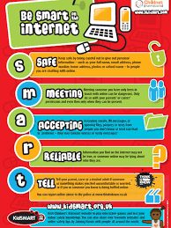
Design and Technology

Today we would like you to design and make a hat.

Design what you want your hat to look like. Think about the materials you will use and the size of your hat. Use materials from around your home to make a hat.

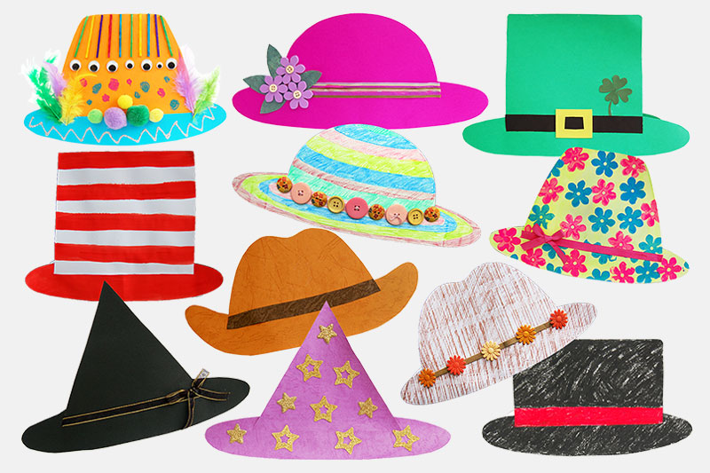

Challenge
- When you have made your hat, please write a sentence to evaluate your design.
- Would it be useful to protect you from the sun?
- When is your hat most suitable to be worn?
- Does your hat fit?
- What is good about your hat? What would you do differently next time to improve your design?

