Home Learning Ideas for all
Monday 30th March 2020
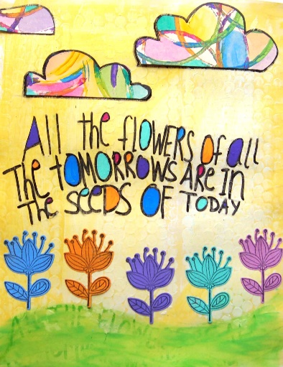
Plant a flower!
If you are able to, why not plant a seed today – you will need a small pot, a small amount of soil, a seed and a little water. You can then keep track of how many days it takes to see it starting to grow. If you do not have these things – why not look for the different flowers you can see blossoming outside? Can you find 5 different types of flowers? Do you know their names?

Which book should you read next?
https://www.bbc.co.uk/cbbc/quizzes/which-classic-childrens-book-should-you-read
Click on the link and answer the multiple choice questions to find out what book would be the perfect suggestion for you. There are lots of other quizzes on this website you could do too!

And finally, go into Espresso (log on details on the Home Learning Ideas) https://www.discoveryeducation.co.uk/what-we-offer/discovery-education-espresso and select the correct Key stage for you and complete the daily challenge… good luck!

