Year 1 Home Learning – Monday 29th June 2020

Below, you will find 6 home learning tasks. You may choose the tasks that you wish to complete and do them in any order. Please do not hesitate to contact us if you have any queries or would like to share the work you have been doing.
year1@highworthcombined.co.uk
Maths  Look at these clips about division, and complete the activities. Remember to always use the internet with adult supervision and follow the school rules about internet safety.  https://www.bbc.co.uk/bitesize/topics/zqbg87h/articles/z9jxhv4 What is division?  https://www.bbc.co.uk/bitesize/topics/zqbg87h/articles/zyp7b82 How to use a number line for division.  https://www.bbc.co.uk/bitesize/topics/zqbg87h/articles/z9pc8mn Division using an array  https://www.bbc.co.uk/bitesize/clips/z2frsg8 division as repeated subtraction.  These links explain what division is, how to divide using a number line, division using arrays and division by repeated subtraction. These are all methods we have used in school previously when talking about division and sharing.  Now answer these division questions and show your working using the methods from above or using objects to support you.  - Ms Hawes’ chickens lay 30 eggs, she wants to put them in boxes of six, how many boxes will she need?  - In the staffroom, there is a box of biscuits with 15 biscuits in. Ms Hawes, Mrs Milner and Mrs Lawrence want to share them equally. How many can they each have?  - Mrs Peters has 12 small chocolate bars and wants to share them between herself and Mrs Bansel, how many chocolate bars do they get each?  - A sweet making machine puts ten lollies in each bag. If the machine makes 90 lollies in total. How many bags can it fill? | Science  Today we are learning about trees. First, look at the labels on this tree diagram and read about the parts of a tree.  Roots: The roots are the part of the tree that grows underground. Roots help support the tree and collect water and nutrients from the soil.  Crown: The crown is made up of the leaves and branches at the top of a tree. The crowns of trees come in many shapes and sizes!  Leaves: Leaves are the part of the crown of a tree. They are the part of the tree that converts energy into food.  Branches: The branches provide the support to hold the leaves.  Trunk: The trunk is the part of the tree that provides its shape and support and holds up the crown. The trunk transports water and nutrients from the soil and sugar from the leaves.  - Go outside with an adult and draw a tree that you see regularly.  - Label the parts of your tree drawing and write about their functions.  - Name the type of tree it is.  - Is the tree an evergreen or deciduous tree?  - Evergreen - A tree that keeps its leaves all year or Deciduous - A tree that loses its leaves in autumn and grows new ones in spring. This link will help.  https://www.bbc.co.uk/teach/class-clips-video/science-ks1-ks2-ivys-plant-workshop-are-plants-the-same-all-year-round/zdvct39  - Draw what your tree would look like at different times of the year.  - https://www.woodlandtrust.org.uk/blog/2020/03/tree-id-kids/ Ask an adult to print some leaf id kits and see if you can identify your tree, maybe you could go for a walk with a grown up and see how many different trees you can identify from the leaves.
English
- Practice writing and reading the Year 1 common exception words in the cursive handwriting style.
- Write each year 1 common exception word in a sentence; underline the common exception word in your sentences.
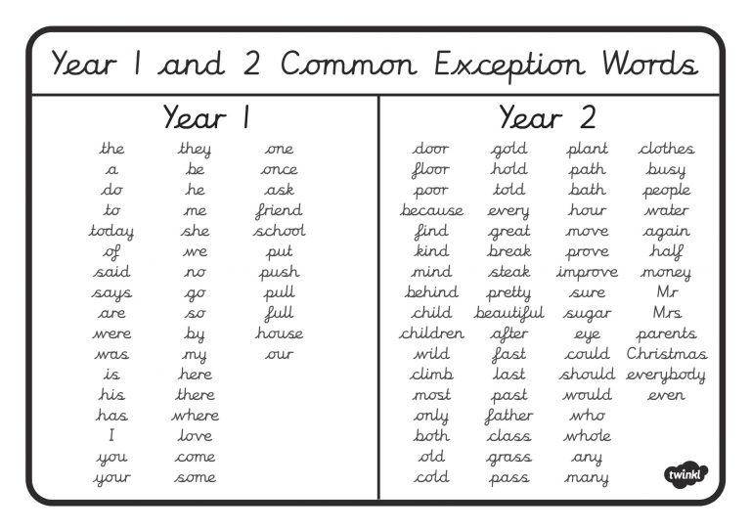
Challenge.
- Can you write a story using as many of the common exception words as you can form the year 1 and 2 list?
Art  Wassily Kandinsky is a famous artist and one of his most famous painting was of concentric circles.  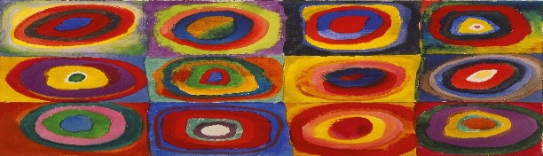  We are going to use his artwork as inspiration to make a tree picture.  Draw or cut and stick the outline of a tree and the grass and sky.  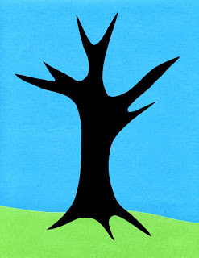  Now make layered circles of colours you can do this with paper or by drawing or painting.  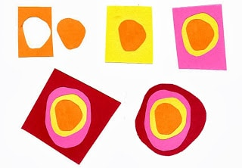  Then add them to your tree.  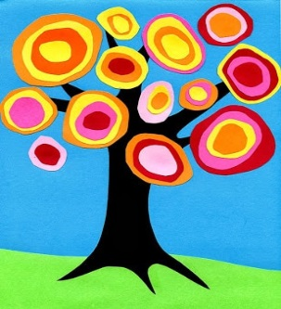  You can make your tree any colours that you like! | Wellbeing  Using your senses to be mindful.  - Listen carefully with your eyes closed for 1 minute and then write down everything you heard.  - Lie with your back on the floor and a soft toy on your tummy. Try to breathe in and out softly and slowly concentrate on watching the way your toy rises and falls as you breathe.  - Find something with a strong and pleasant scent e.g. orange peel. Place it close to your nose and try to concentrate on the smell for 1 minute.  - Ask an adult to place a range of objects with different textures in a bag. Then without looking, touch each object in the bag describe it to the adult and see if you can guess what it is.  - Select a piece of food you like to eat, eat it and describe what it tastes like , can you recognise the individual ingredients in it? Does the taste come in successive waves or all at once?  - Now take a moment and list 5 things you can hear, 4 things you can see, 3 things you can touch, 2 things you can smell and 1 thing you can taste.  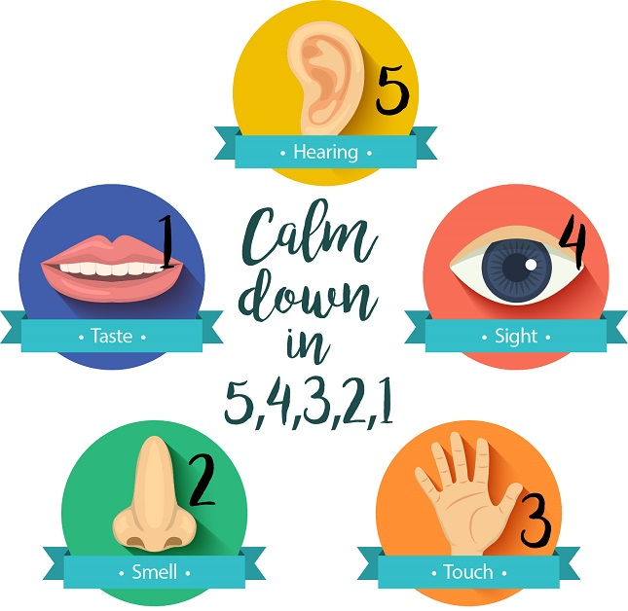
Design technology , Geography and History
Look at the list of the seven manmade wonders of the world and the pictures, select the one you like the most.
- Draw a picture of the wonder you like the most and decide what materiasl you will make it out of ( junk modeling, lego etc)
- Now make your own version of the man made wonder of the world
- Write a sentence about the wonder you have chosen and why
- Do you know where in the world it is?
- When you have made your wonder, evaluate your model. What is good about it? What could you do to improve it next time?
- Researvch about your wonder of the world and write some sentences about it.

Don’t forget to take a picture and send it to us!

