Year 2 Home Learning
Week Commencing 30/03/2020 - Monday 30th March
For some of our home learning tasks you will need to create a Twinkle account. Please follow the link from our school website. https://www.highworth.bucks.sch.uk/web/home_learning_ideas/459242
You will also need to use Espresso login details (Login: student5906; password: coding)
Use the book sent home or a blank piece of paper to record your work.
Maths Task  2D Shapes  Draw the following shapes (square, circle, triangle, rectangle, pentagon, hexagon, octagon) on a piece of paper or card (you can use card from a cereal box). Cut out the shapes and write their names correctly. Play a game ‘What am I?’ Put the shapes in a box or a small bag. Pick up a shape without taking it out of the bag and describe it. The other player needs to guess the shape. (i.e. ‘I have two short sides, two long sides and 4 corners. What am I?’) | English Task  Write about your weekend and things that you did (5-6 sentences). Remember to use capital letters and full stops.  Try to include some of words of the week from previous lessons. (scarlet, peculiar, tremendous, cheerful, astonished, resist, dingy, sneak).  Challenge!  You can’t start your sentences with ‘I’. Try to use a different sentence opener for each sentence.  Draw a picture about your favourite thing that you did over the weekend.
SPaG/ Spelling  Adjectives  Look through the book you are currently reading. Find 5 interesting adjectives and write them down in your book.  Now use them in the sentences of your own.  Challenge! Have a go at drawing a picture for each adjective. | Reading Comprehension  Twinkle activity  Year 2 A Monster Surprise Differentiated Reading Comprehension Activity  https://www.twinkl.co.uk/resource/a-monster-surprise-differentiated-reading-comprehension-activity-t-or-2017  You don’t have to print it out. You can read the text and write down the answers in your book. Just put a number of each question and write an answer next to it.
Art  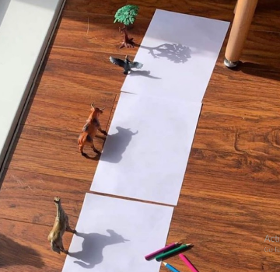  Have a go at shadow drawing. You can use any toys/objects from your house. | App/ game  Topmarks  Practise your 2 and 5 times tables  Follow the link below.  https://www.topmarks.co.uk/maths-games/hit-the-button  Happy playing!

