Home Learning Ideas for all
Tuesday 28th April 2020

Bucks Mind
Currently at Bucks Mind, they are exploring ways of staying connected with members from their Older Adults Service who may be experiencing feelings of loneliness and isolation at this challenging time. Therefore, they would truly appreciate support from our children with this one off project by having them write letters, stories, poems, jokes or even riddles alongside drawings to help brighten up an older person’s day 😊. If you would like to get involved, all you have to do is write, type or draw pictures and post these by Friday 8th May to the following address:
Buckinghamshire Mind, 260 Desborough Road, High Wycombe , HP11 2QR.
Examples could include: themselves, their family, pets, hobbies and interests, spring, food, their best holiday, music, movies or anything that takes their fancy. It would be great to hear if your child has got involved with this act of kindness!

Twinkl Videos
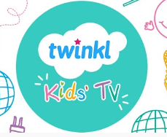
As well as providing lots of fantastic resources on their website, Twinkl have also got a YouTube channel. https://www.youtube.com/channel/UCMY4o8_rPjmFoatx7F4TvHQ
This channel includes many ‘how to draw’ videos, Science experiments, Phonics videos and many more!

Mindful Breaths
A good way to start the day in a calm and relaxed manner is to take deep mindful breaths. Can you follow the instructions on the card on the page below to take soft, slow and mindful breaths? Hopefully it will make you feel more awake and ready for the day ahead!

