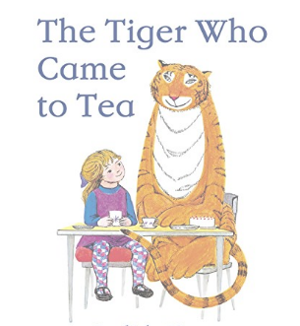
Home Activities 3 of 3

This week our activities are based around The Tiger Who Came to Tea by Judith Kerr. We hope you enjoy reading the story and completing the activities. Please continue to select games from Phonics Play and enjoy sharing books together. Have fun!

Please send us your learning to yearr@highworthcombined.co.uk we would love to hear/see what you’ve been up to!

Think about the end of the story. The tiger never came back to Sophie’s house. Where did he go? Did he go back to the zoo? To the jungle? To another house for tea? You decide. Can you write a sentence about where the tiger went? | Sophie needed help to get undressed and to put her coat on. Can you get dressed and undressed all by yourself? Can you use zips and buttons? | The tiger drank all of the tea from the teapot. It was empty! Take a cup and carefully fill it with water until it is full. Can you drink the water to show the cup is ‘nearly full’? ‘Half full’? ‘Half empty’? ‘Nearly empty’? ‘Empty’?
The tiger was very greedy. He ate all of the sandwiches, the buns, the biscuits and cakes! Count out six biscuits (you can use paper shapes or real ones!). Share six biscuits between Sophie and her Mummy? How many biscuits will they have each? Can you share ten biscuits equally between two? How many will they have each? Can you share five biscuits equally? | Learn something new together! With your family, can you learn to say ‘please’ and ‘thank you’ in different languages? | Create a picture or a model of a tiger. You can draw, paint, make a mask or a model of a tiger. Think about the colours and patterns you will use.

