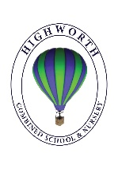
Home Learning Ideas for all
Thursday 21st May 2020
Sign up for largest at home choir event!
Mrs Martin would love it if everyone signed up to take part in the largest at home choir event ever! Young Voices (which our Year 4 children take part in every year) are leading a mammoth event and it’s free to join. The event is on 2nd June, but it would be a good idea to sign up now and to start learning the words if you do not know the song, “Power in Me” already! https://www.youngvoices.co.uk/powerinme

Become a World Guinness Book Record Breaker today!
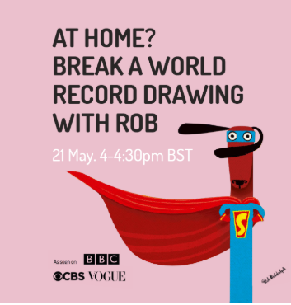
Rob will be live on YouTube at 4.00pm but in order for the attempt to meet Guinness World Records’ criteria they need participants – young and old – to register for the free lesson at www.artworldrecords.com and be there for the whole 30 minutes. The teachers would love to hear if you took part – perhaps share a picture of your drawing too? Good luck!

the Willows the Musical
Mental Health Awareness Week
As you will be aware, this week is Mental Health Awareness Week. On the next page are instructions on how to make your own Kindness Cup. Who in your family will you be able to award your cup to? Why?

