Extra Home Learning – HID Children

To replace some of the tasks in the class home learning you may wish to try some of these. Parents, please simplify or extend depending on needs and age of children. Have fun! There is an email address prepared for you to use.

Signed Story  Watch a signed story and draw a picture of what happened in the story,  Retell the story  You can video it and send it to me  You can send me a picture of your drawing | My Favourite Meal  Draw a picture of your favourite meal. You can label the food.  Write a few sentences about what the food tastes like and why you  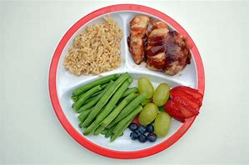  like it. Teach the signs  of the food to your  family
Reading a Story  Read your favourite book with an adult and sign as you read.  You can video it and send it to me.  OR:  You can write why you like it. | Make a Diary  Draw a picture about what you do each day. Did you  - Watch a film?  - Make something?  - Go for a walk? What did you see?  - Play a game? Who with?  Tell me as much as you can about it. You can write, draw or sign a video and send it to me.
Play A Game  Play a game with someone in your family.  Draw a picture of you playing it. You can send me a photo of you playing it or your picture.  You can tell me about the game by signing it and sending me a video | Counting the Days  Find the date on the calendar at home. With your mum or dad:  Count and sign:  How many days have you had away from school?  What day is it on the last day of this month?  How many days are there altogether this month?

