Week 8 Home Activities 2 of 3
Here are some suggested activities you could complete as a family. Have fun and keep well! Please do send us photos of what you have been doing at yearn@highworthcombined.co.uk

Literacy/Communication  Choose a favourite story to read with a grown up. Ask your grown up to read it to you first whilst you listen. Then swap over. You read the story whilst your grown-up listens. Use the pictures as cues to help you tell the story. Don’t worry if you don’t use the same words as your grown up. When you have finished telling the story tell your grown up which was your favourite part.  Draw a picture of your favourite part of the story and send it to us on email. Can we guess which story you have been reading?  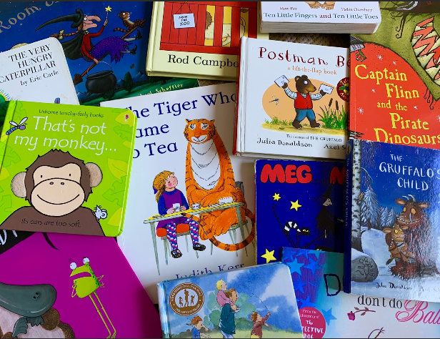 | Mathematical Development  Recognising and naming 2D shapes  Can you find any 2D shapes in your house or in your garden?  Have a go at this activity.  https://www.bbc.co.uk/bitesize/topics/zf33y9q/articles/zrmkcqt  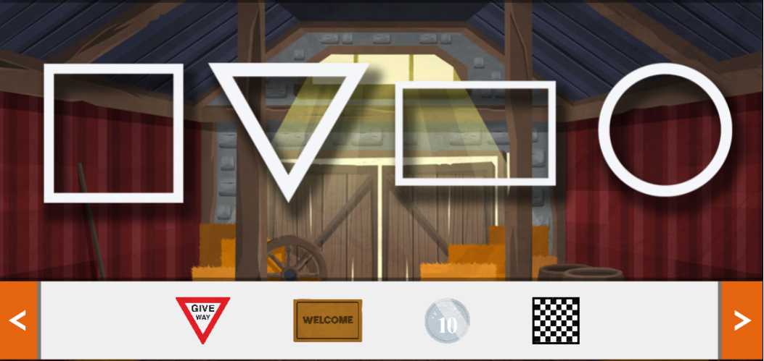 | Knowledge and Understanding of the World  Exploring Floating and Sinking  Watch the video ‘Maddie’s Do You Know’  https://www.bbc.co.uk/cbeebies/watch/do-you-know-sinking-and-floating-song  Ask a grown up to get a large bowl and fill it with water. Collect a variety of different objects from around the house eg. Metal spoon, wooden spoon, plastic bottle, coins, keys, plastic toys etc. Before you put them into the water can you say whether they will float or sink.  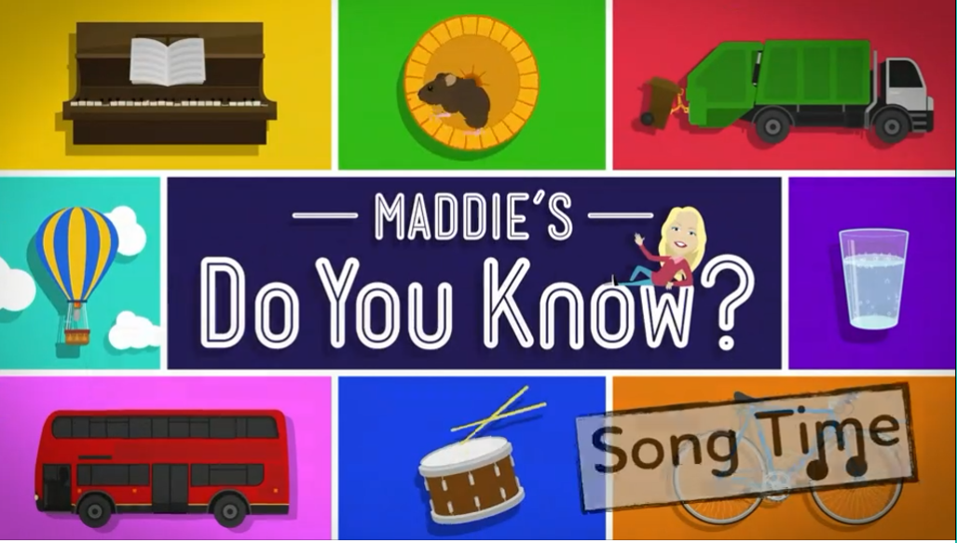
Physical  Keep practicing writing your name…We love seeing the pictures of your writing so do share at yearn@highworthcombined.co.uk.  Challenge:  How many different ways can you balance on different parts of your body?  - On your hands  - On your elbows  - On your knees  - On your back  Take a picture and share it on the website. | Personal and Social  How can we help others?  Can you make your bed and tidy your bedroom yourself? Take a picture of your achievements. How does it make you feel when you have done it? How does your grown up feel that you have helped them? How else can you be a helper at home?  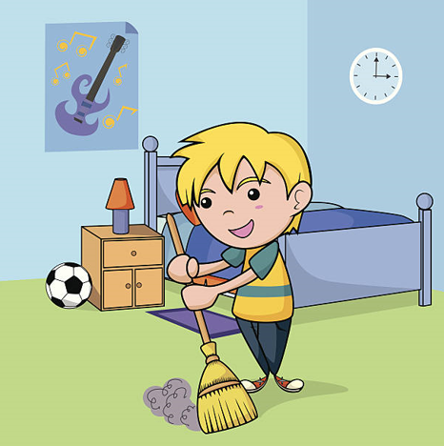 | Creative  Linked to your favourite story use props and objects you find at home to help to role play the story. Ask an adult to join you in your play. Which character are you going to be?  

